# OVER NIGHTERS 5

# BODY MATERIAL : LEATHER COLOR : BLACK & WHITE LINING : COTTON TWILL

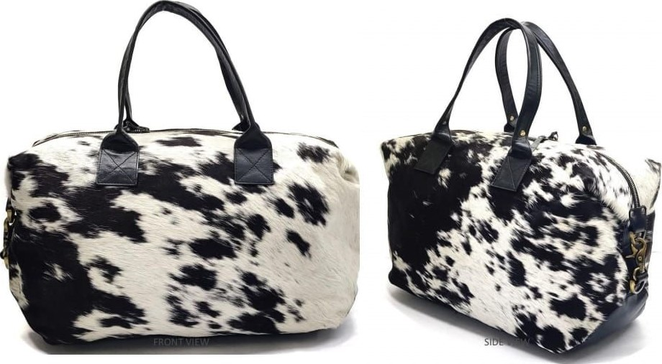

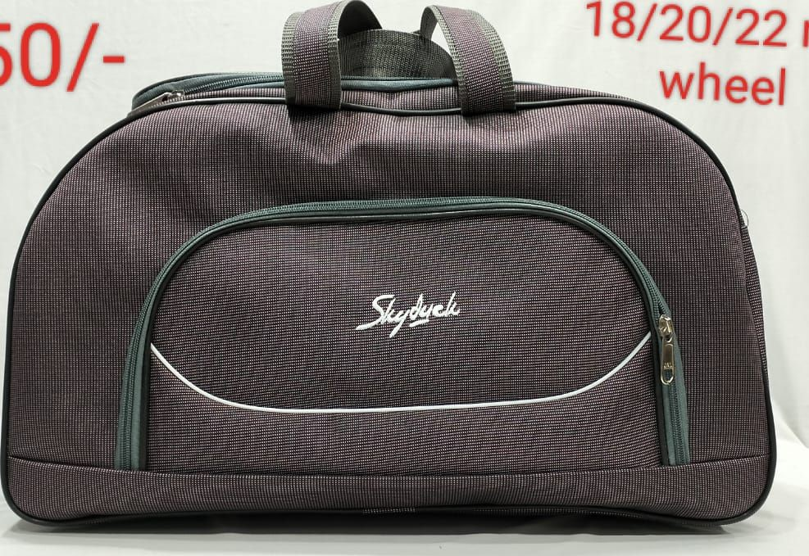

non

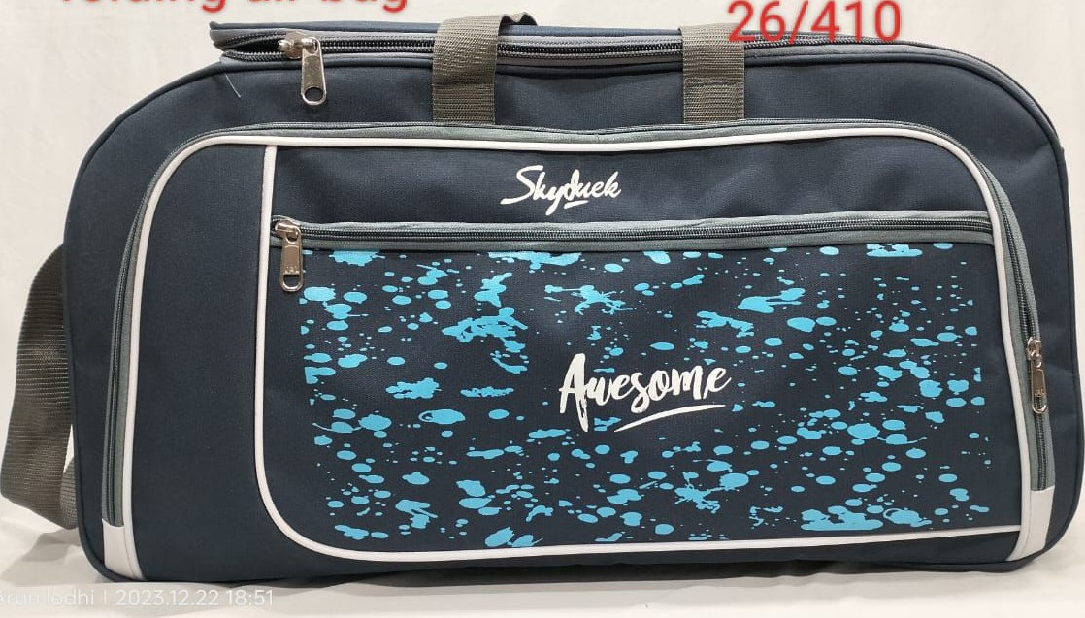

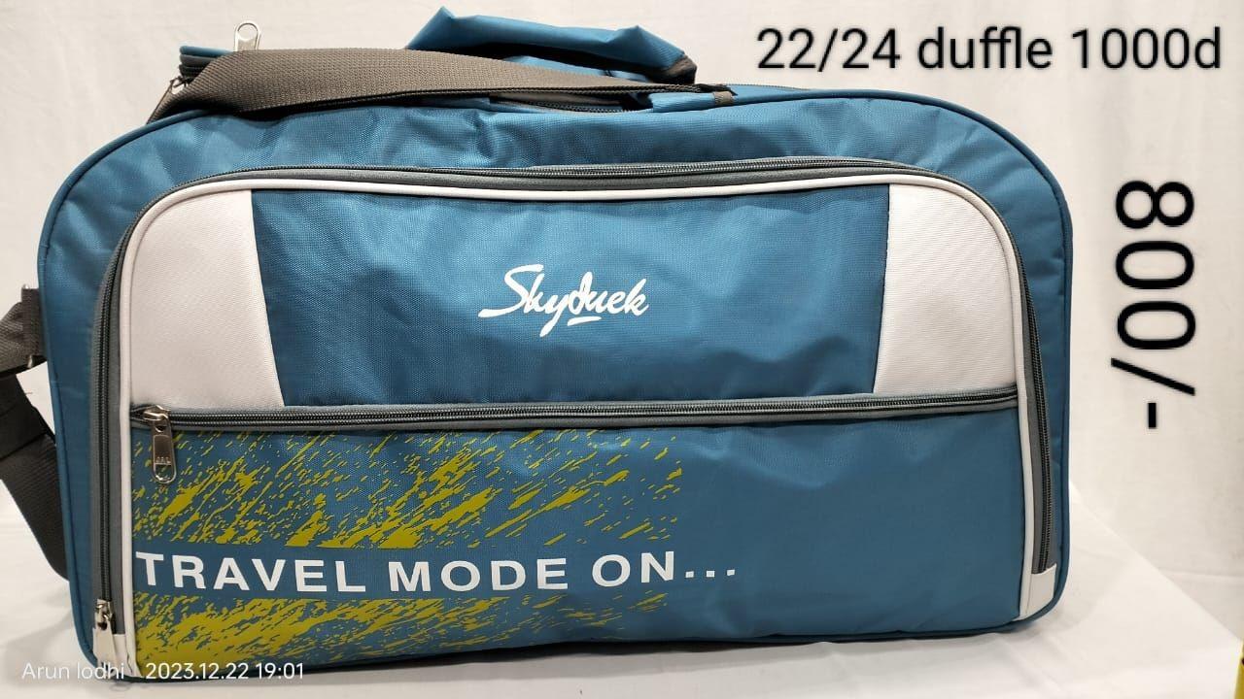

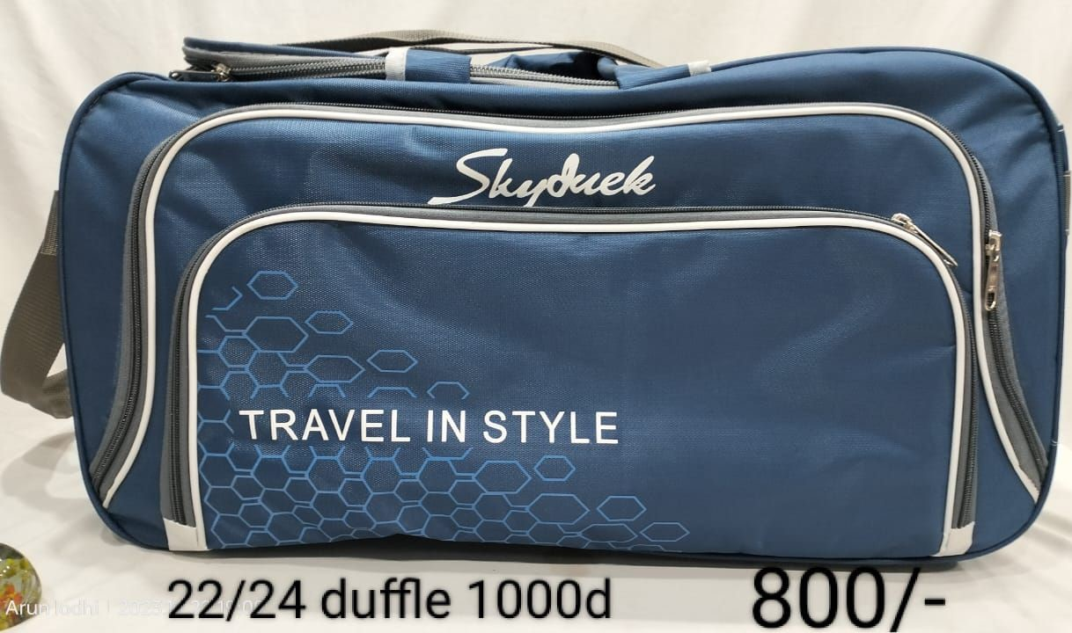

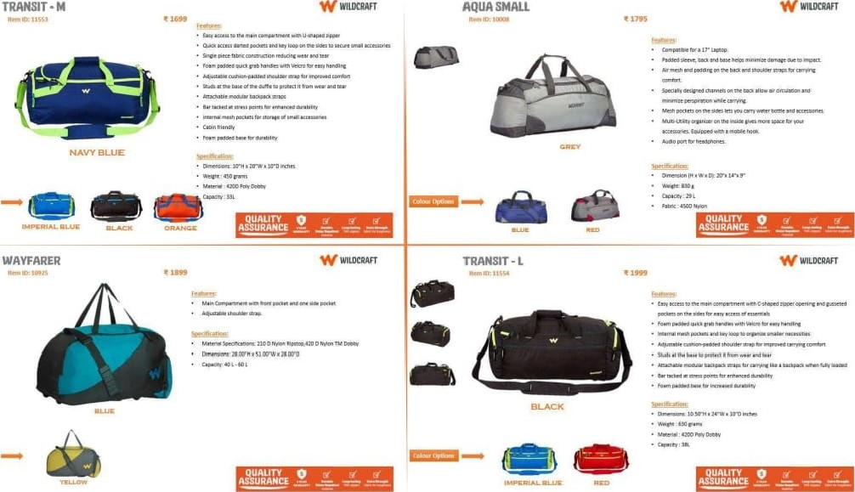

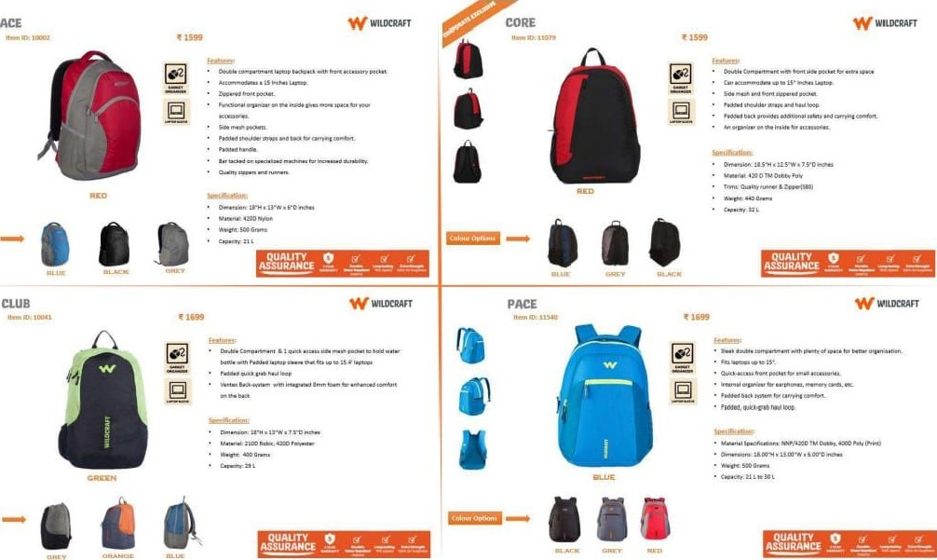

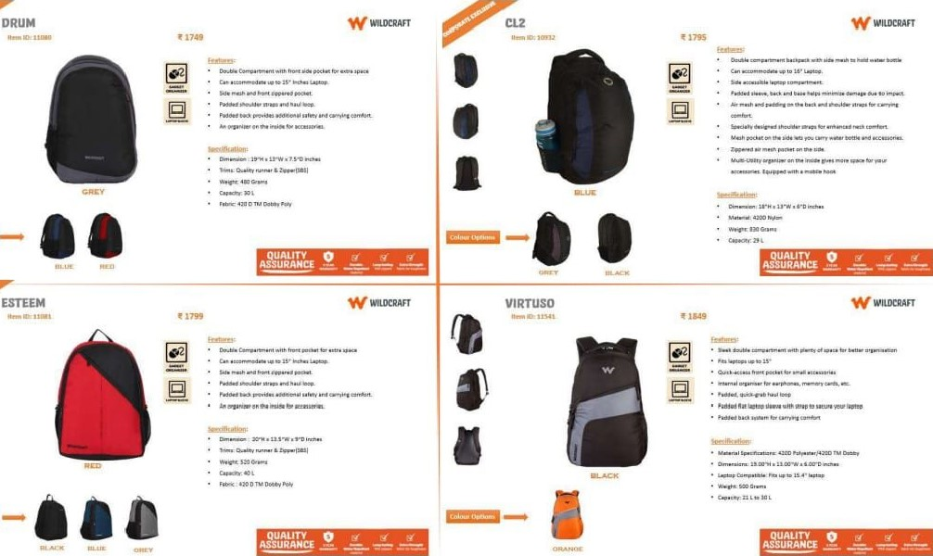

## — ana Quaury

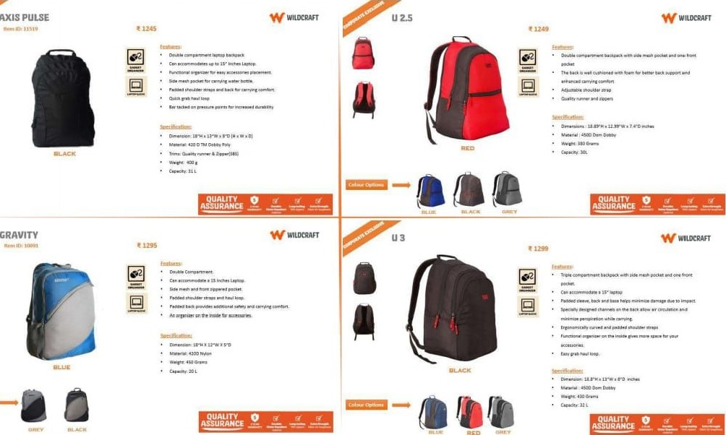

AXIS

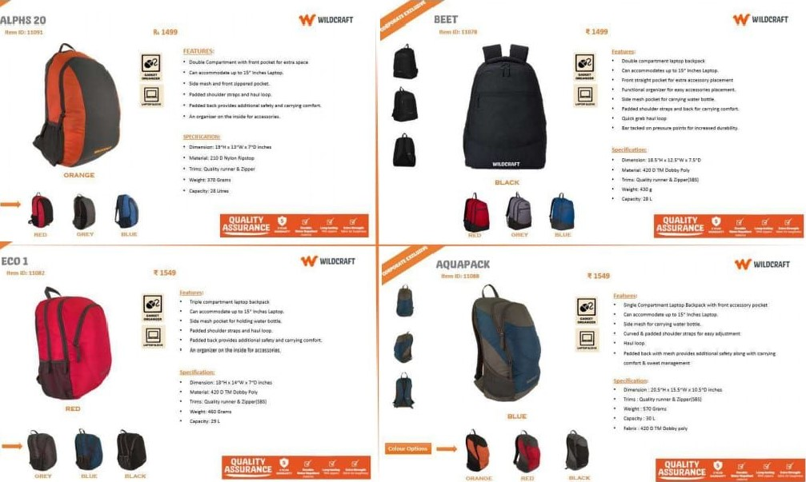

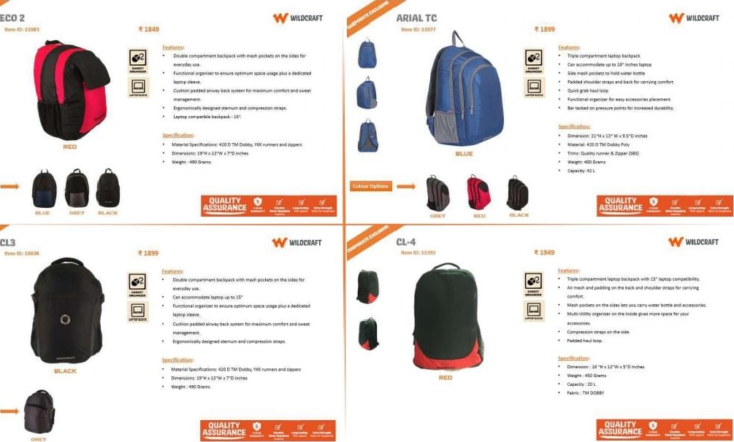

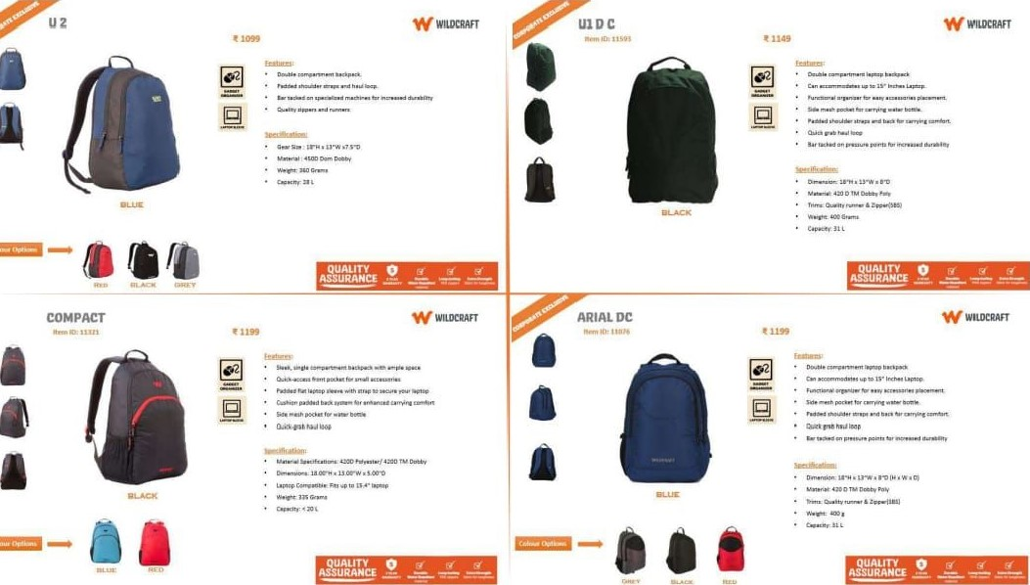

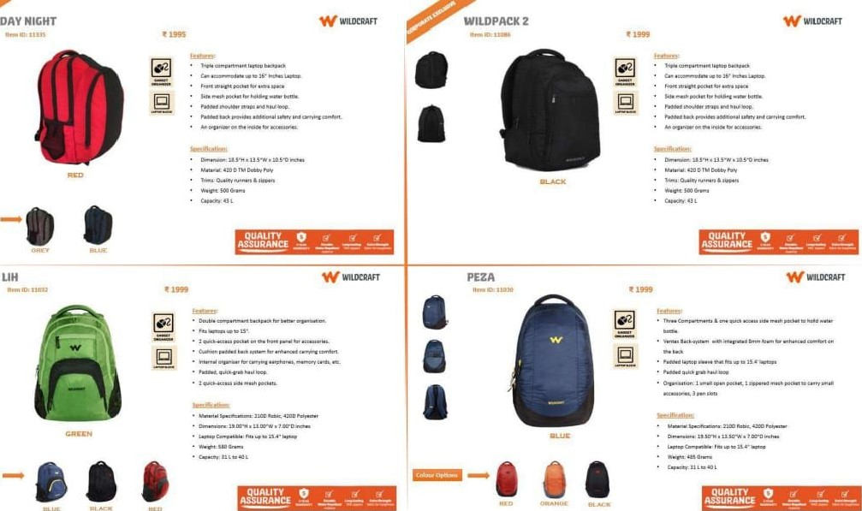

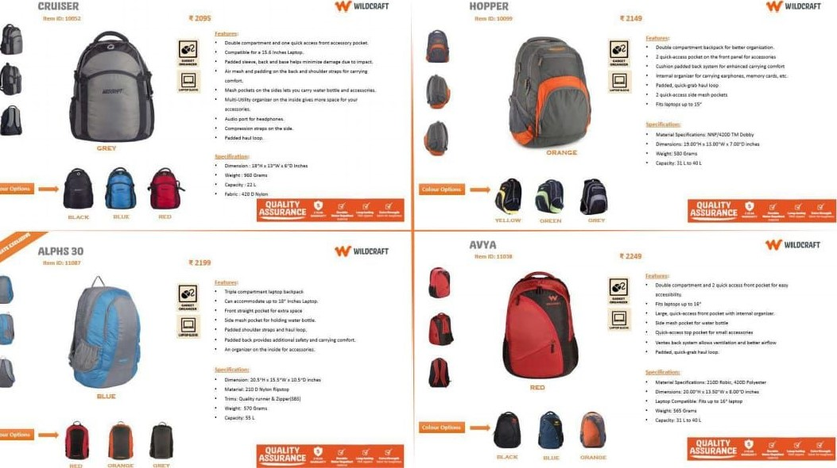

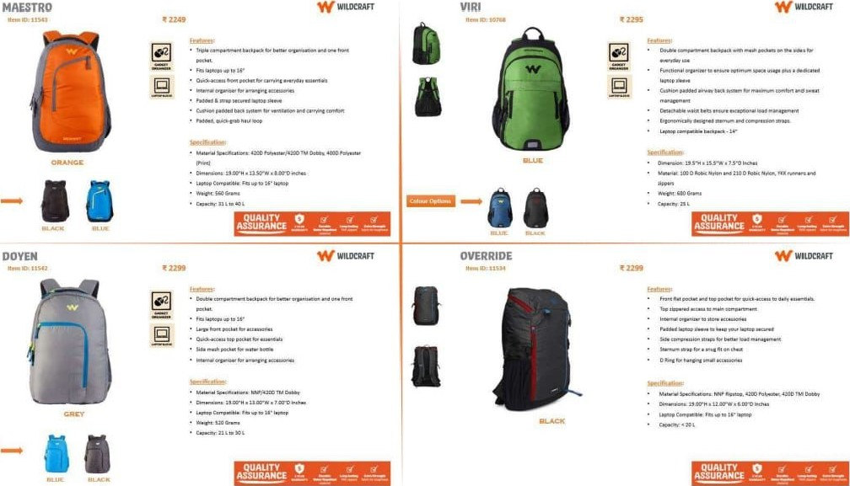

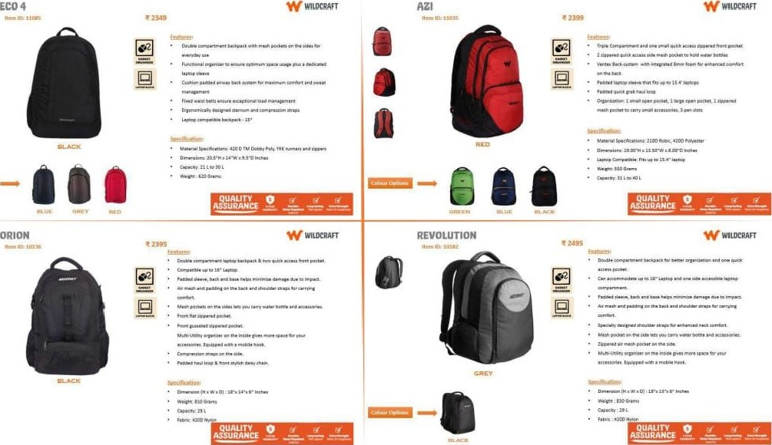

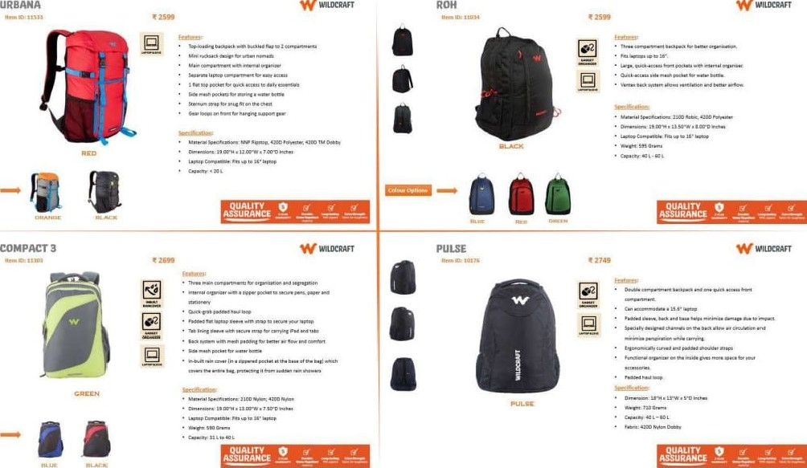

W

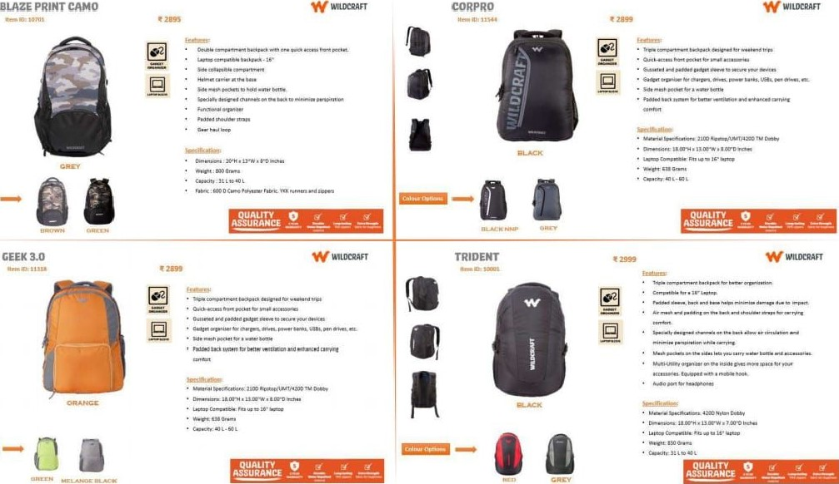

## TRIDENT XL W WILDCRAFT DEVIANT W wuDCRAFT

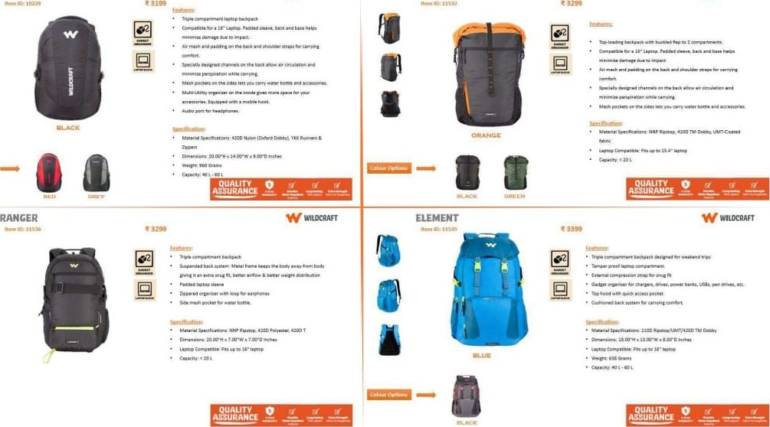

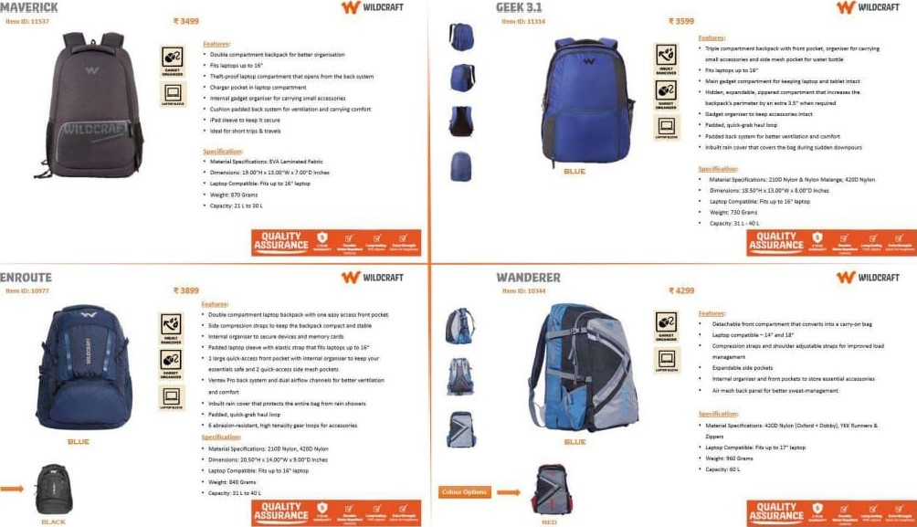

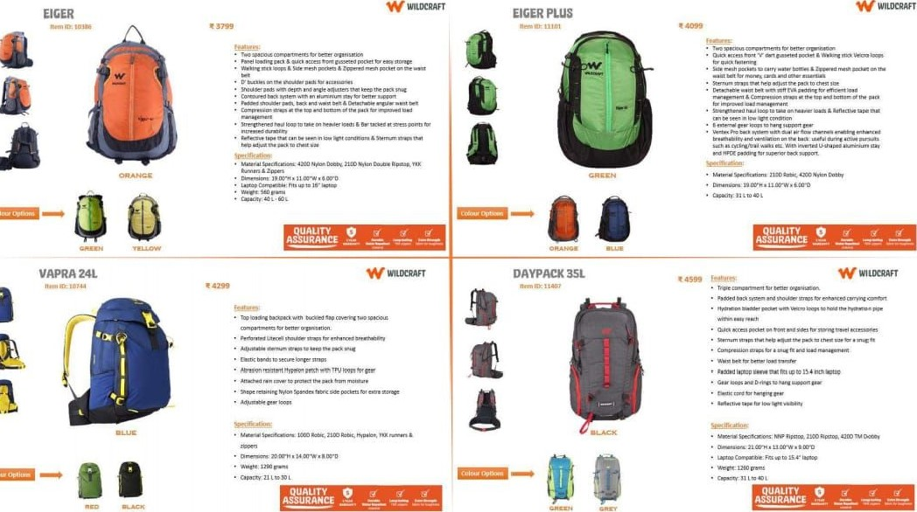

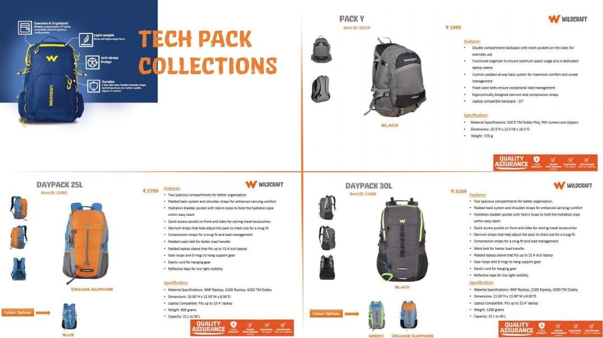

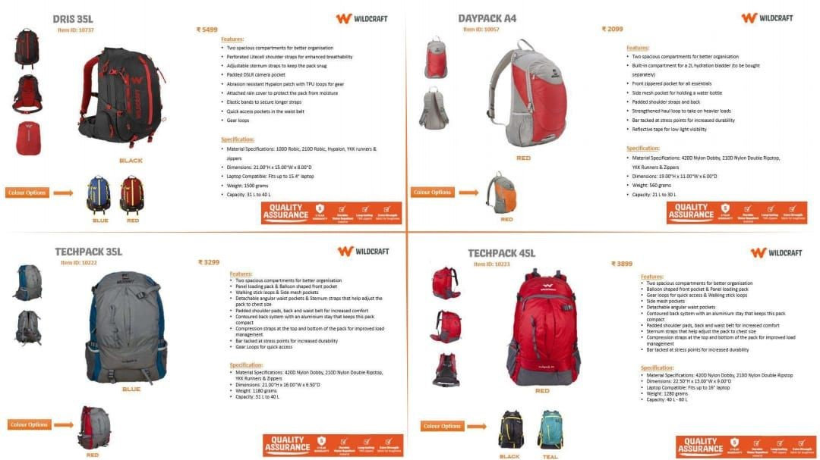

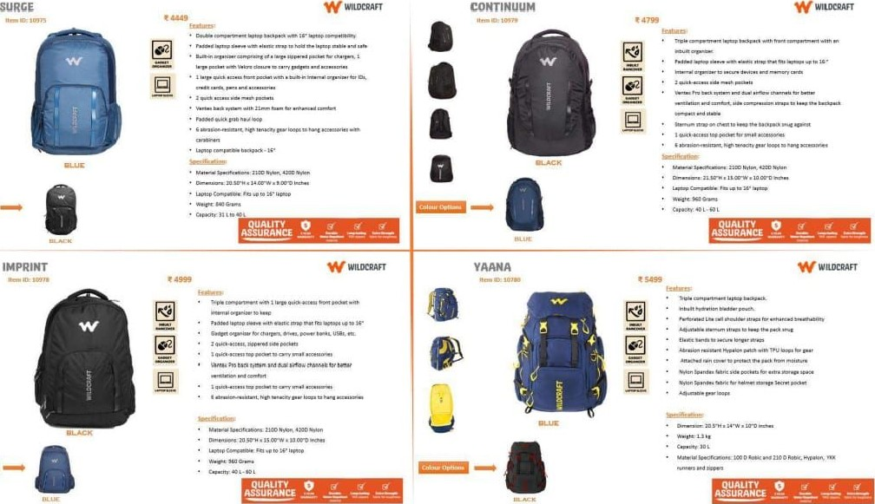

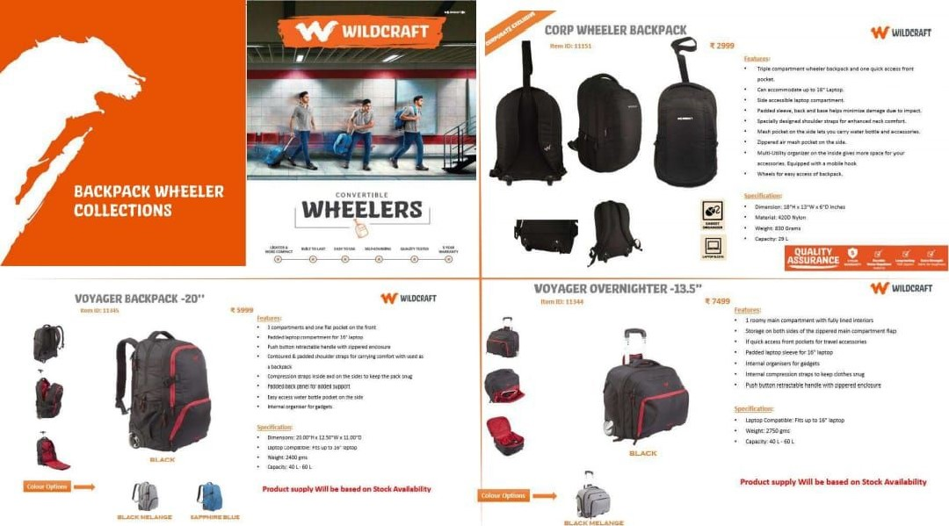

FRISBEE W WIWCRAFT WHIZZ W vłwcRAFT

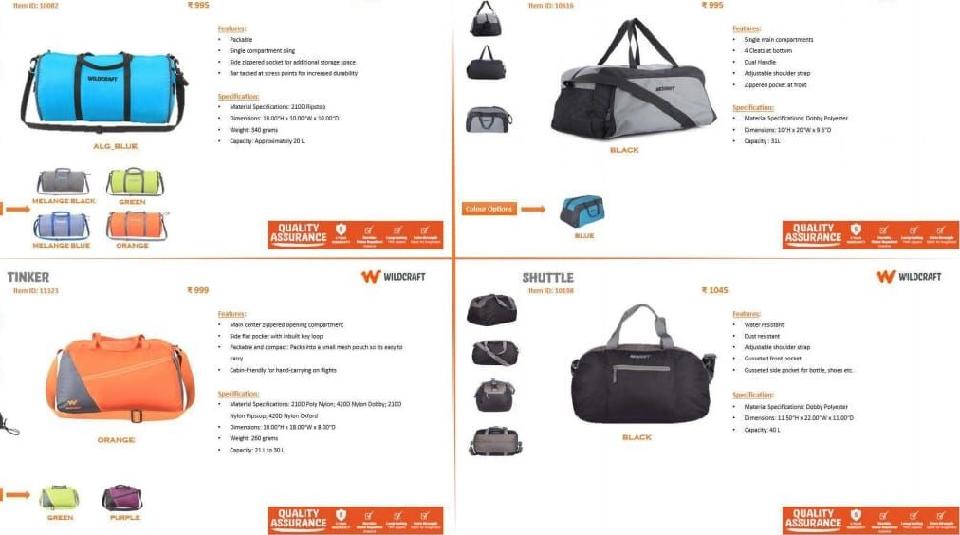

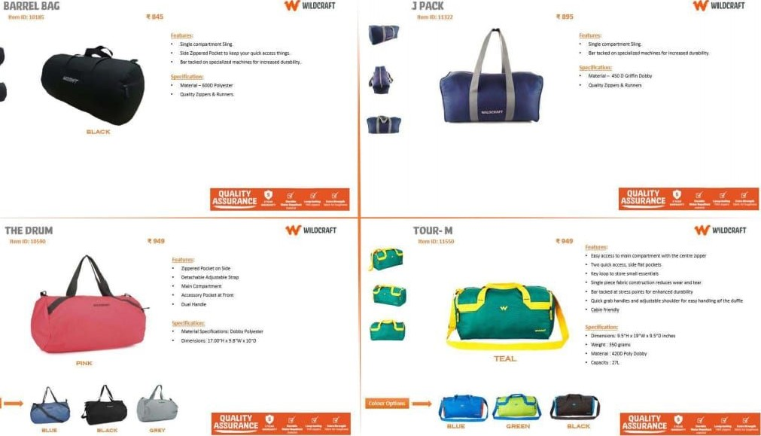

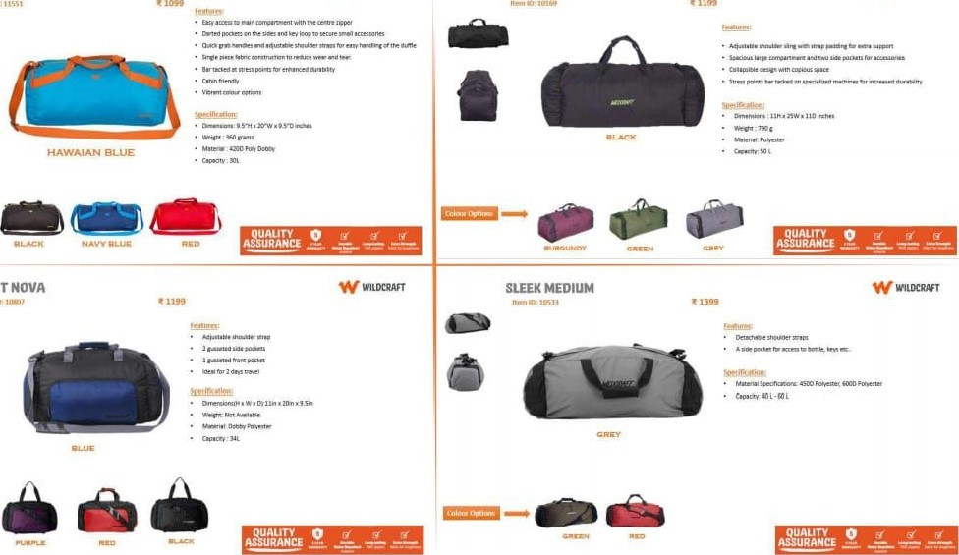

WEND-

M

W

WILDCRAFT

POWER

DUFFLE

WROCRAFT

ORBIT

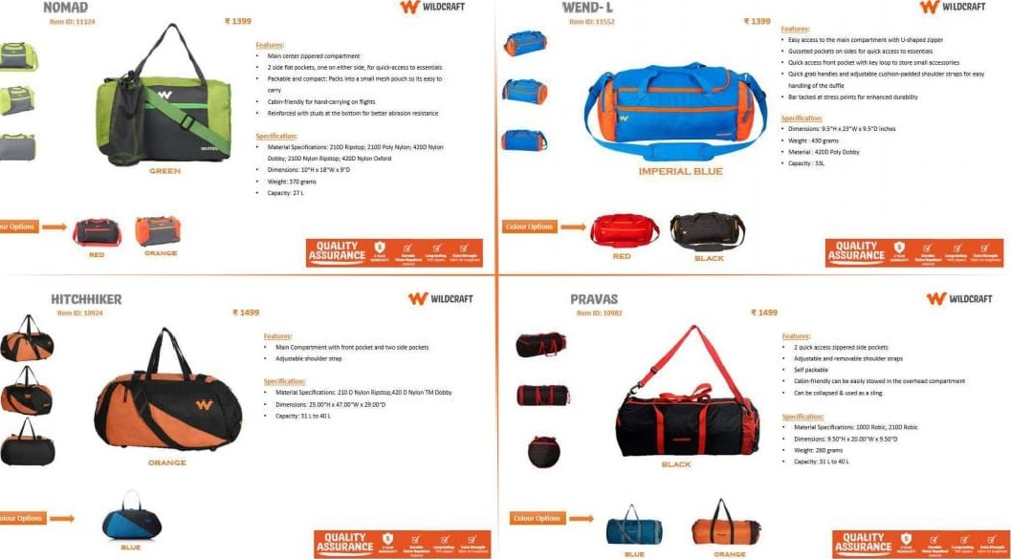

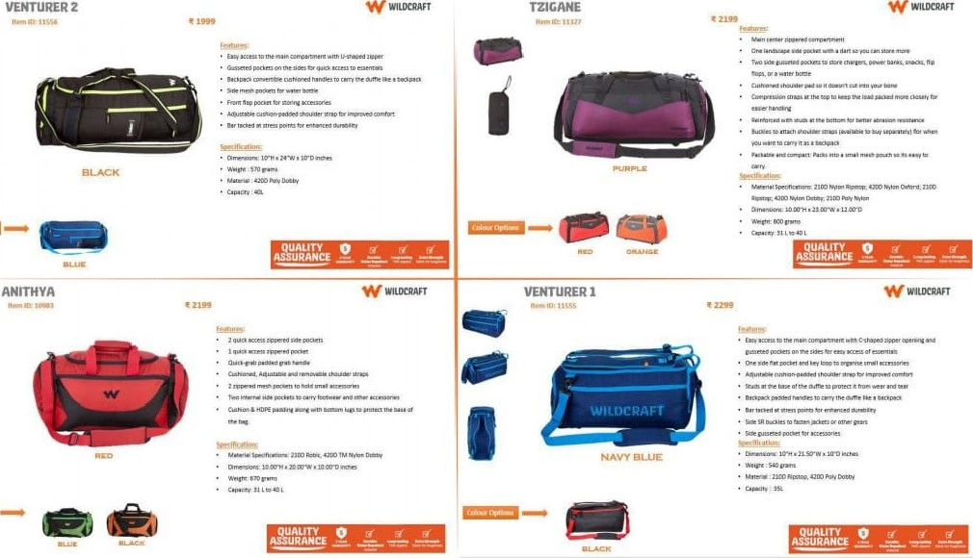

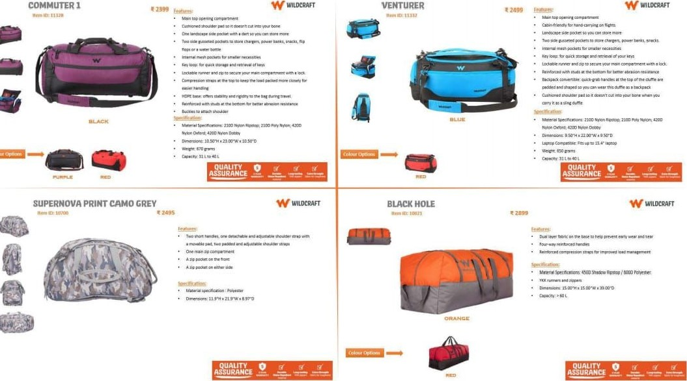

W WİLDCRAFT

## DUFFLE-WHEELER COLLECTİONS



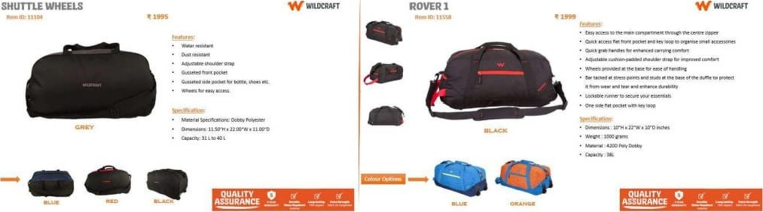

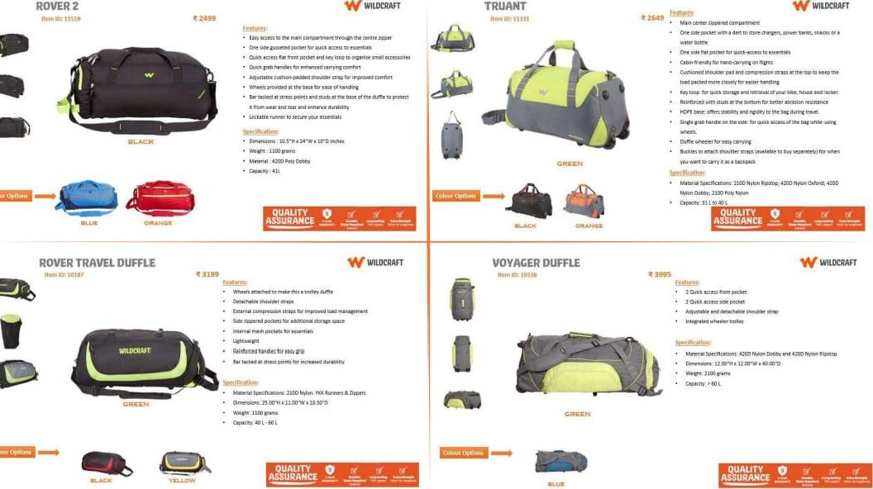

WitmnAFT

W wuocwT

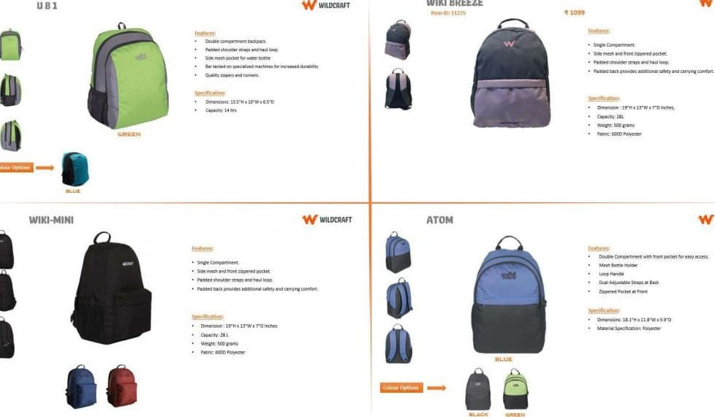

WIKI

BREEZE

W

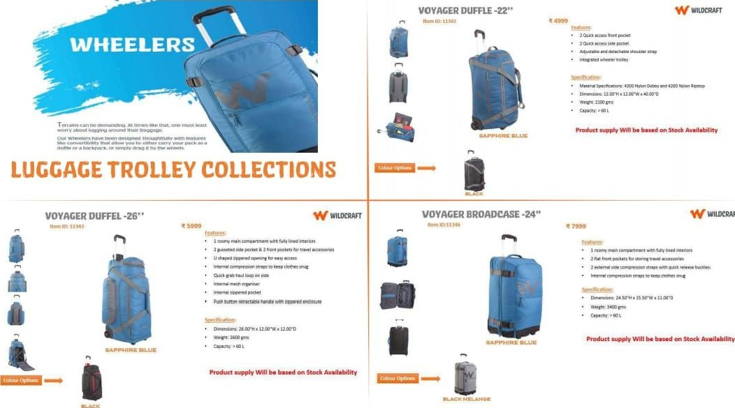

WILDCAAFT

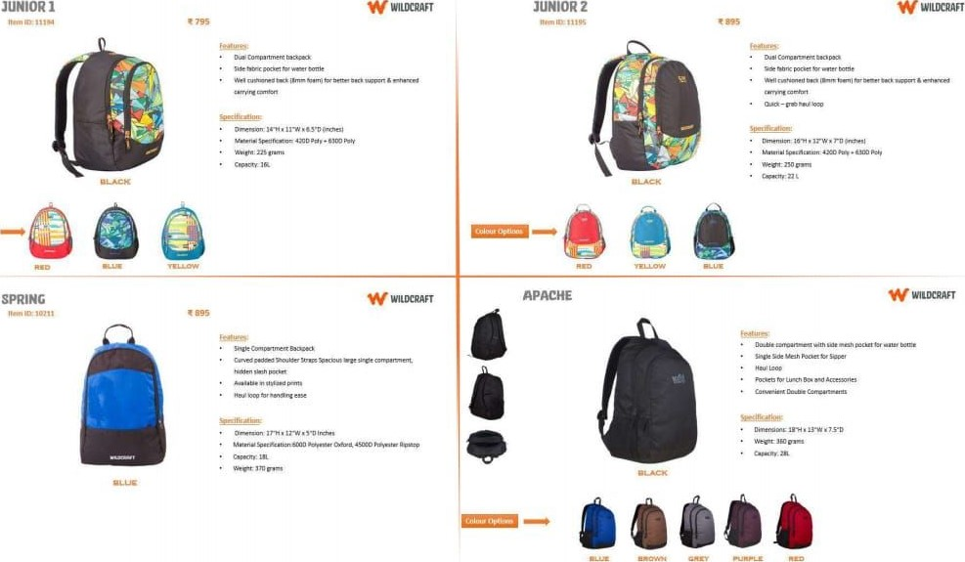

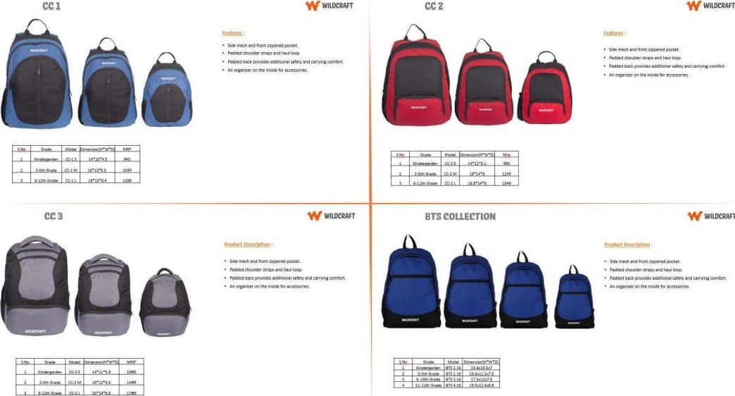

WILtrRAFT

UTILITVI W WILERAFT UTILITY2 W WIUXRAFT

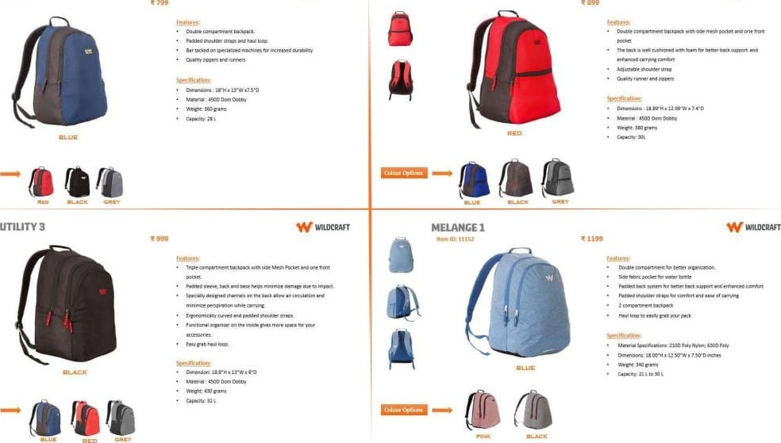

BRICKSI BRICKS2 W WILERAFT

|  |  |
| --- | --- |
|  | a 0 00 |
| W WILERAFT | BRICKS S    —- oaa |

BRICKS3 W MLXRAFT

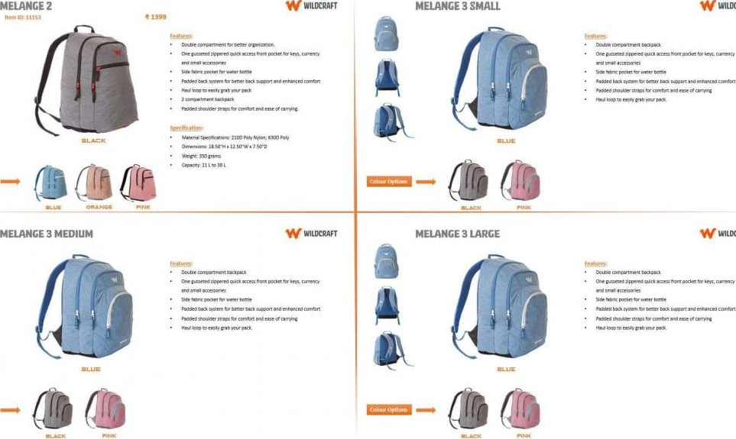

WILLRRAFT

WIUXRAFT

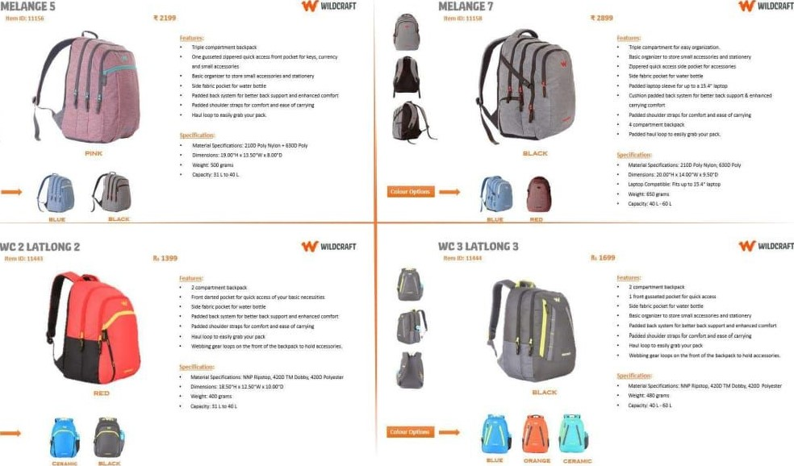

### WC 4LATLONC4 WC 6 LATLONGS

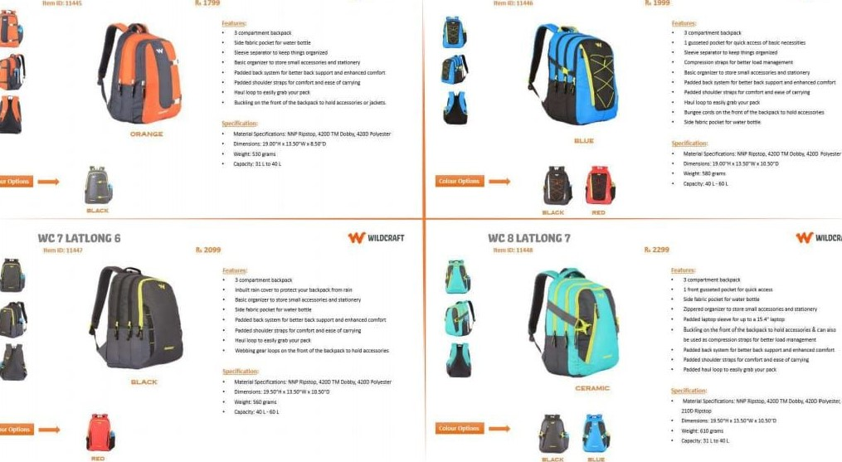

#### 7 FOLIAGE 4 W WILDCRAFT WC 8 FOUAGEȘ wnDCRAFT

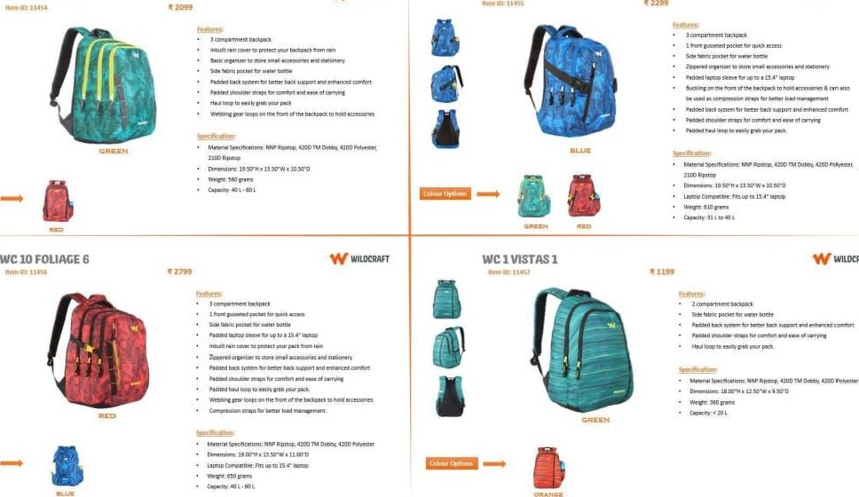

WIUXRAFT

WC 3 W WILDCRAFT

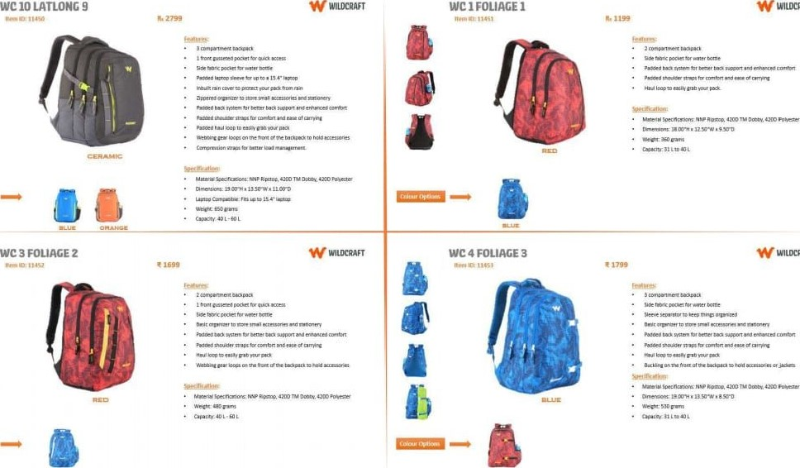

WILtnAFT

2FLORA1  WC 3 FLORA 2 WILERAFT

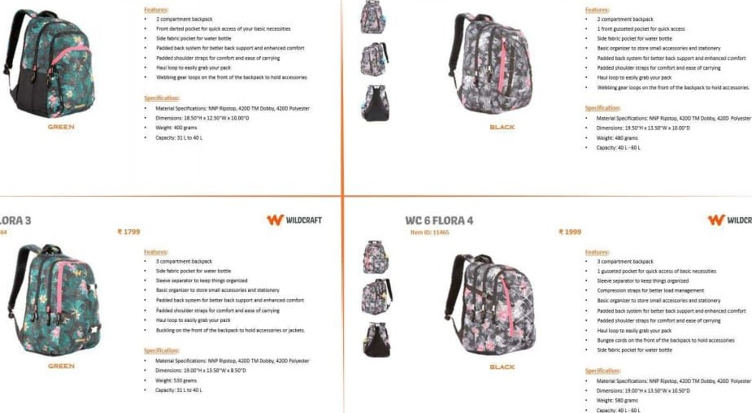

FLORA

WC

4

WIUXRAFT

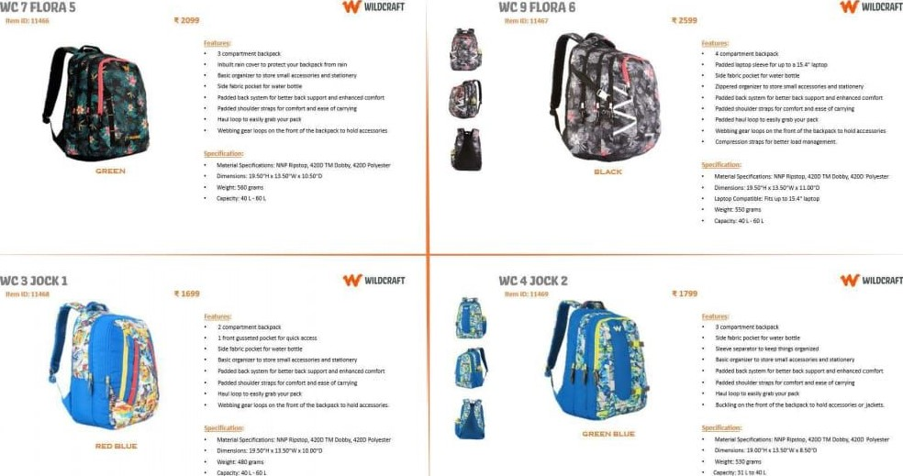

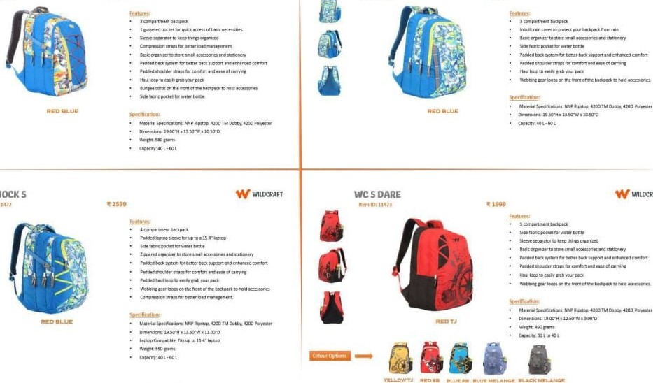

JOCK

s

JOCR3

W

WILDCRAFȚ

WC7JOCK4

WIUXRAFT

WC

9

WILERAFT

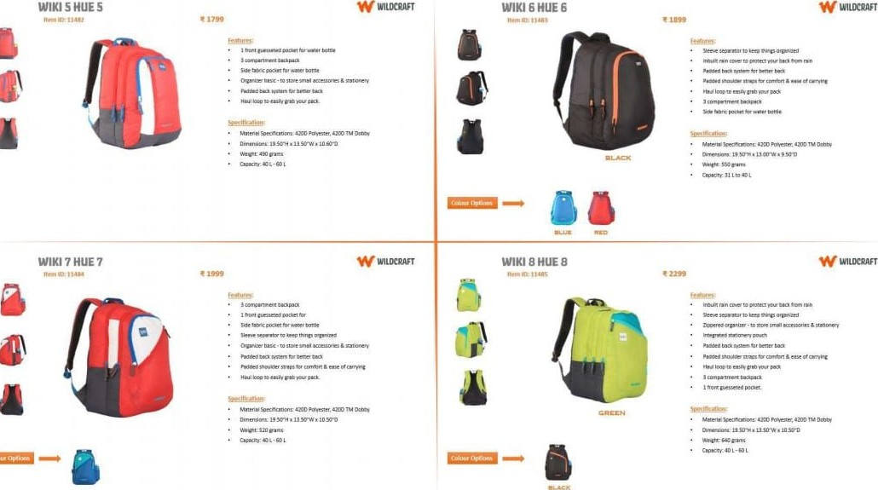

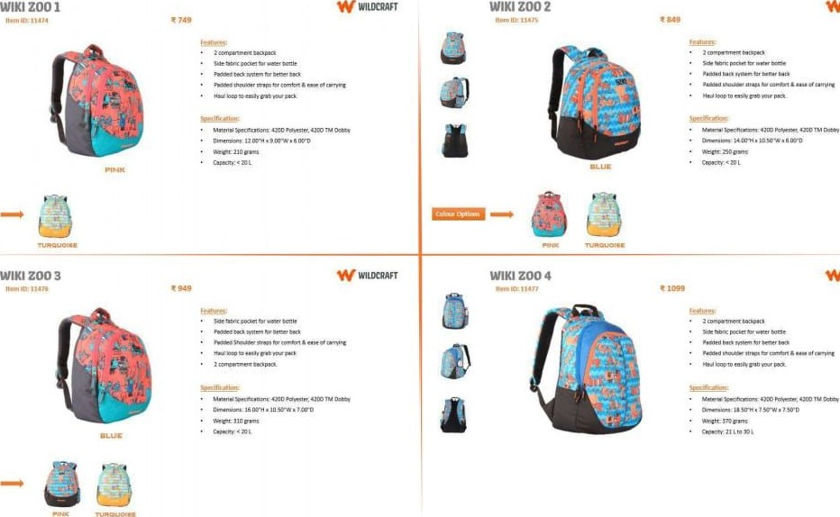W WIUXRAFT

7 PUNK S

#### WIKI 9 PUNK 7

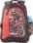

W WILDCRAFȚ 8 PUNKS W

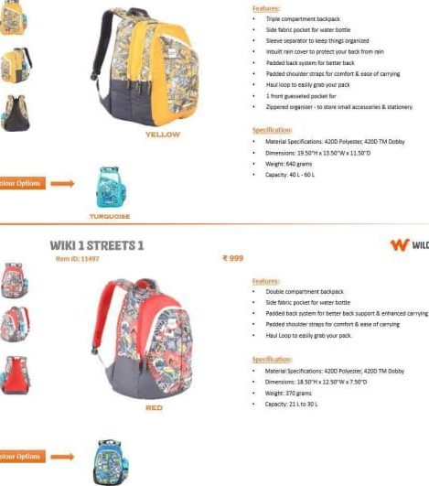

W

WILERAFT

WIUXRAFT

#### HUE 9 DOODLE

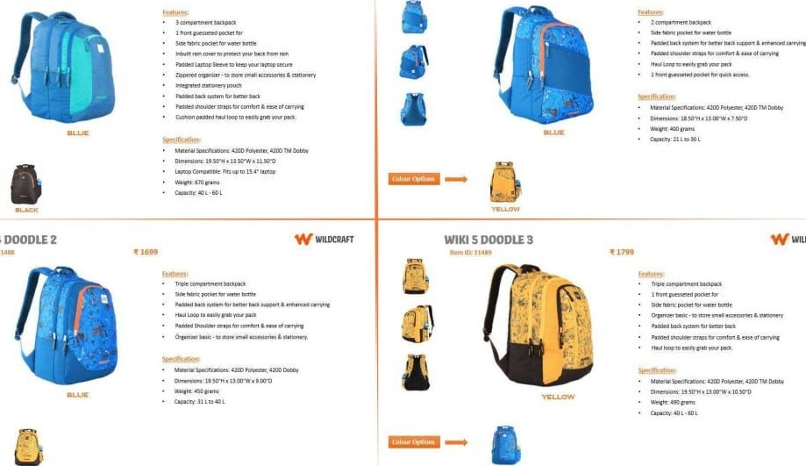

wiki

4

WIUXRAFT

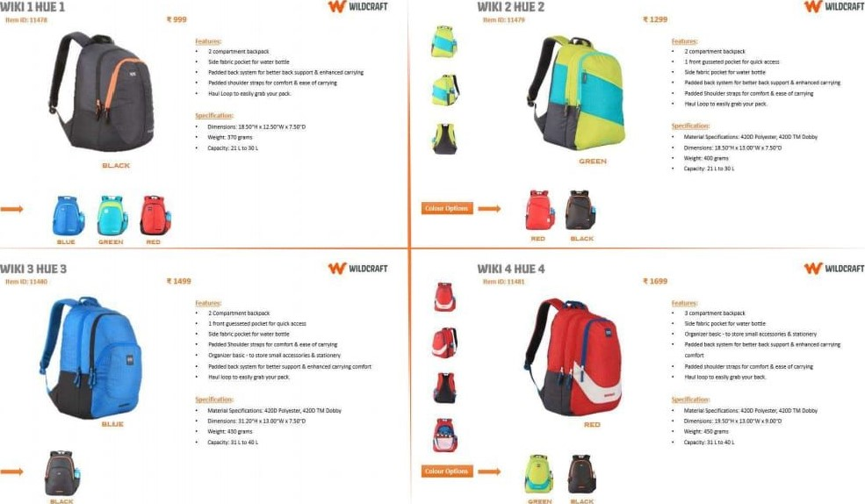

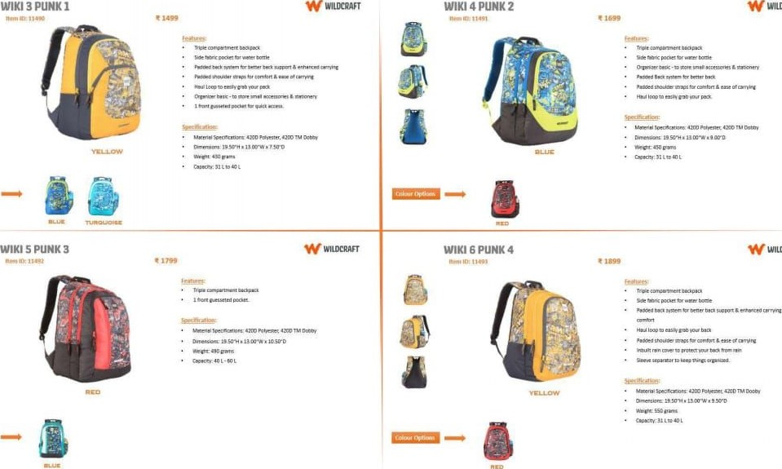W WILERAFT

WILDCRAFT

8 STREETS S W WIUÄAFT AZTEC 1 W WILLRRAFT

|  |  |  |  |  |
| --- | --- | --- | --- | --- |
|  |  |  | |  |
|  |  |
|  |
|
| AZTEC 2 | WIKI 3 AZTEC 3 | | | W |

WIKI 2 WILER_AFr

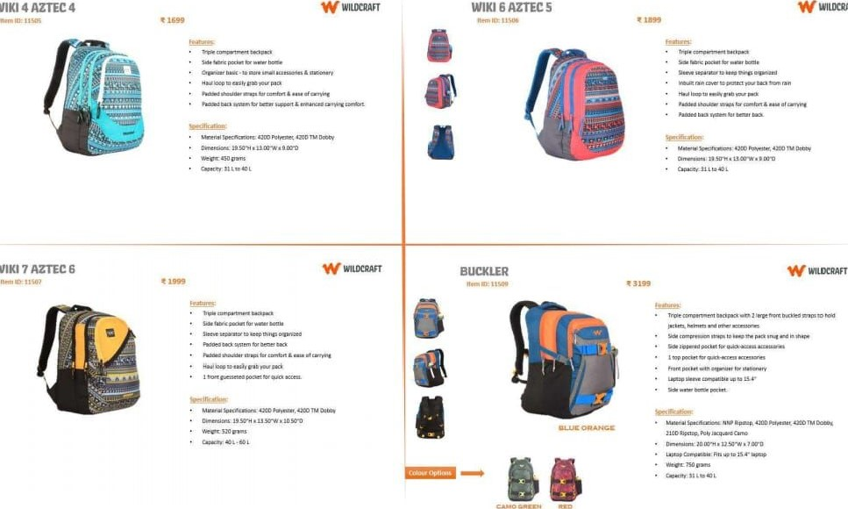

WIKI

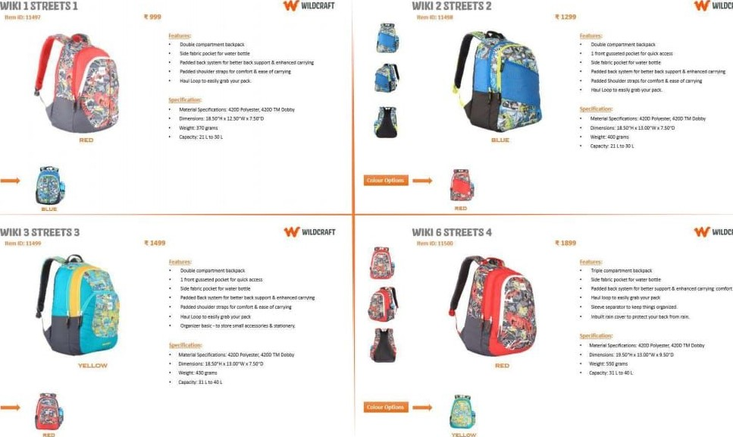

WILERAFT

WIUXRAFT

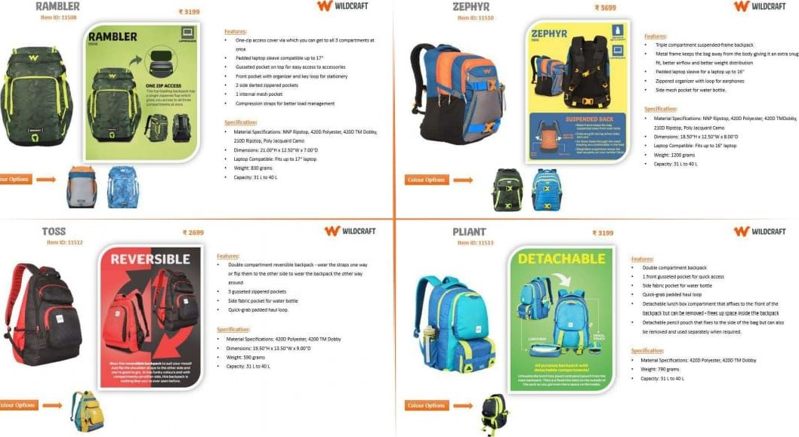

## WILDCRAFT RUCKSACK COLLECTIONS

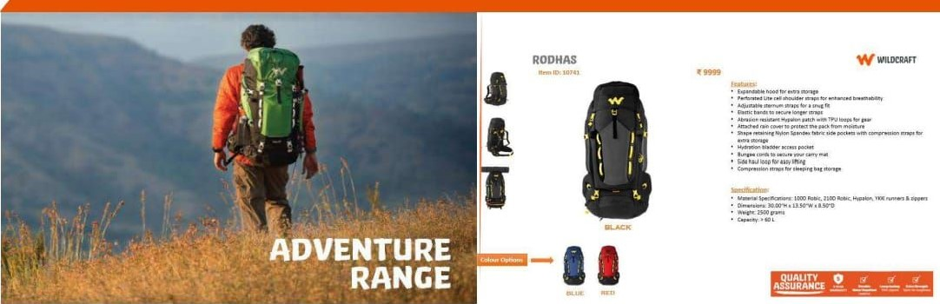

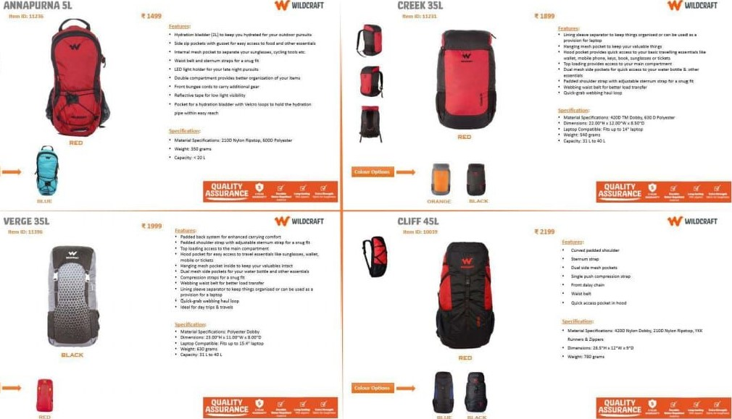

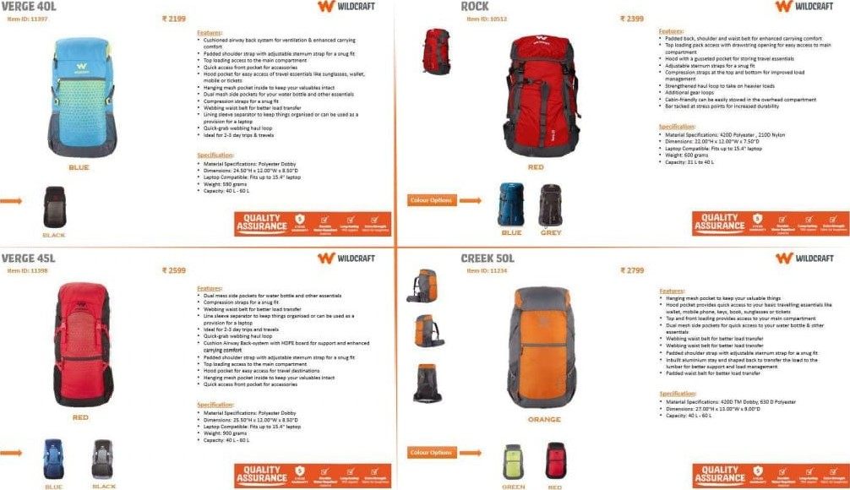

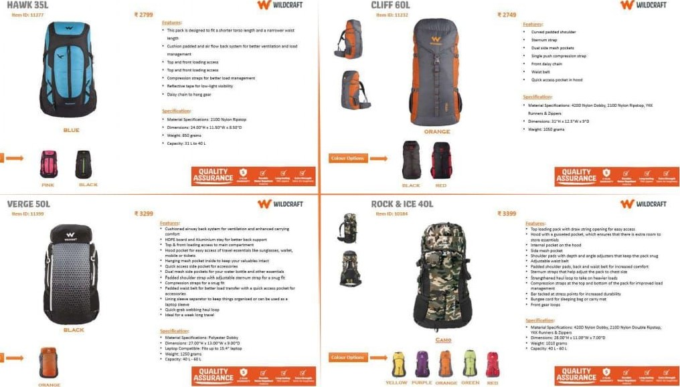

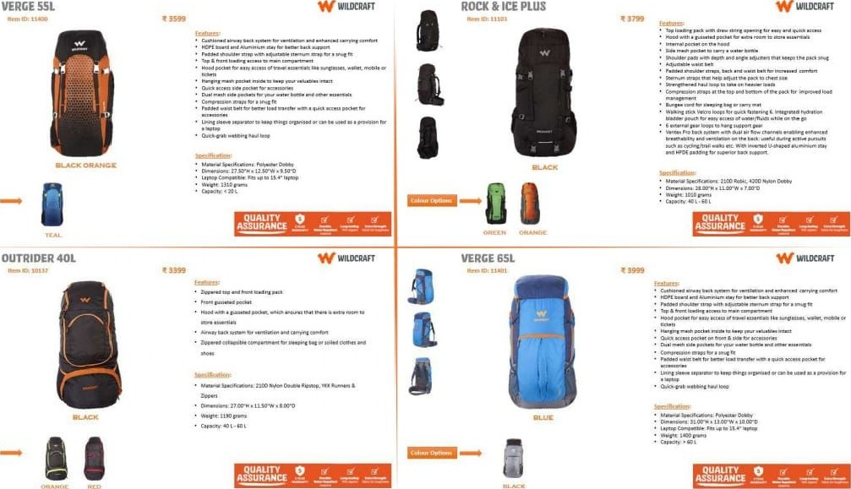

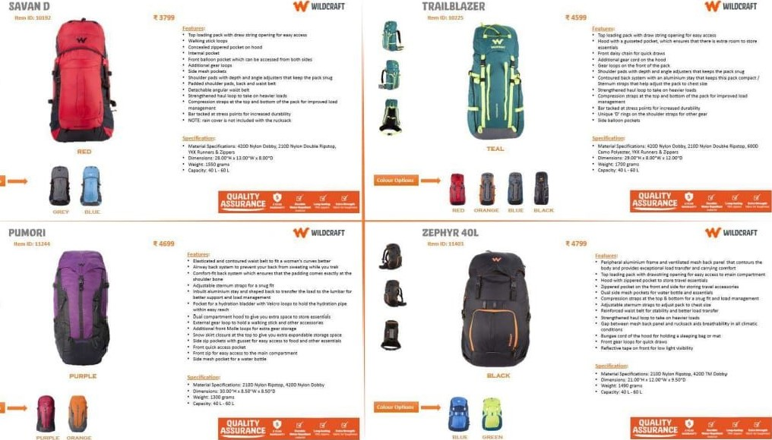

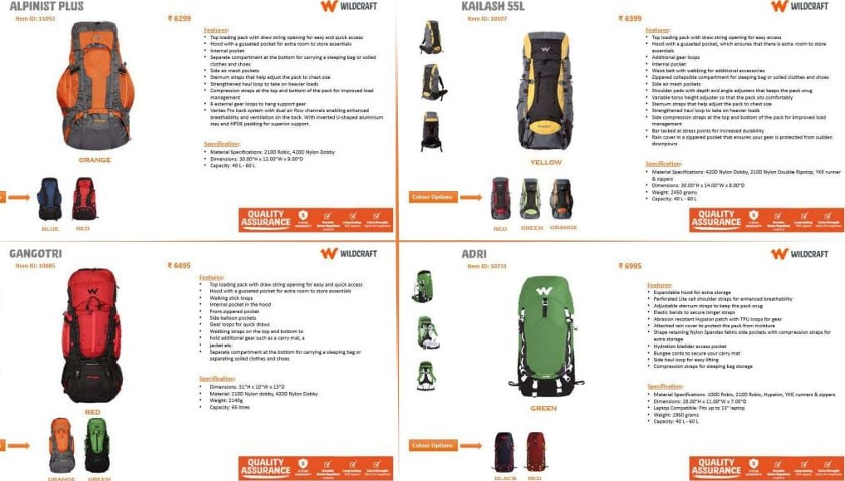

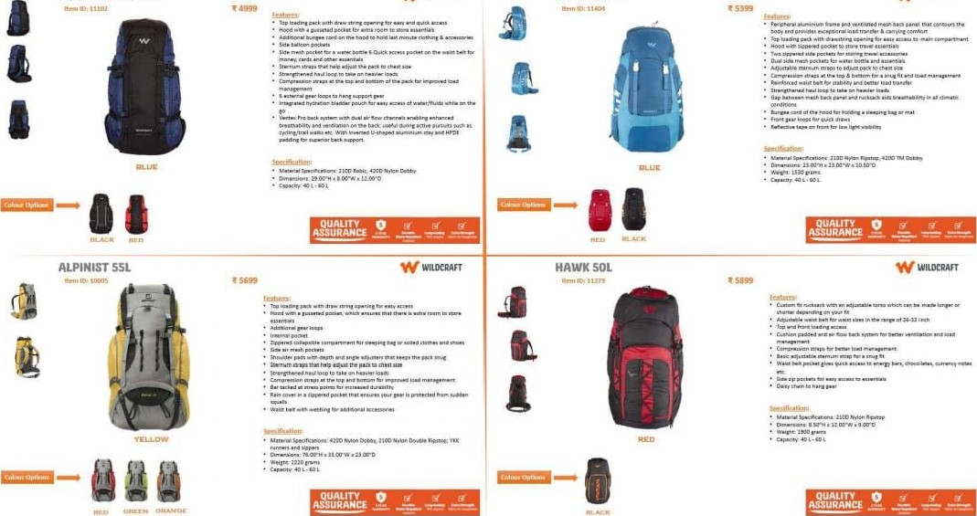

TRAILBLAZER

PLUS

ZEPHYR

SOL

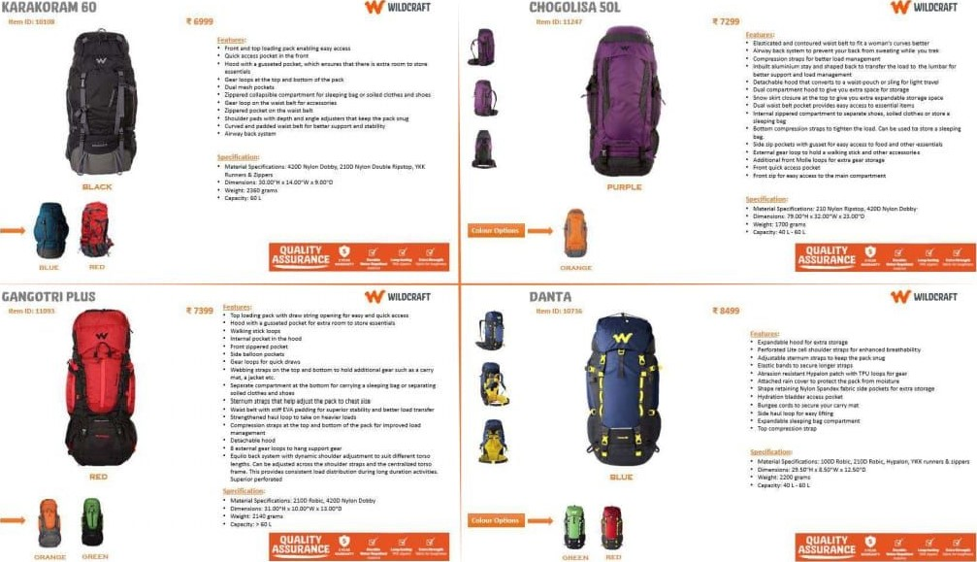

### PAC N GO MESSENGER PAC N GO DAYPACK

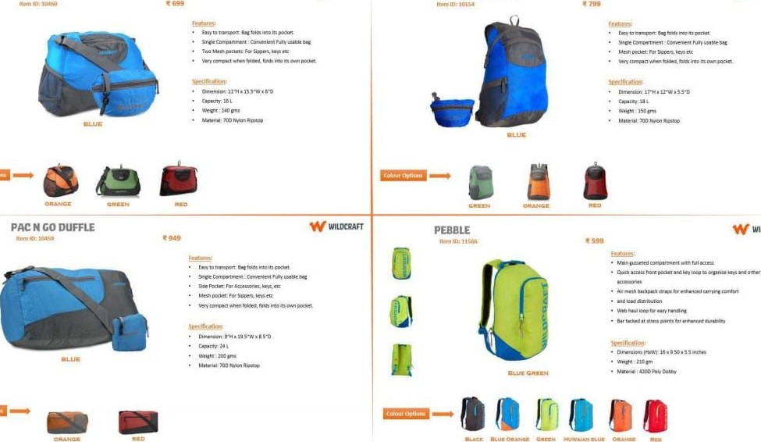

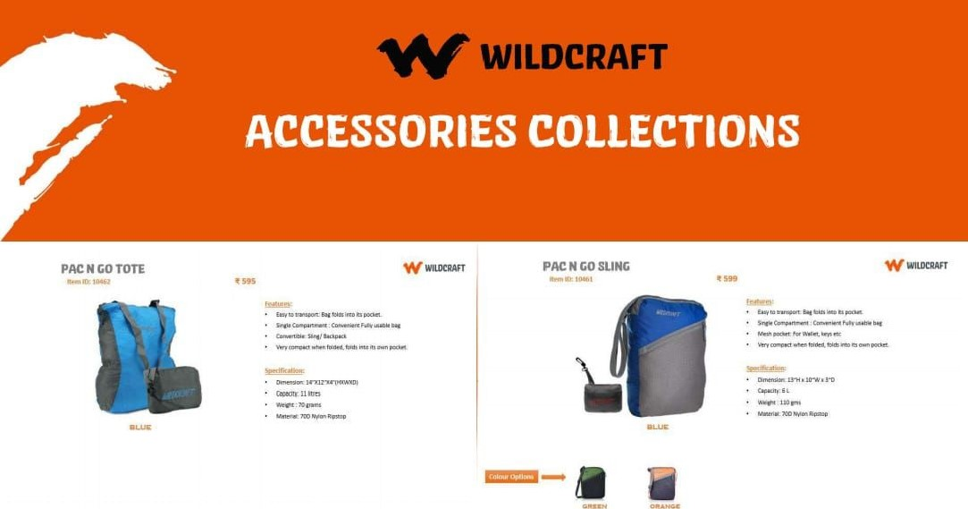

WILDCRAFT

W MLRRAFT

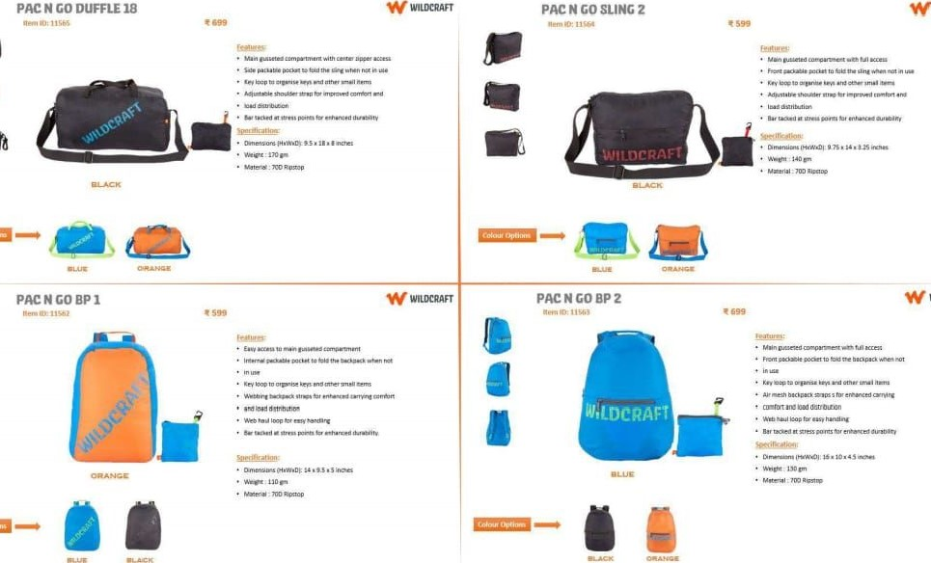

2

WILDCRAFT W

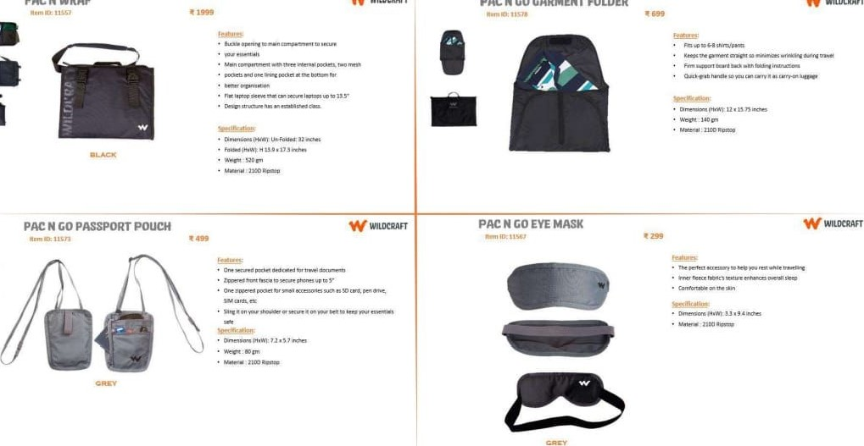

PAC

N

WRAP

WILDCRAFT

PAC

N

GO

GARMENT

FOLDER

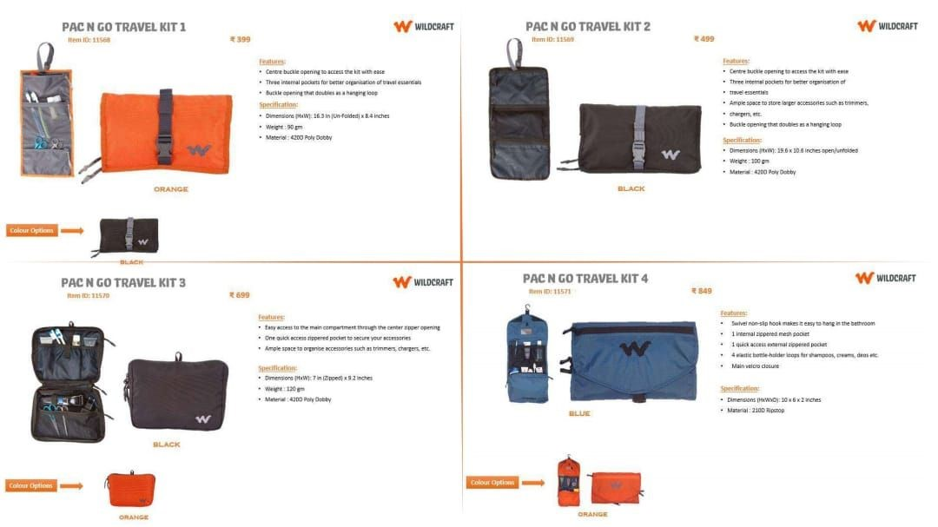

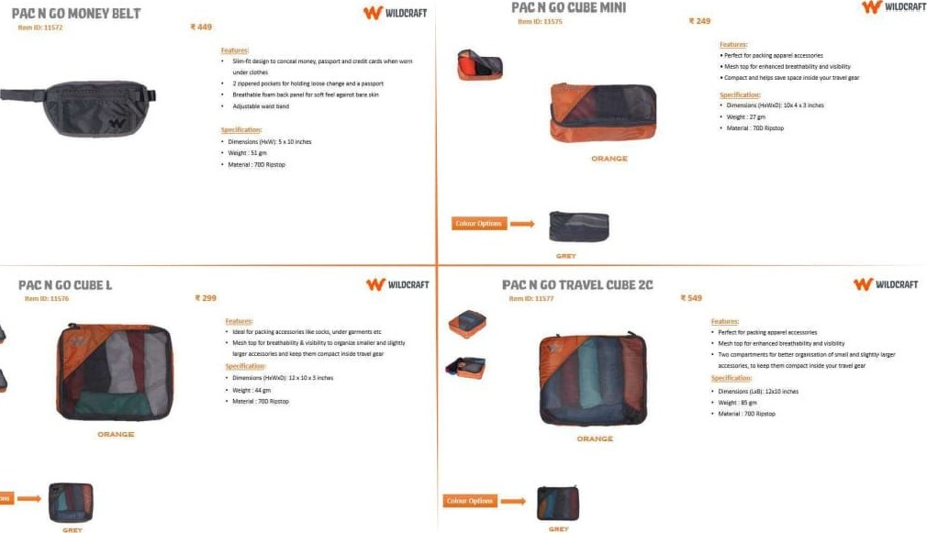

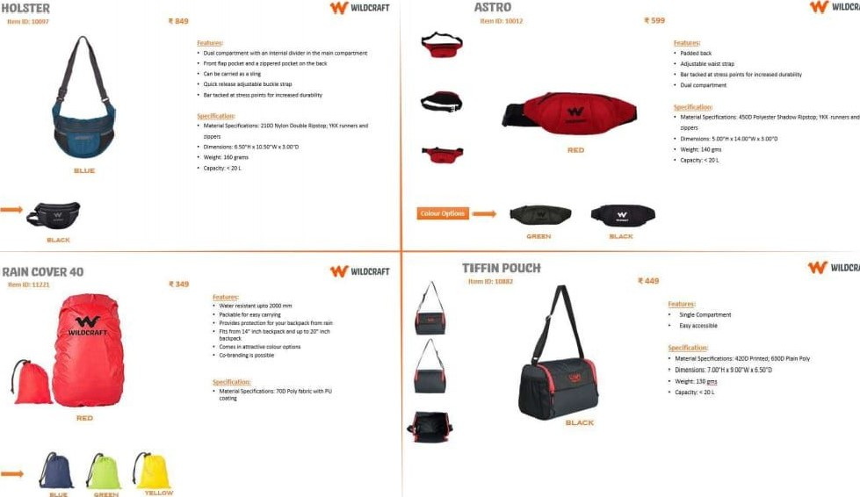

WILDCRAFT

WILDCAAFT

### TRITAN BOTTLE 800ML TRITAN BOTTLE IL W WIIRRAFT

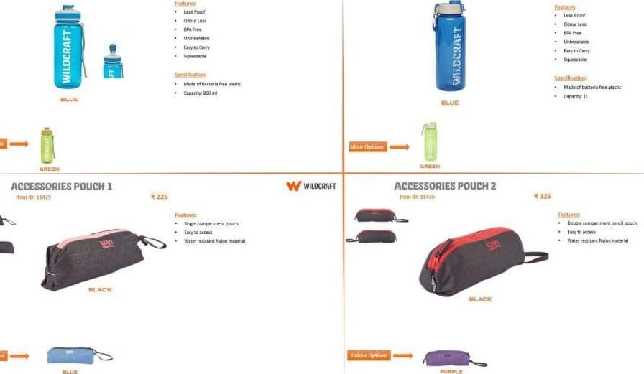

MLtRRAFT

### PAC N GO SHOE SACK STRING BAG W WUDCRAFT

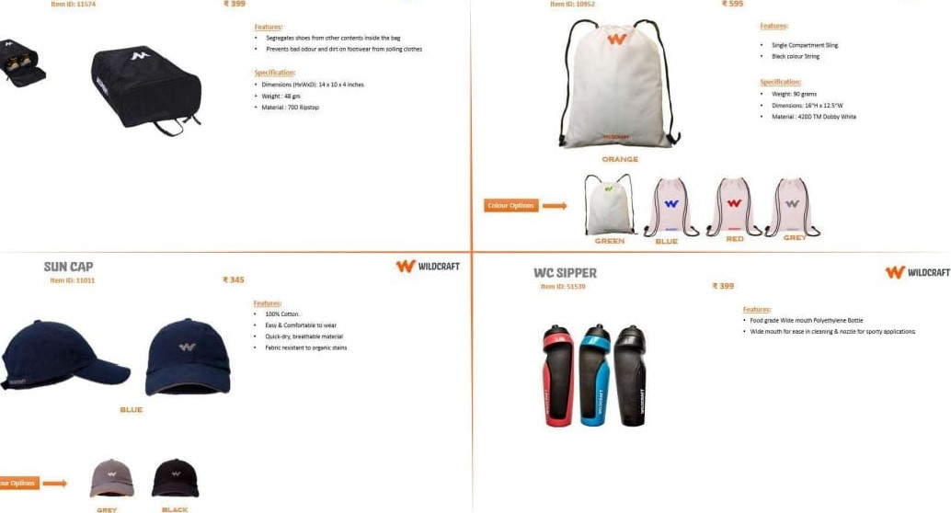

### WRISTLET S WRISTLET M WILERAFT

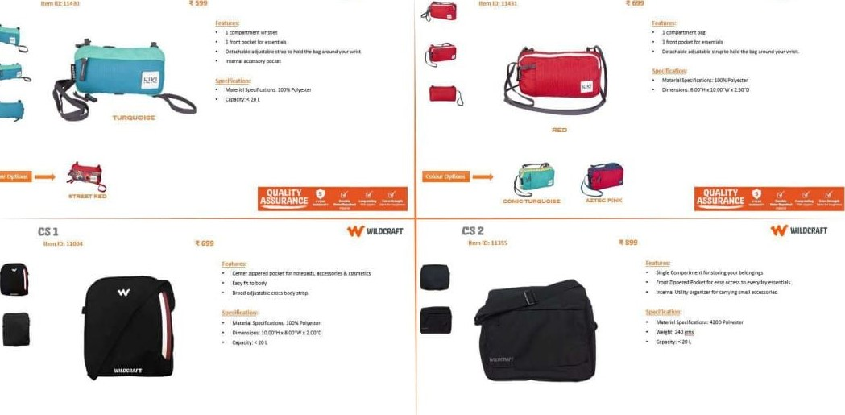

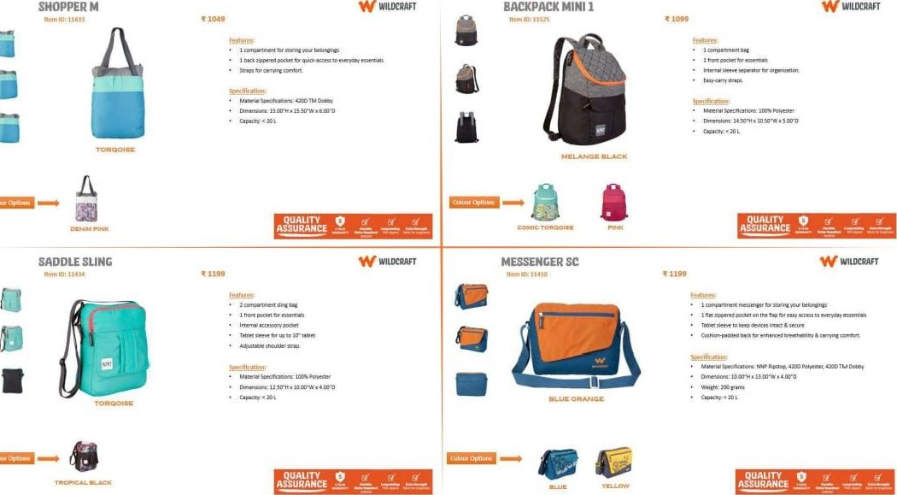

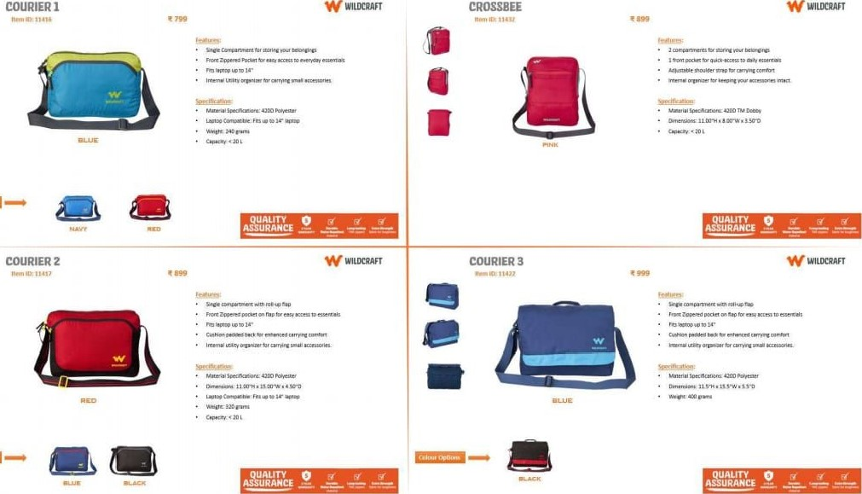

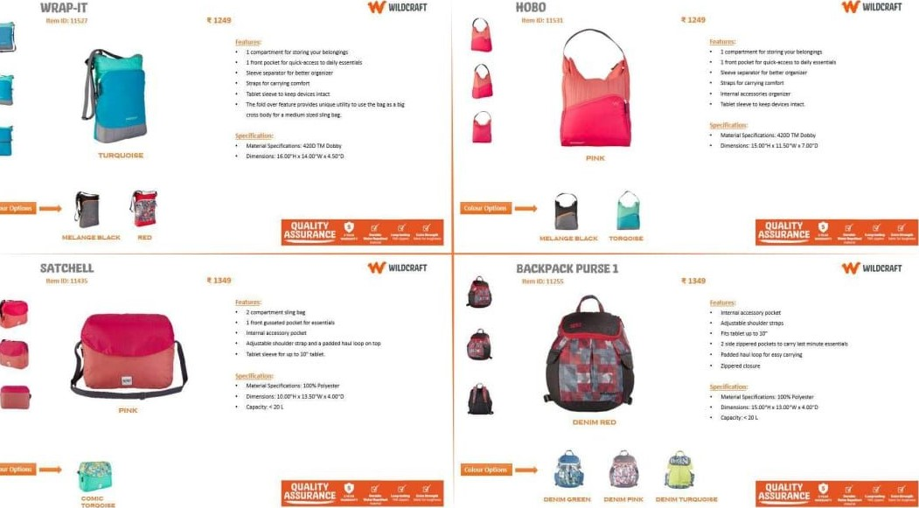

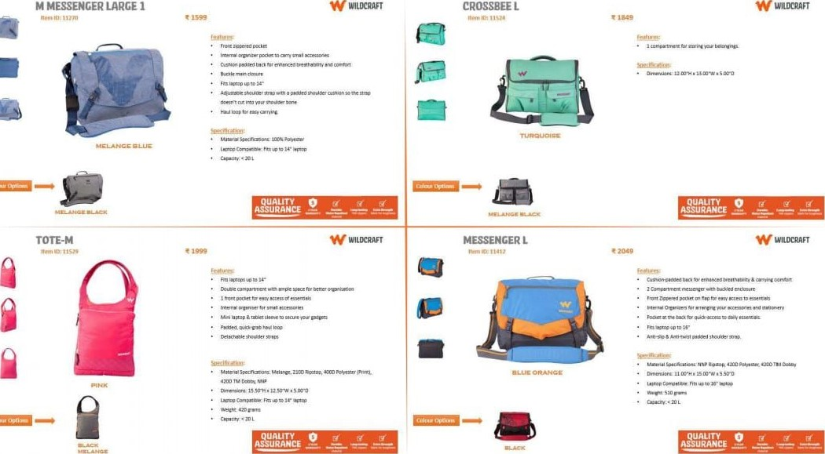

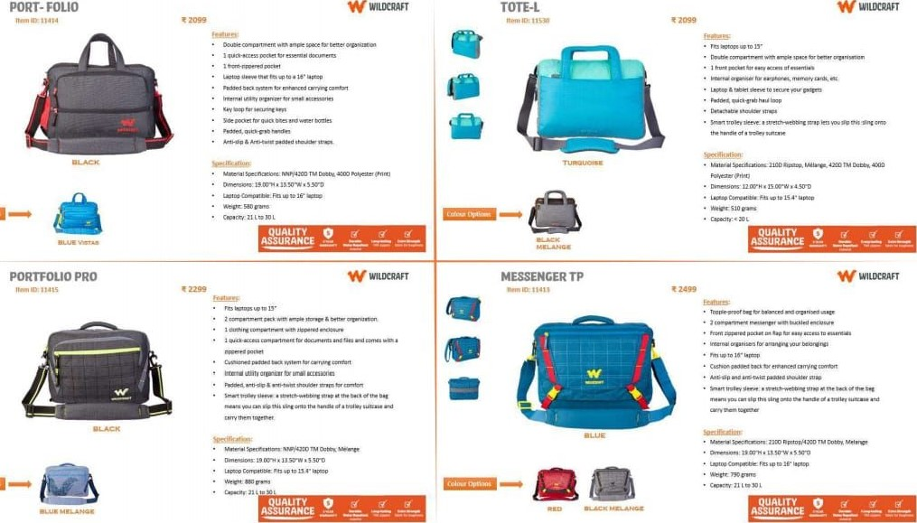

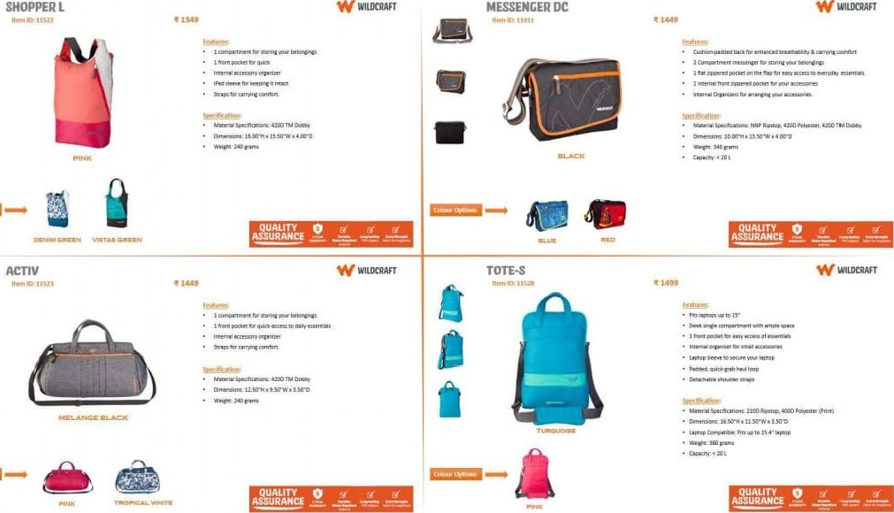

 W WROCAAFT

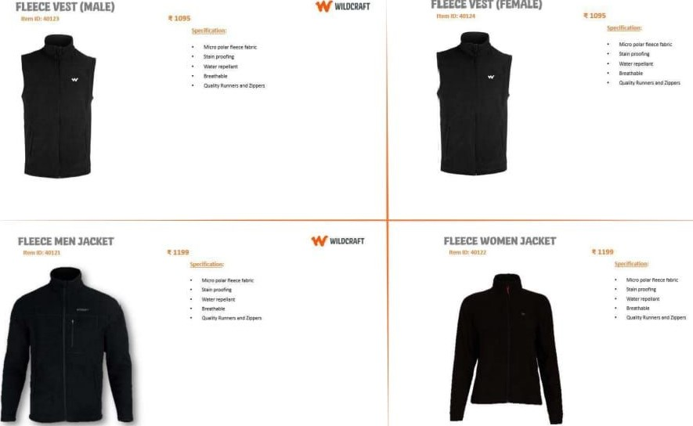

FLEECE

VEST

(FEMALE)

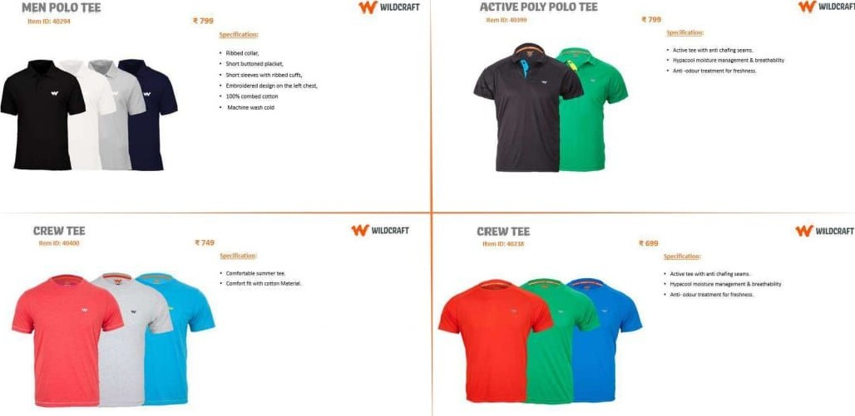

WILDCRAFT

WILDCRAFT



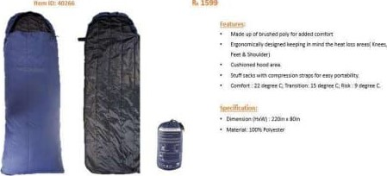SLEEPING BAG COLLECTIONS





### TRAVEUTE

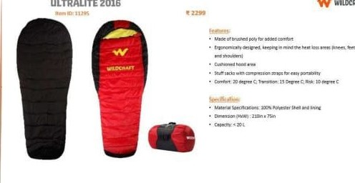

WUDCRAFT

W

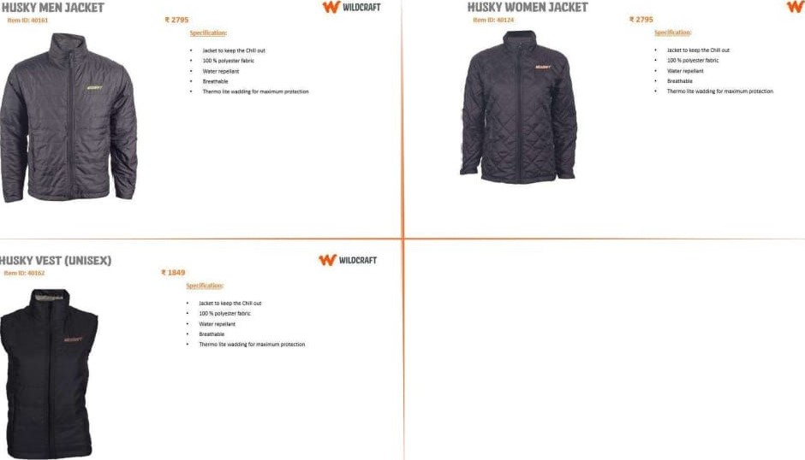

HUSKY

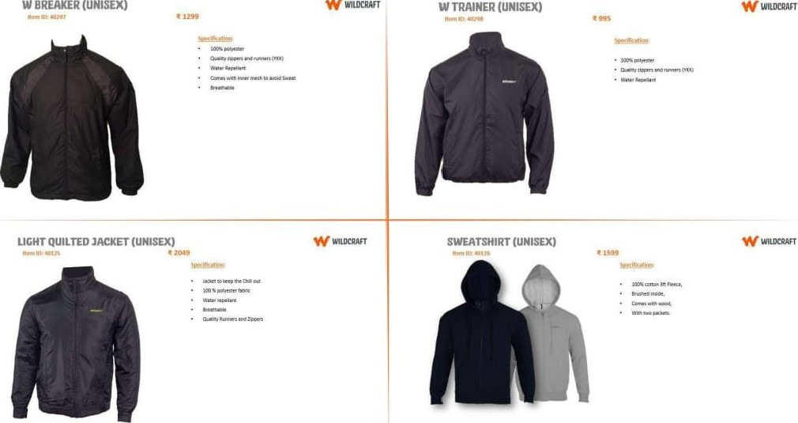

W

W

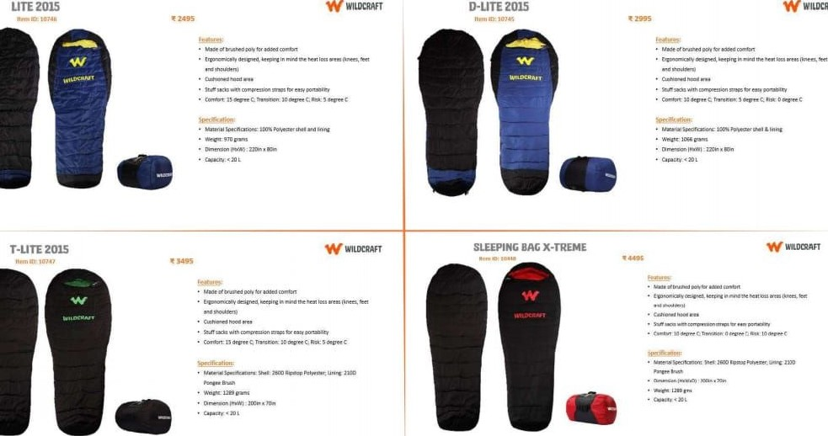

WuxRAFT

#### THE CONVERTIABLE BACKPACK BODY MATERIAL : LEATHER

|  |  |
| --- | --- |
| COLOR | . BROWN |
| LINING | : COTTON TWILL |

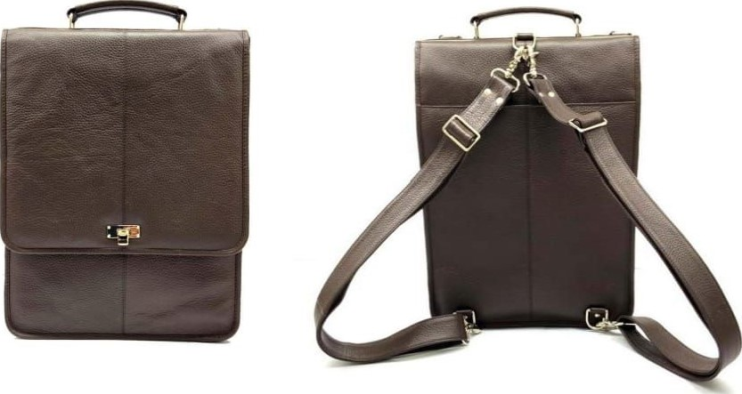

FRONT VIEW BACK VIEW

OVER NIGHTERS

#### BODY MATERIAL : LEATHER COLOR . NERO LINING : COTTON

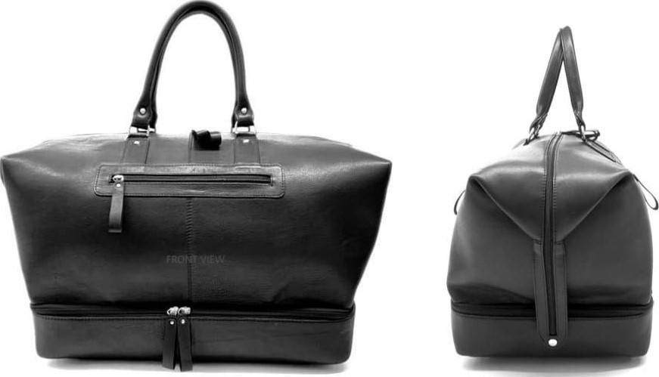

#### OVER NIGHTERS 6 BODY MATERIAL : LEATHER

|  |  |
| --- | --- |
| COLOR | : WHITE |
| LINING | : COTTON |

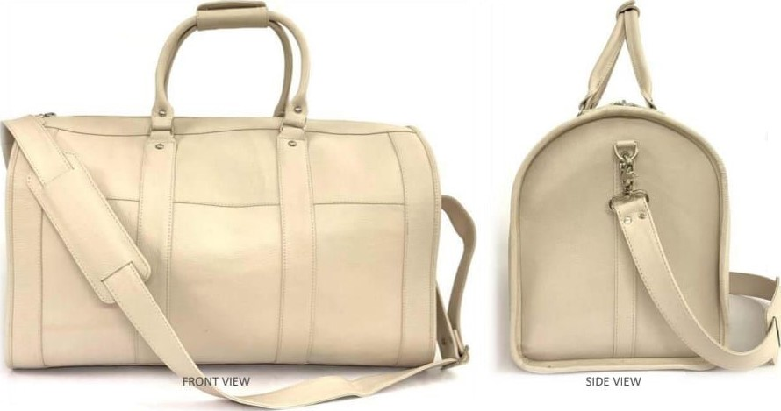

THE LEATHER BRIEFCASE

#### BODY MATERIAL : LEATHER

|  |  |
| --- | --- |
| COLOR | . BROWN |
| LINING | : COTTON |

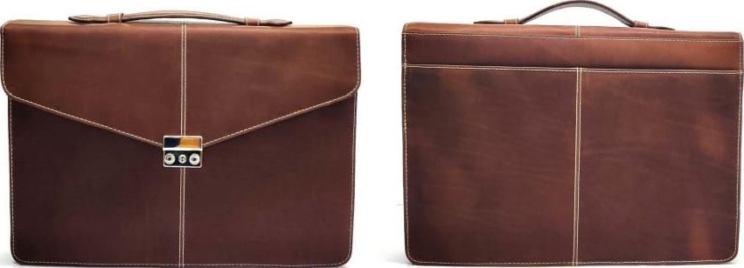

FRONT VIEW SIDE VIEW

LEATHER BRIEFCASE 2.0

#### MATERIAL : LEATHER . BLACK : COTTON TWILL

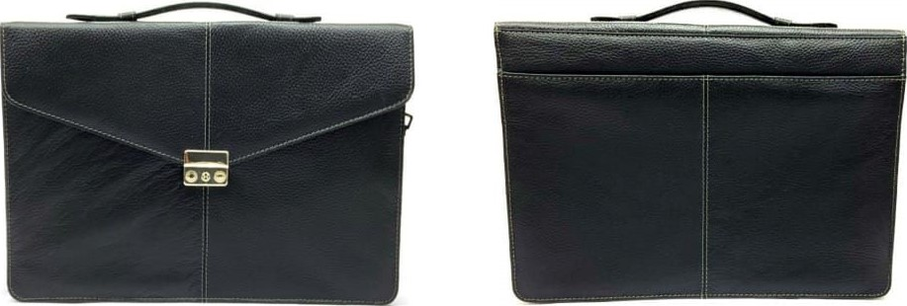

FRONT VIEW BACK VIEW

CAMBRIDGE BACKPACK

#### BODY MATERIAL : LEATHER

|  |  |
| --- | --- |
| COLOR | . BURGANDY |
| LINING | : COTTON TWILL |

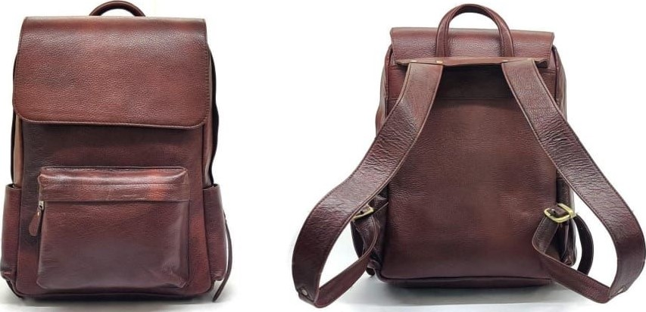

FRONT VIEW BACK VIEW

JAIPUR TOTE BAG

#### MATERIAL : LEATHER : BROWN & BEIGE : COTTON TWILL

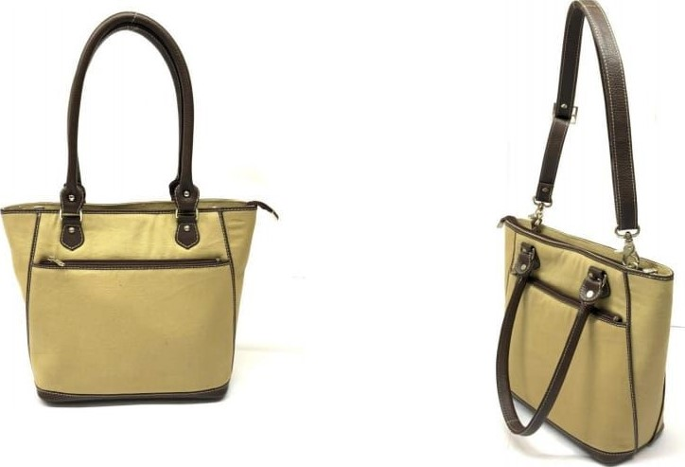

FRONT VIEW SIDE VIEW

TOTE - 001

BODY MATERIAL : LEATHER COLOR : TAN

### LINING

WORK BAG 2.0

#### MATERIAL : LEATHER : BROWN & RED : COTTON TWILL

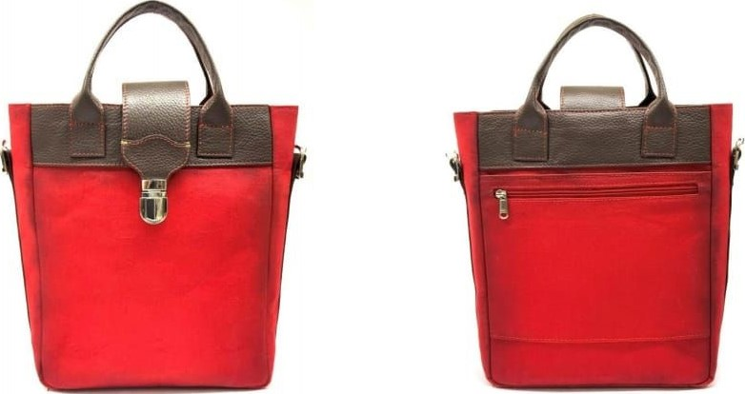

FRONTVIEW BACK VIEW

SMALL COMMUTER MESSENGER BAG

BODY MATERIAL : LEåTWEQ

COLOR . BLACK

#### LINING : COTTON TWILL

FRONT VIEW SIDE VIEW

NEUTER TOTE BAG

#### MATERIAL : LEATHER : BLACK & TAN : COTTON TWILL

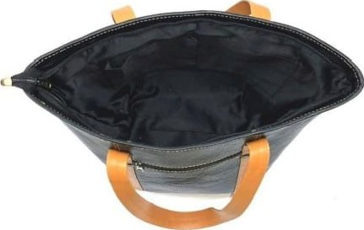 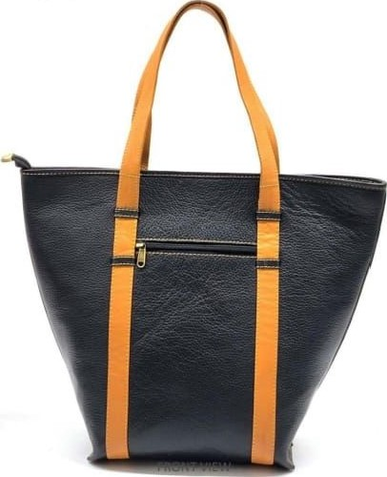 TOP VIEW

#### CITY SHOULDER BAG BODY MATERIAL : LEATHER

|  |  |
| --- | --- |
| COLOR | . BLACK |
| LINING | : COTTON TWILL |

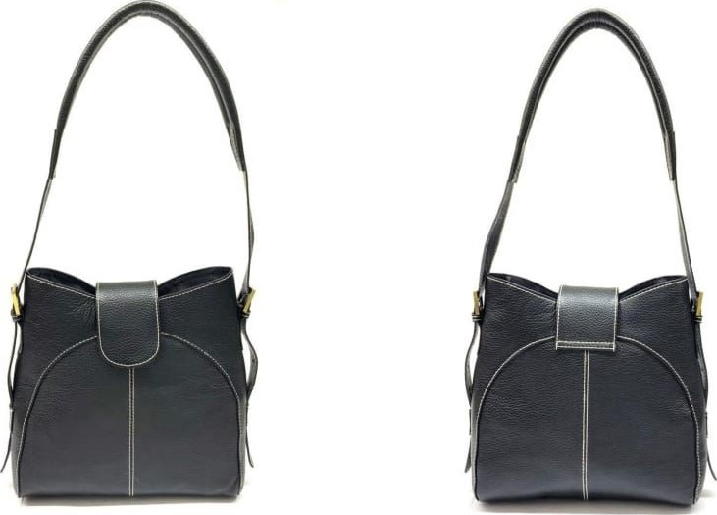

FRONT VIEW BACK VIEW

JAIPUR TOTE BAG 2.0

#### MATERIAL : CANVAS & GENUINE LEATHER : GREEN & TAN : COTTON TWILL

V•cvv SIDE VIEW

THE WORK BAG

#### BODY MATERIAL : LEATHER

|  |  |
| --- | --- |
| COLOR | : BLACK & BROWN |
| LINING | : COTTON TWILL |

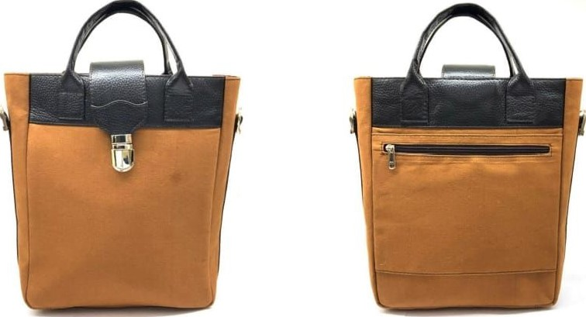

BACK VIEW

# CITY SHOULDER BAG 2.0

#### BODY MATERIAL : LEATHER

|  |  |
| --- | --- |
| COLOR | : TAN & MUSTARD |
| LINING | : COTTON TWILL |

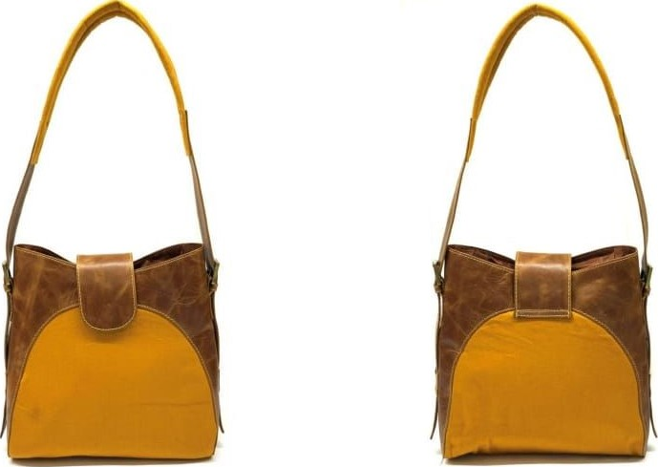

FRONT VIEW BACK VIEW

# SMALL COMMUTER MESSENGER BAG 2.0

BODY MATERIAL : LEATHER COLOR

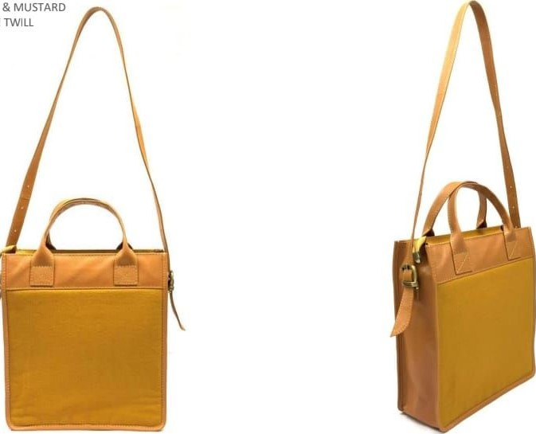

:

YELLOW

:

COTTON

### LINING

#### SIDE VIEW

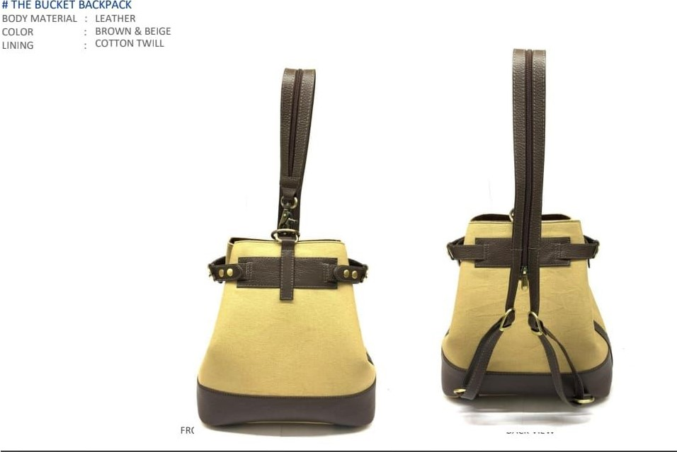

NEWYORK BACKPACK

#### BODY MATERIAL : LEATHER COLORBROWN a RED LINING . COTTON TWILL

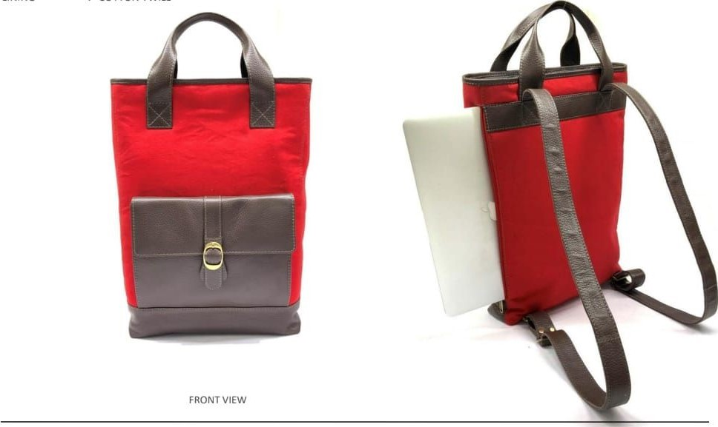

NEWYORK BACKPACK 2.0

BODY MATERIAL LEATHER COLOR BROWN & RED

### LINING TWI

FRONTVIEW 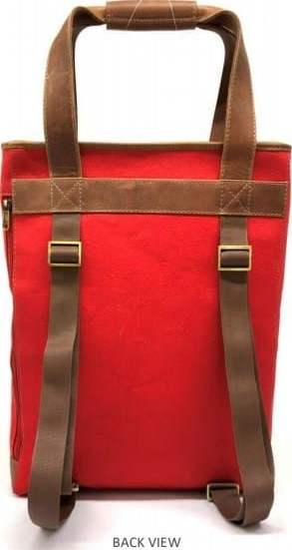

MINI RUCKSACK 3.0

MATERIAL : LEATHER & CANVAS

: & BLUE

#### LINING : COTTON TWILL

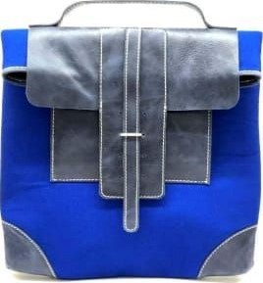

FRONT VIEW

BUCKET BACKPACK 2.0

### MATERIAL NDM & CANVAS

BLUE & BLACK

#### . COTTON TWILL

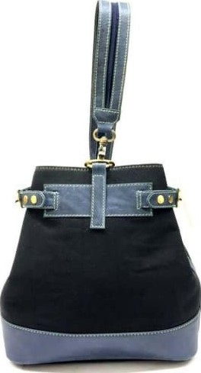

FRONT VIEW

MINI RUCKSACK

#### MATERIAL : LEATHER : BROWN & MUSTARD : COTTON TWILL

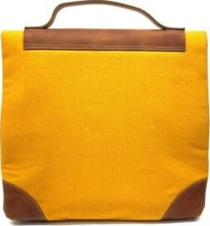

MINI RUCKSACK 2.0

#### MATERIAL : LEATHER & CANVAS : TAN & CAMO : COTTON TWILL

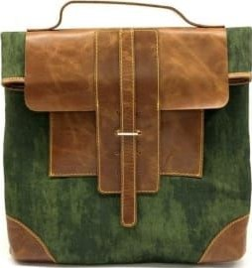

POSTMAN MESSENGER 2.0

#### MATERIAL : LEATHER . BROWN : COTTON TWILL

POSTMAN MESSENGER

#### MATERIAL NDM & CANVAS

BLUE & BLACK

##### COTTON TWILL

LONDON SLING BODY MATERIAL :

|  |  |
| --- | --- |
| COLOR | . NEON ORANGE & GREY |
| LINING | . SUEDE |

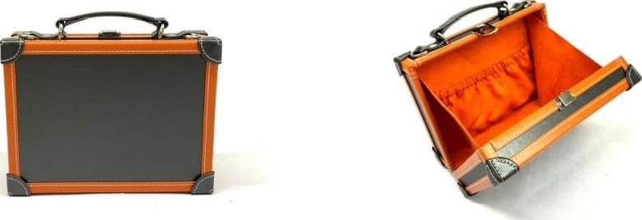

OPEN VIEW

PASSPORT

#### BODY MATERIAL COLOR . TAN LINING . COTTON TWILL

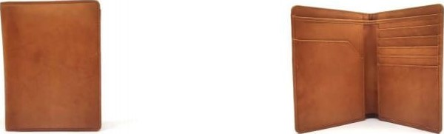

FRONT VIEW SIDE VIEW

PARIS LOCK

BODY MATERIAL

### COLOR . NEON ORANGE & GREY LINING SUEDE

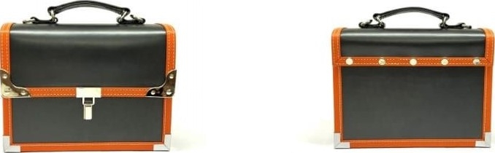

#### BACK

OMBRE PURSE MATERIAL :

#### BROWN . COTTON TWILL

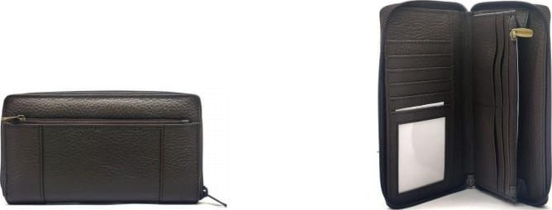

SIDE

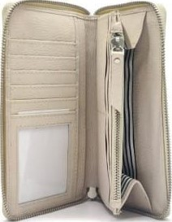# THE OMBRE PURSE 2.0

#### BODY MATERIAL : LEATHER

|  |  |
| --- | --- |
| COLOR | WHITE |
| LINING | . COTTON TWILL |

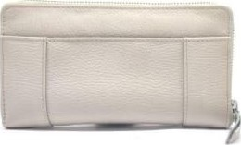

LAPTOP SLEEVE

#### MATERIAL DUAL TONE & CANVAS . TAN & BEIGE . COTTON TWILL

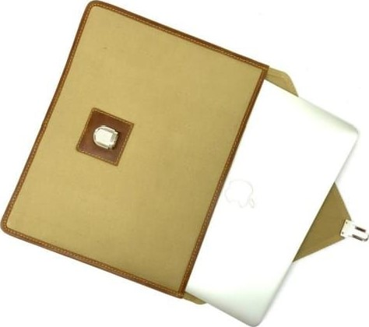

FRONT VIEW OPEN VIEW

HUSSLER

#### BODY MATERIAL ARIZONA COLOR NERO LINING . COTTON TWILL

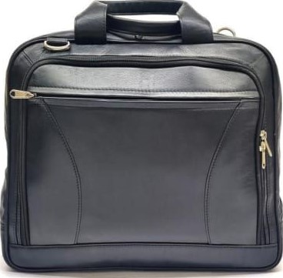

FRONT VIEW

OMBRE PURSE

#### MATERIAL LEATHER PURPLE . COTTON TWILL

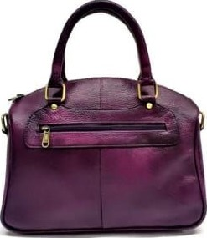

FRONT VIEW SIDE VIEW

BEER HOLSTER

BODY MATERIAL LEATHER COLOR BROWN

### LINING

FRONT VIEW

LAPTOP SLEEVE 2.0

#### MATERIAL : NDM & CANVAS BROWN & BROWN . COTTON TWILL

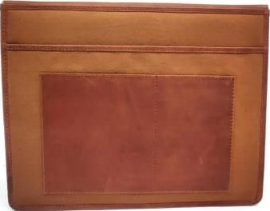

FRONT VIEW SIDE VIEW

|  |  |
| --- | --- |
| COLOR | NERO |
| LINING | . COTTON |

#### BOOM BUCKET BODY MATERIAL ARIZONA

MOON SLING -1

#### BODY MATERIAL ARIZONA

|  |  |
| --- | --- |
| COLOR | BLACK & WHITE |
| LINING | . COTTON TWILL |

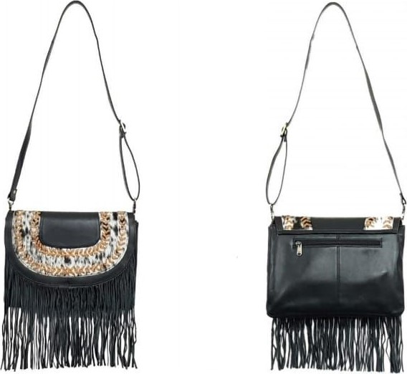

SIDE VIEW

# THE DUAL FLAP PURSE

#### BODY MATERIAL LEATHER COLOR . TAN LINING COTTON

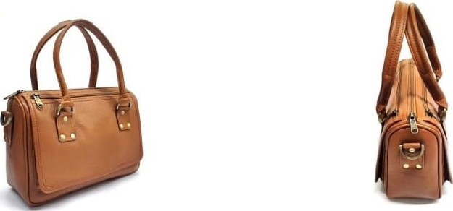

FURRY MESSANGER

#### BODY MATERIAL : LEATHER

|  |  |
| --- | --- |
| COLOR | : TAN |
| LINING | : COTTON |

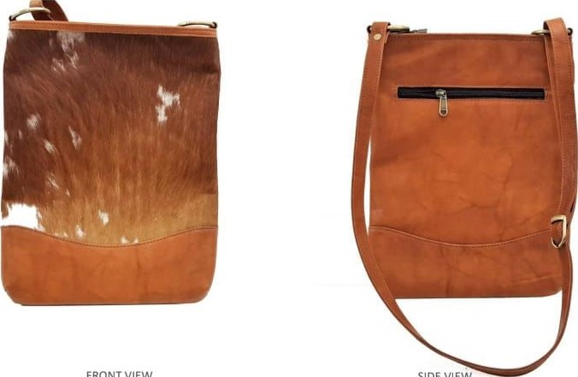

SIDE

VIEW

#### MOON SLING -4 BODY MATERIAL : ARIZONA

|  |  |
| --- | --- |
| COLOR | BLUE |
| LINING | COTTON |

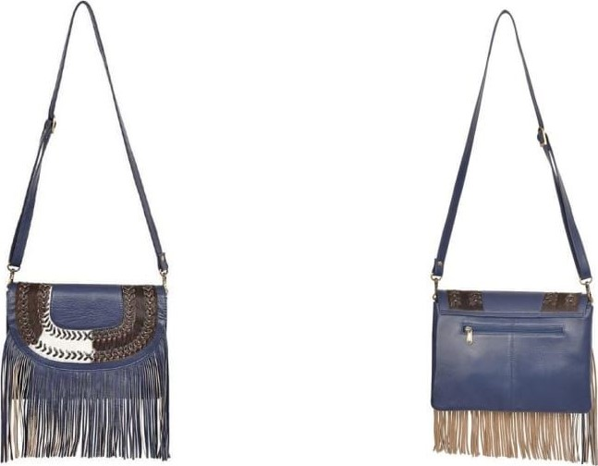

GLAM MESSANGER

#### BODY MATERIAL : LEATHER

|  |  |
| --- | --- |
| COLOR | NERO |
| LINING | . COTTON |

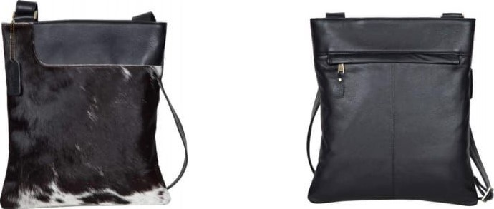

FRONT VIEW SIDE VIEW

THE POT

#### BODY MATERIAL LEATHER COLOR BURGANDY LINING . COTTON

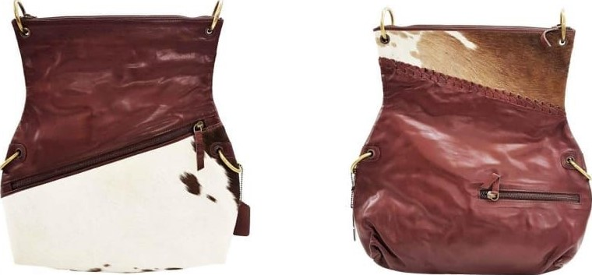

##### FRONT VIEW

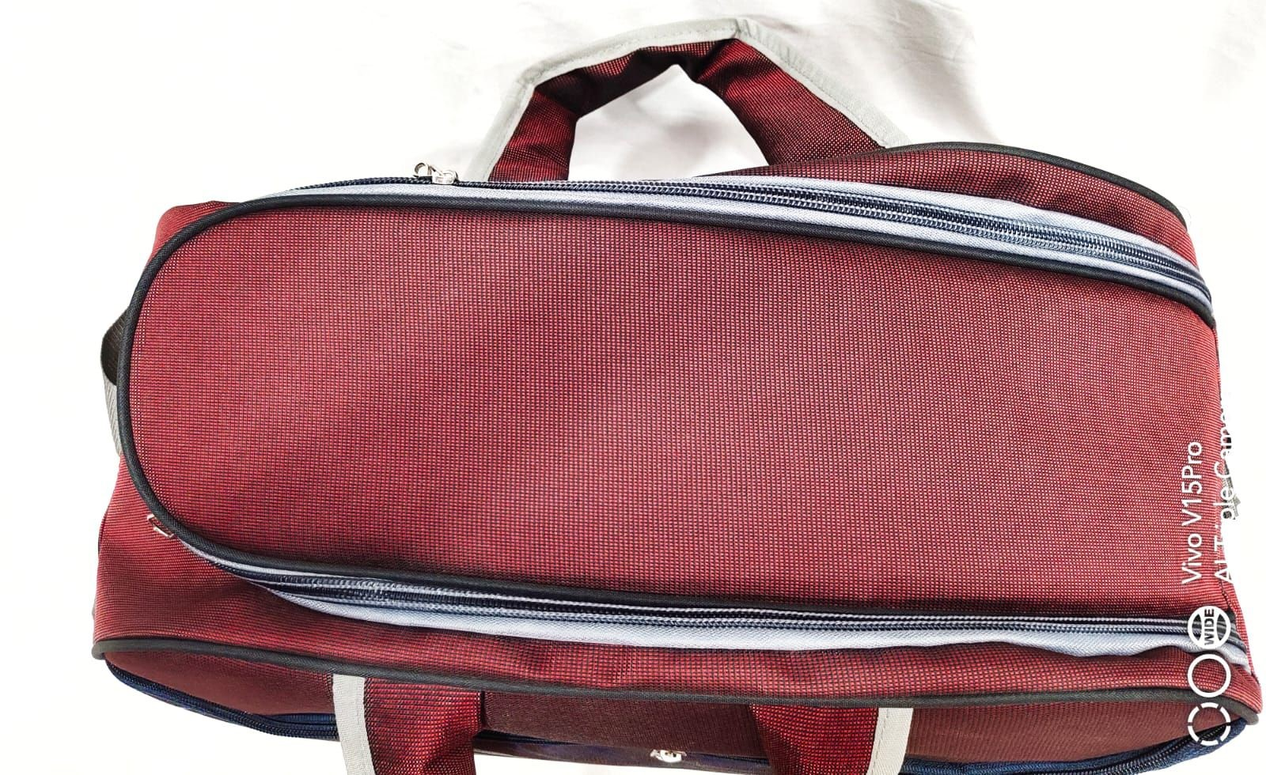

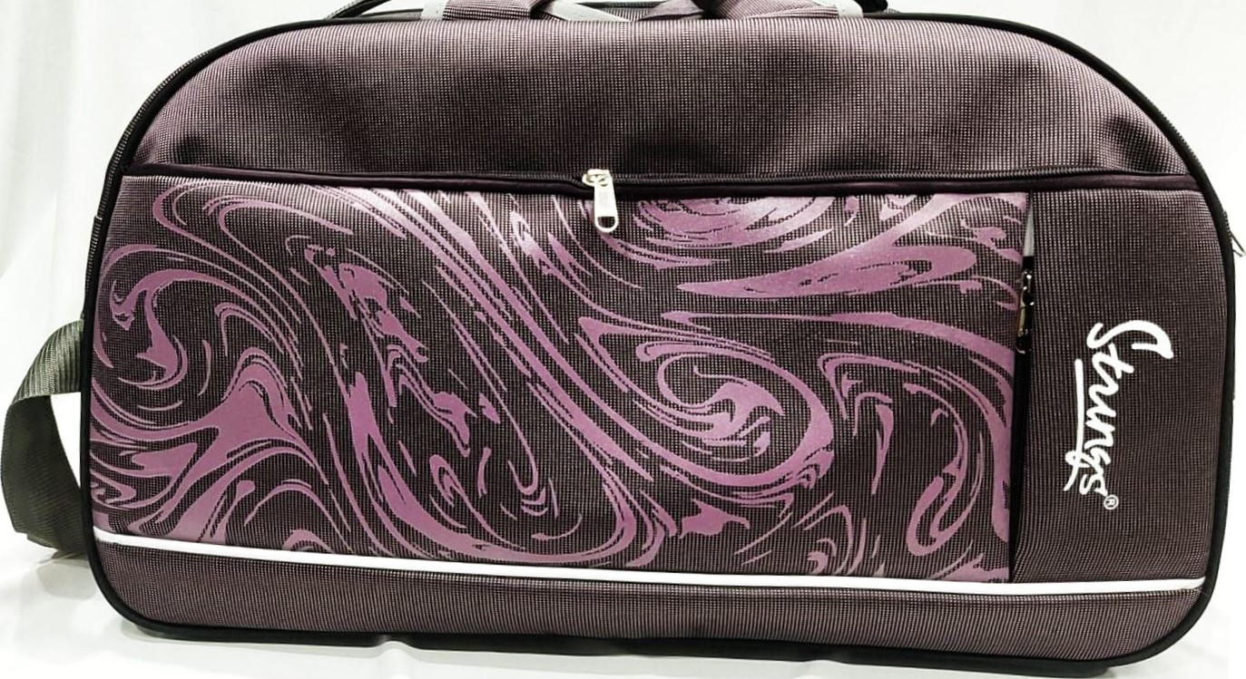

聳우罋수까1

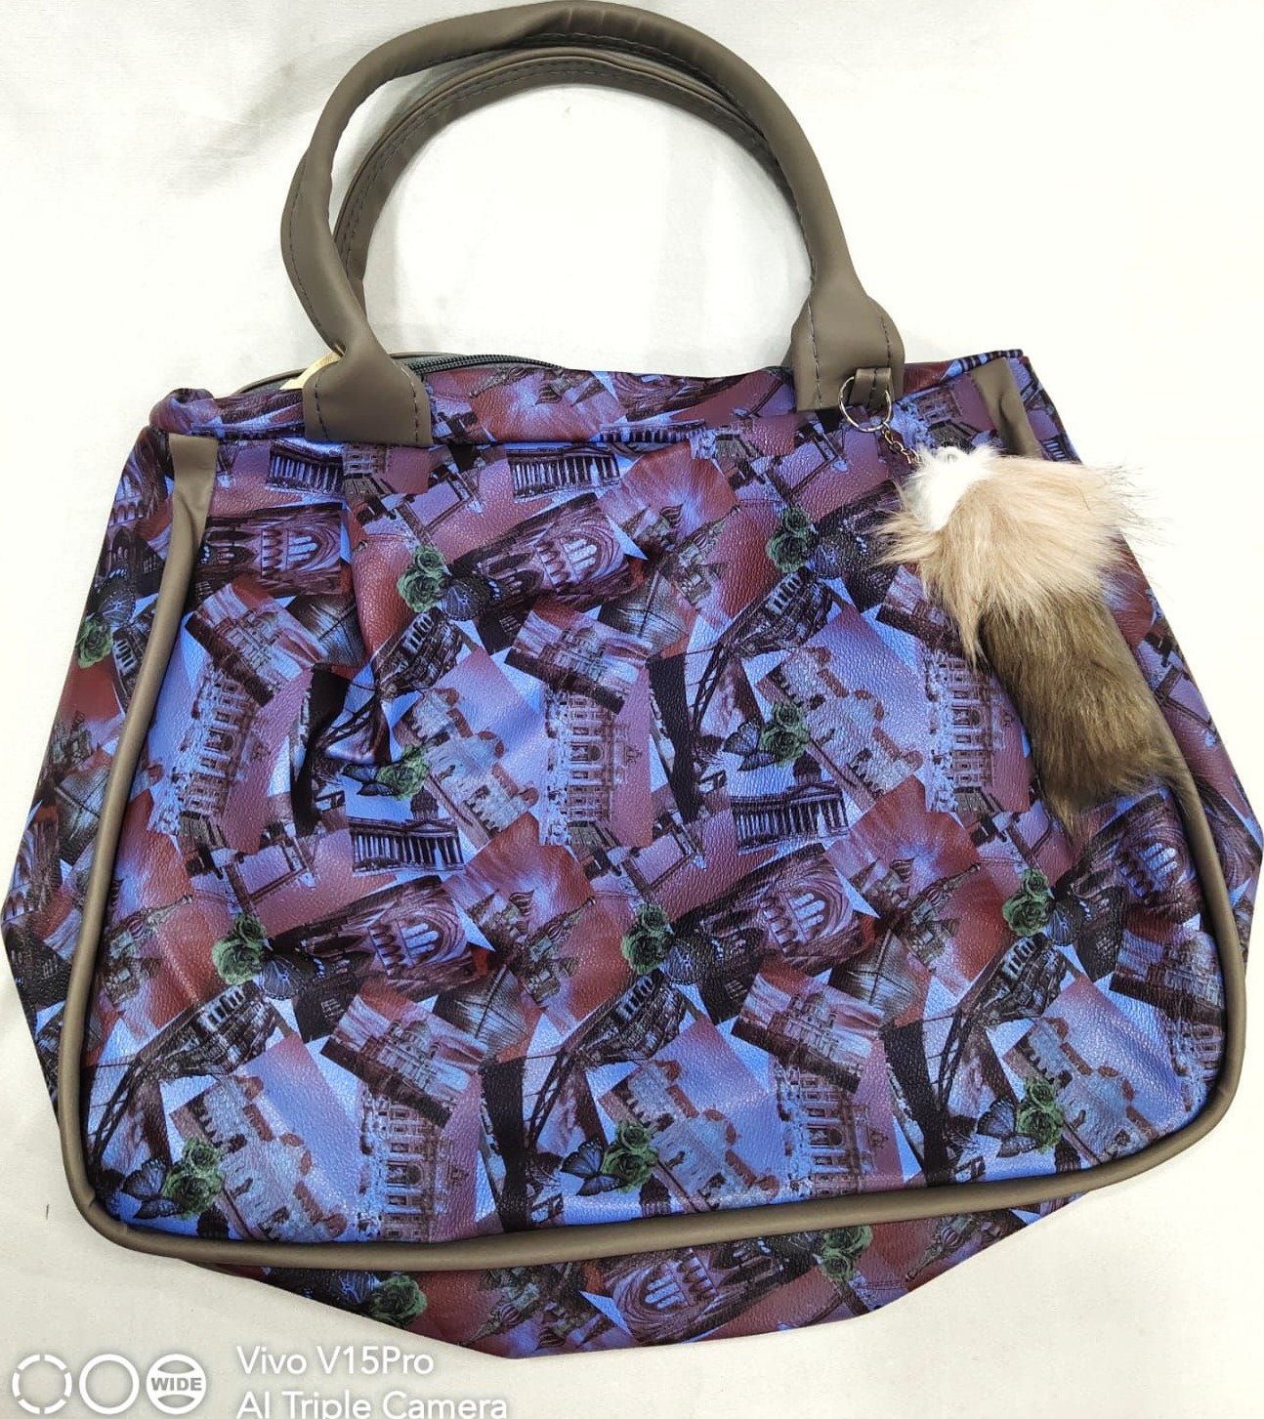

Al

'Triple

Carpeïaù

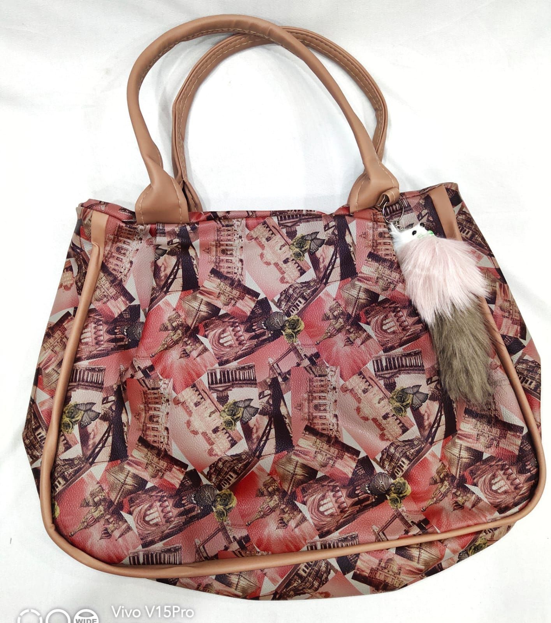

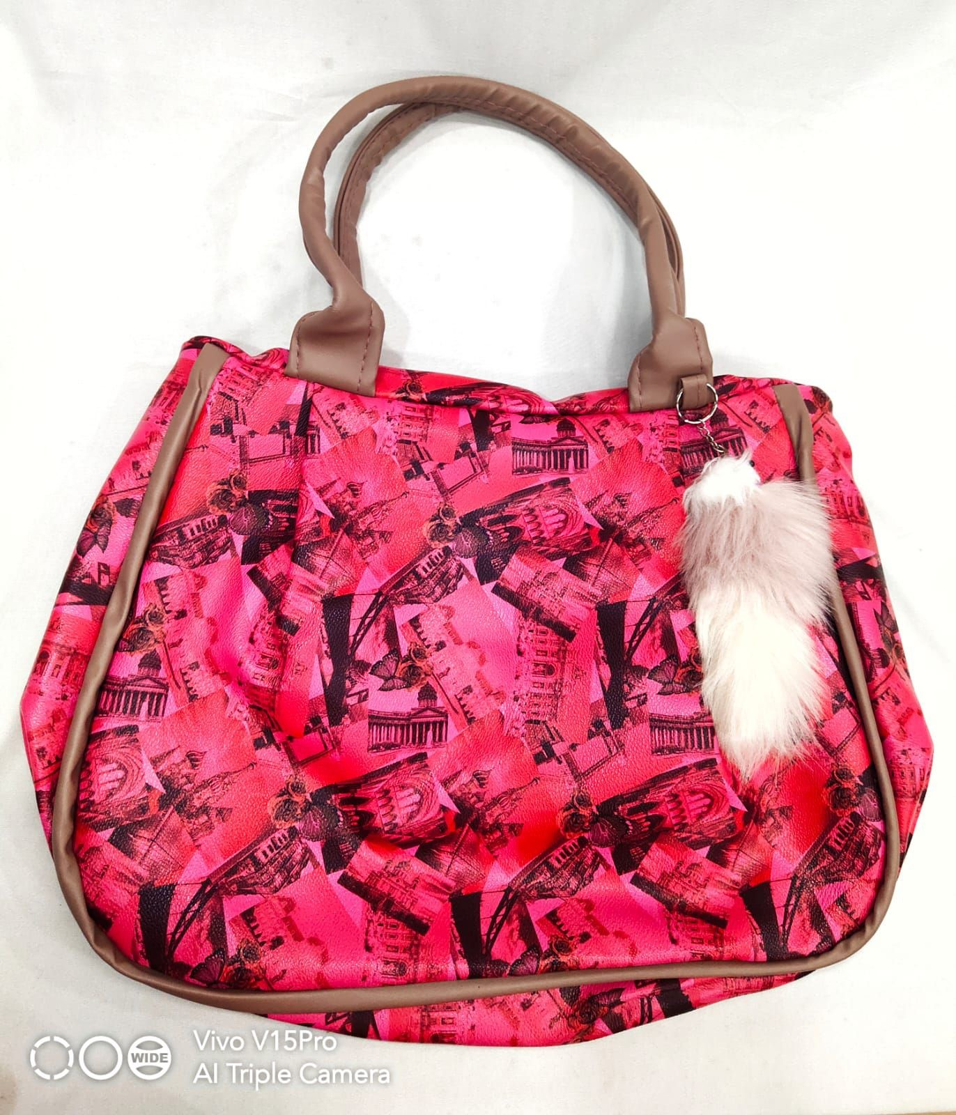

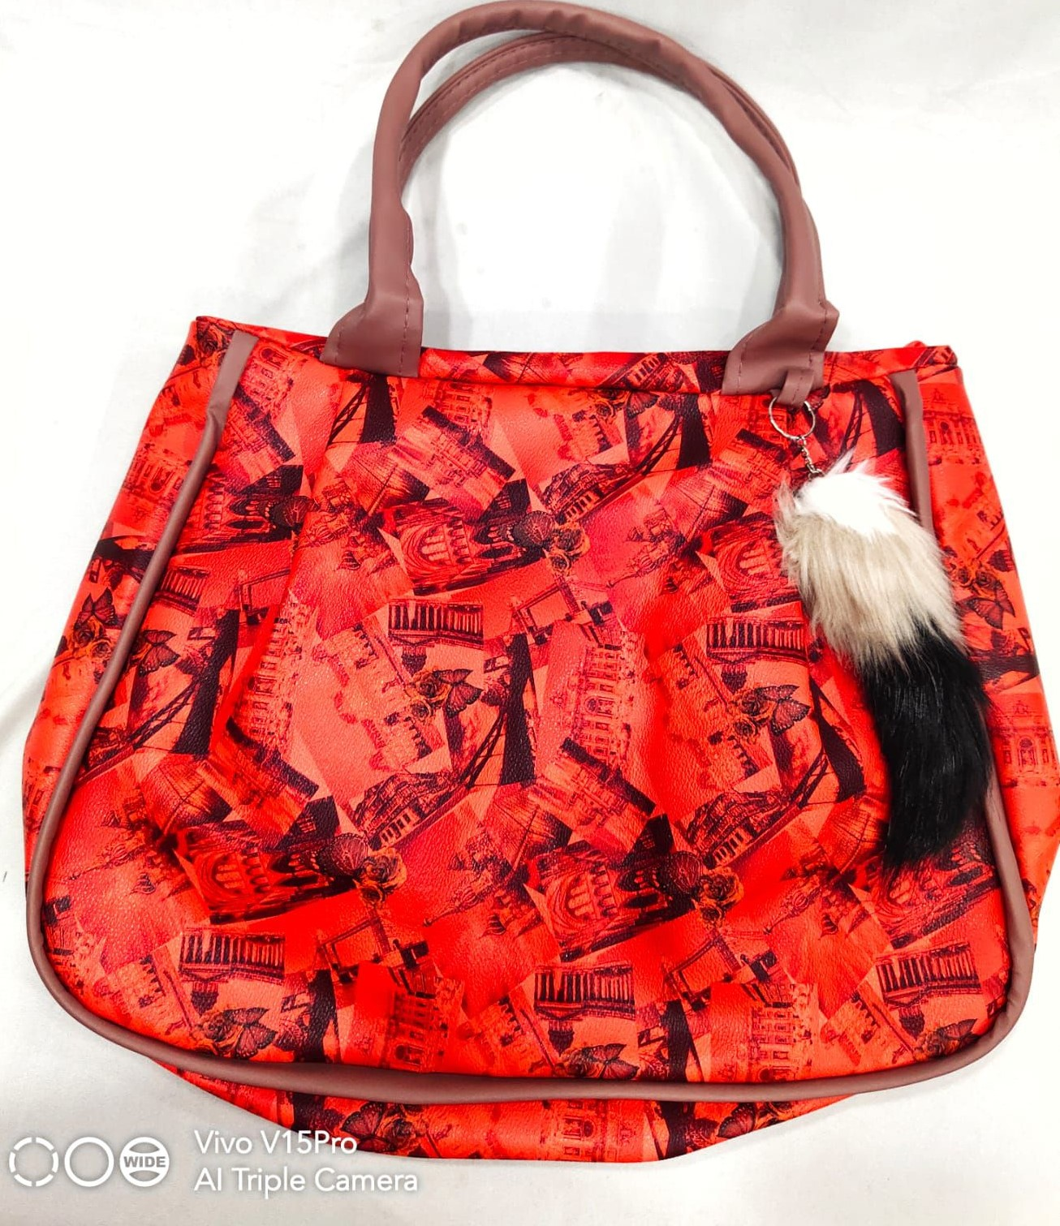

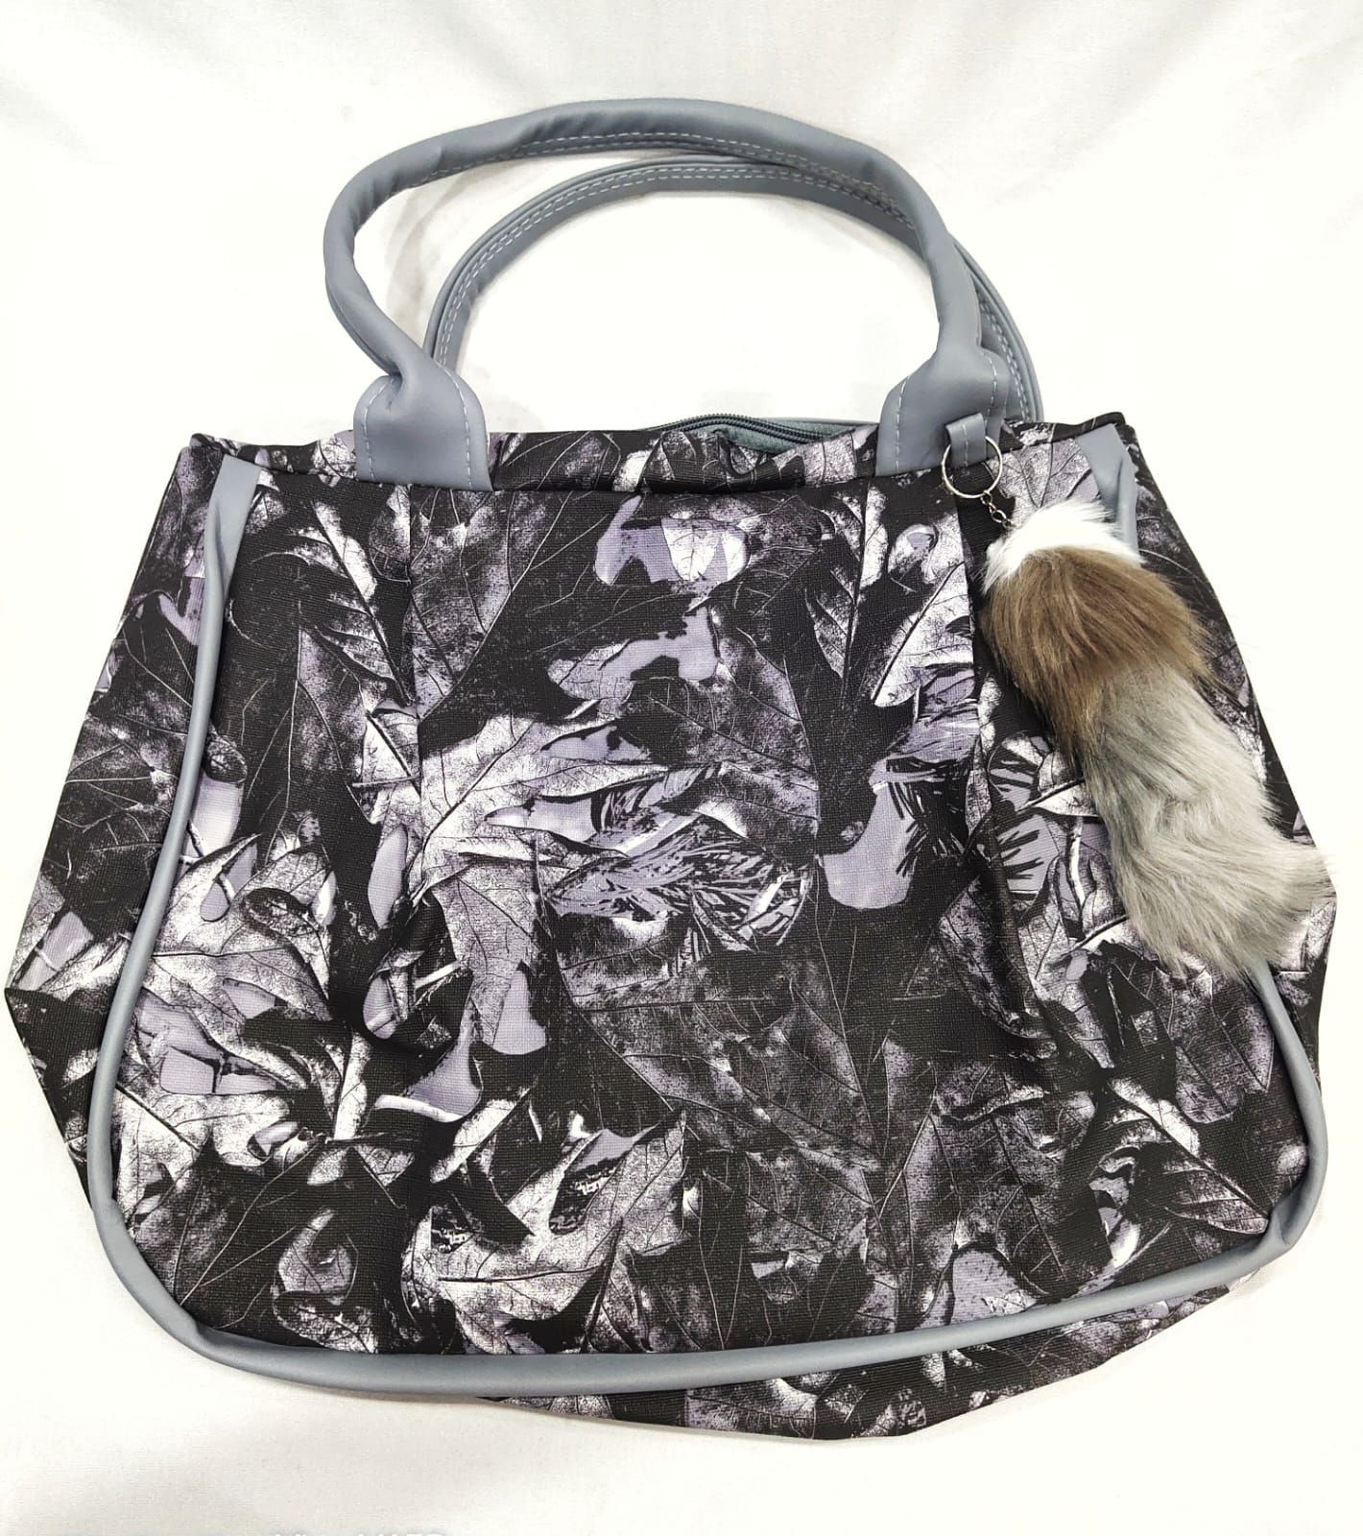

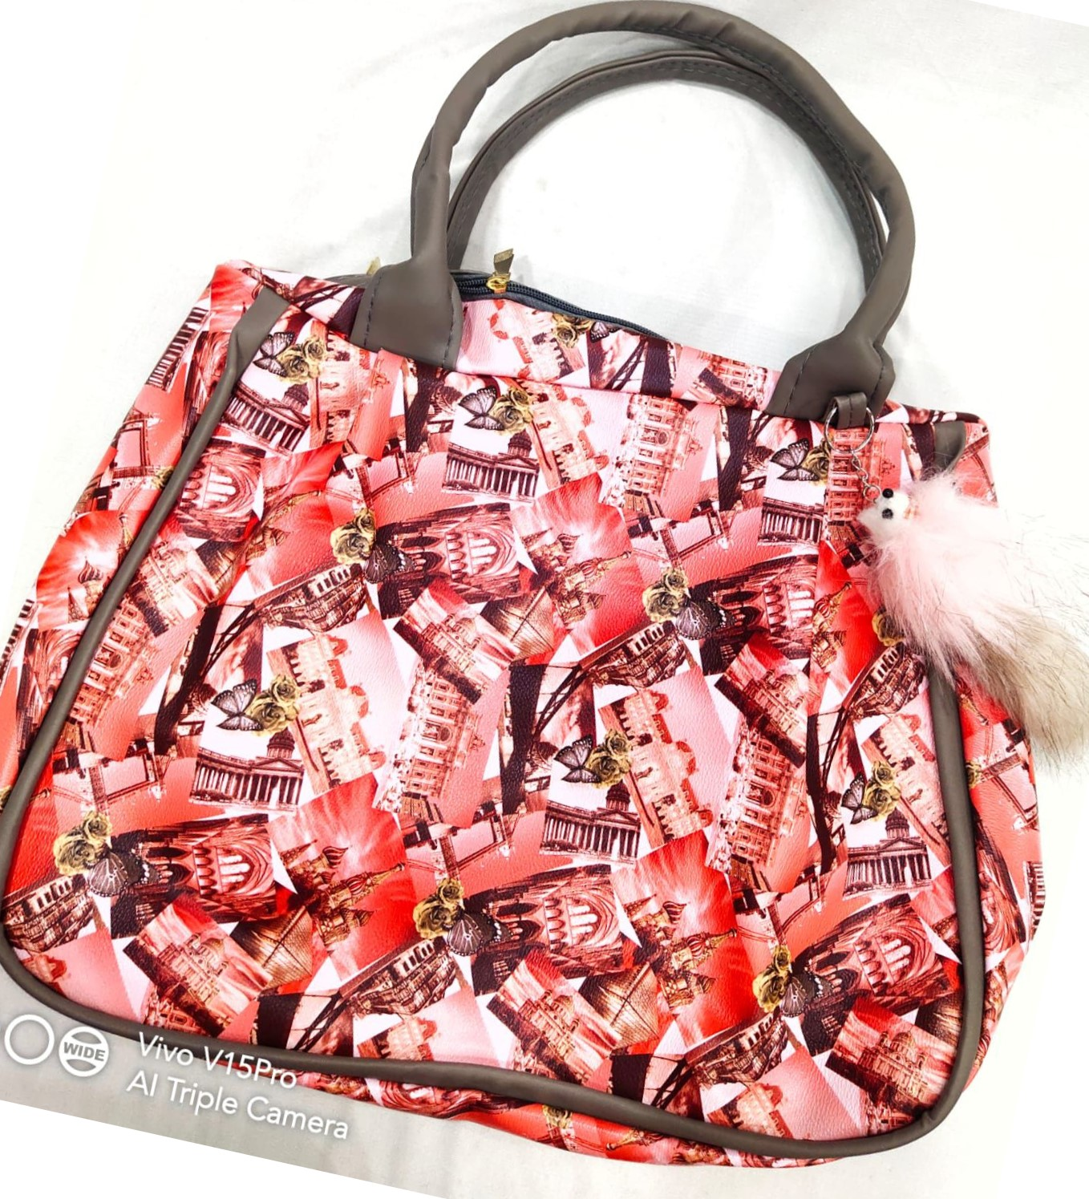

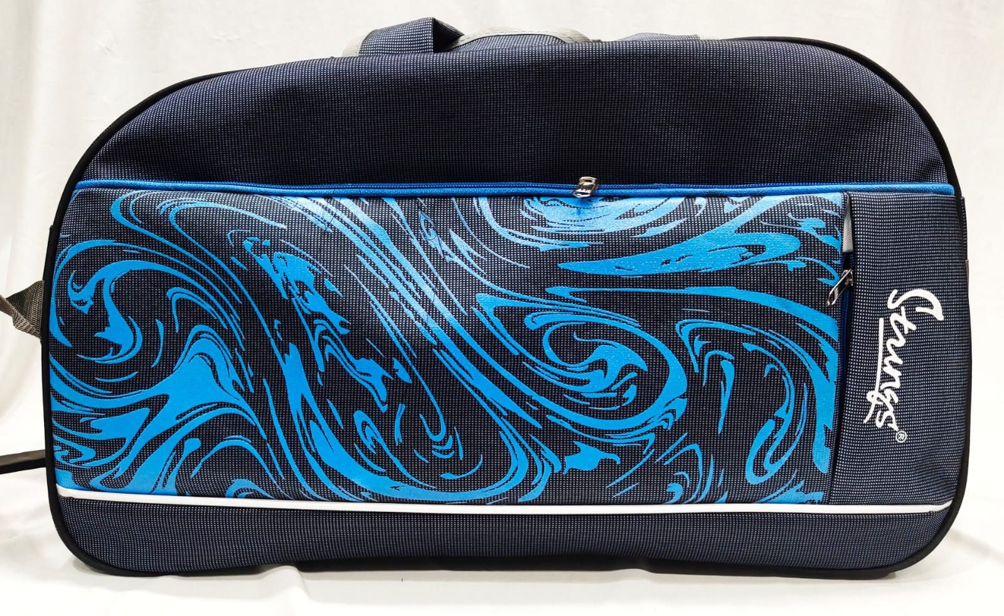

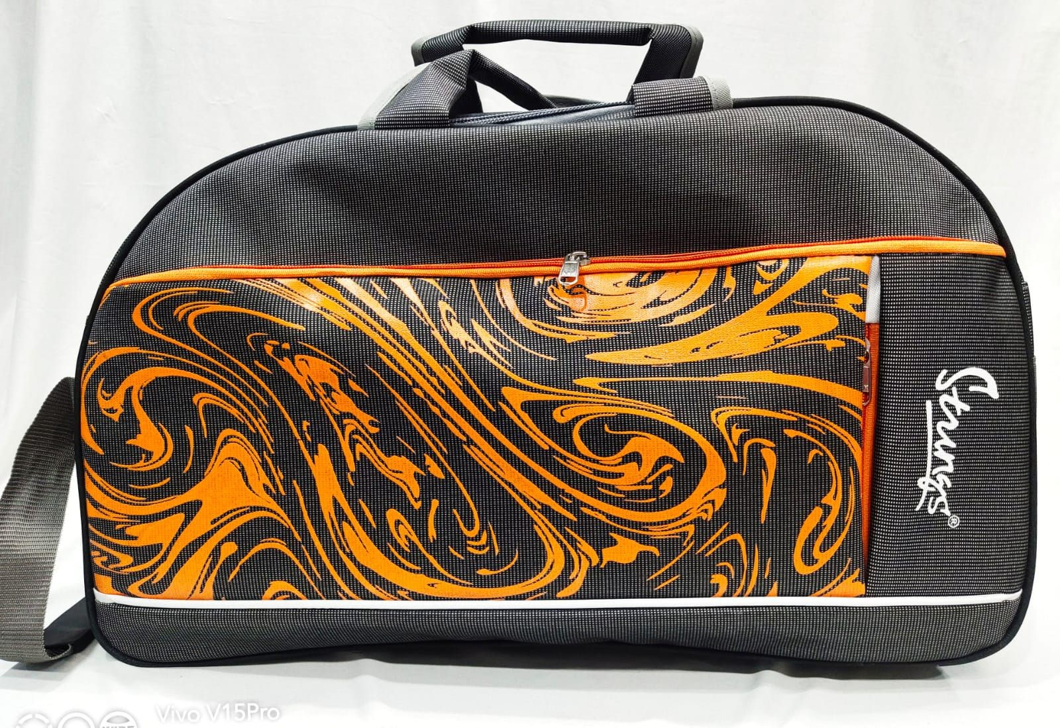

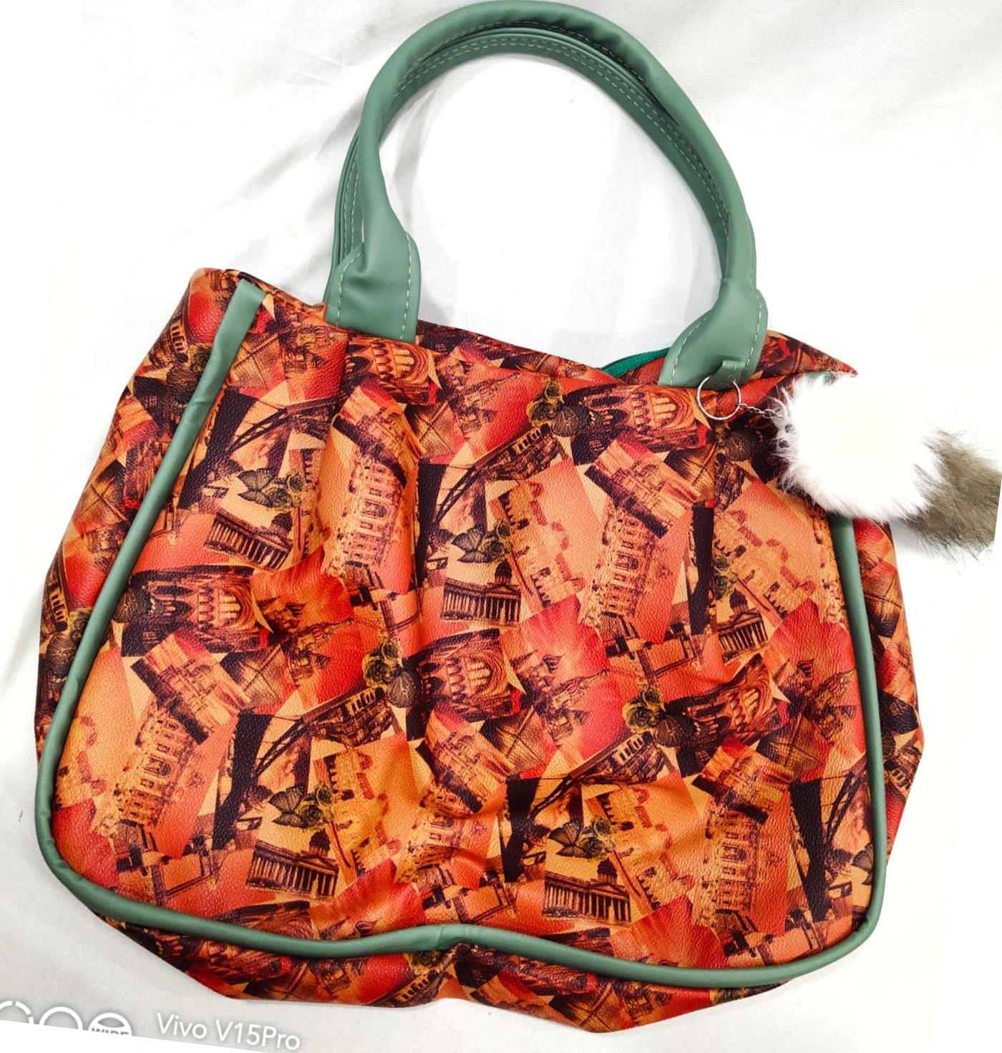



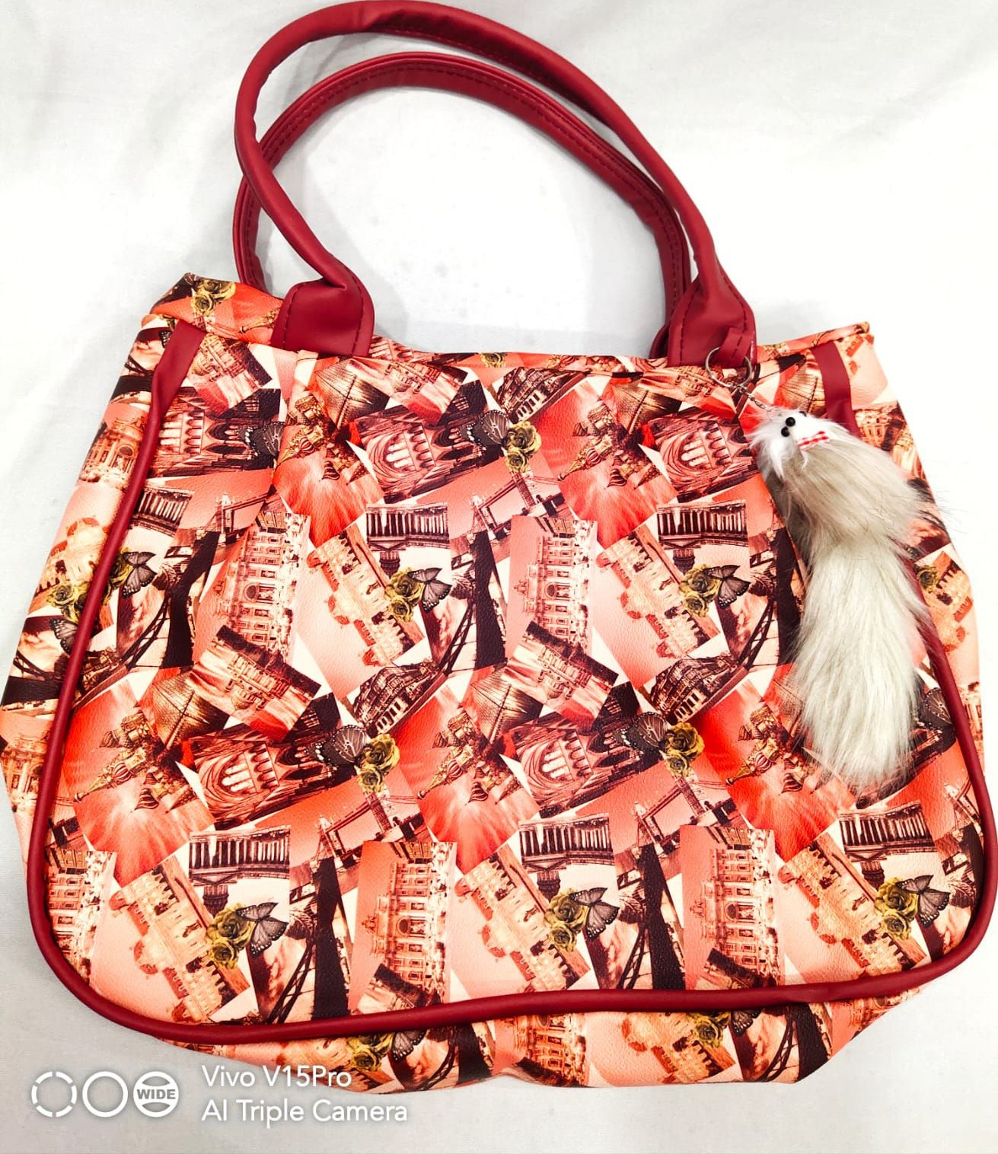

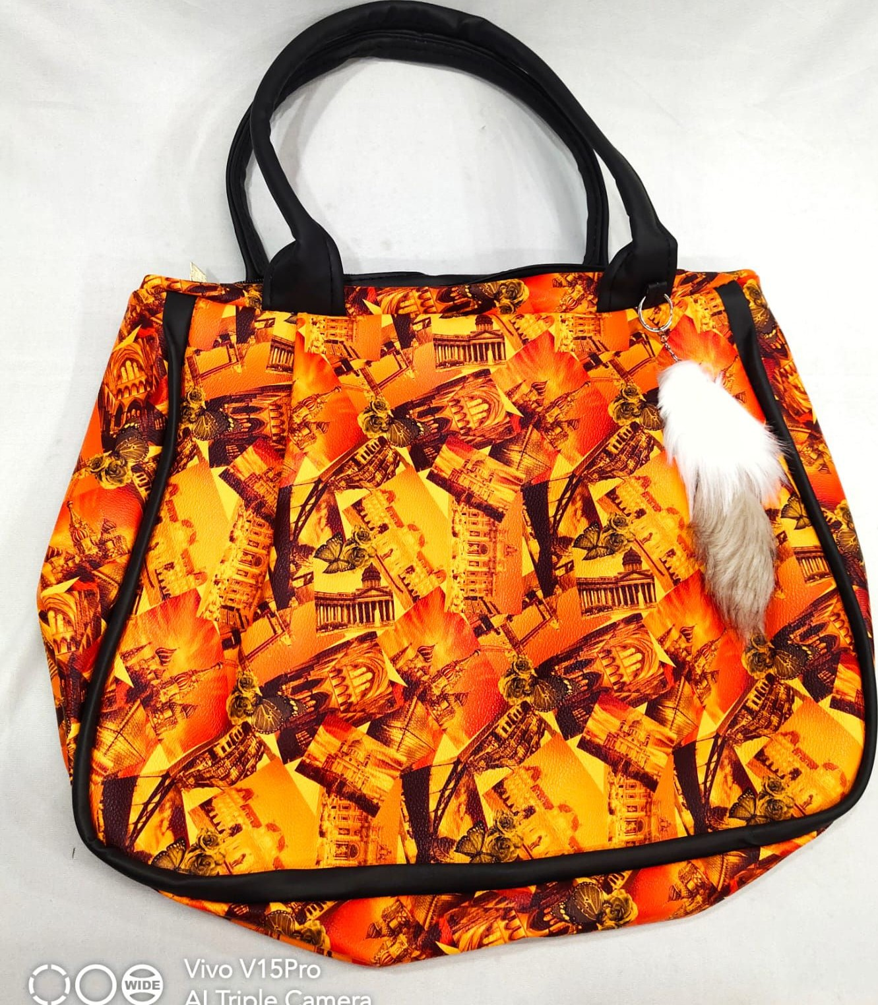

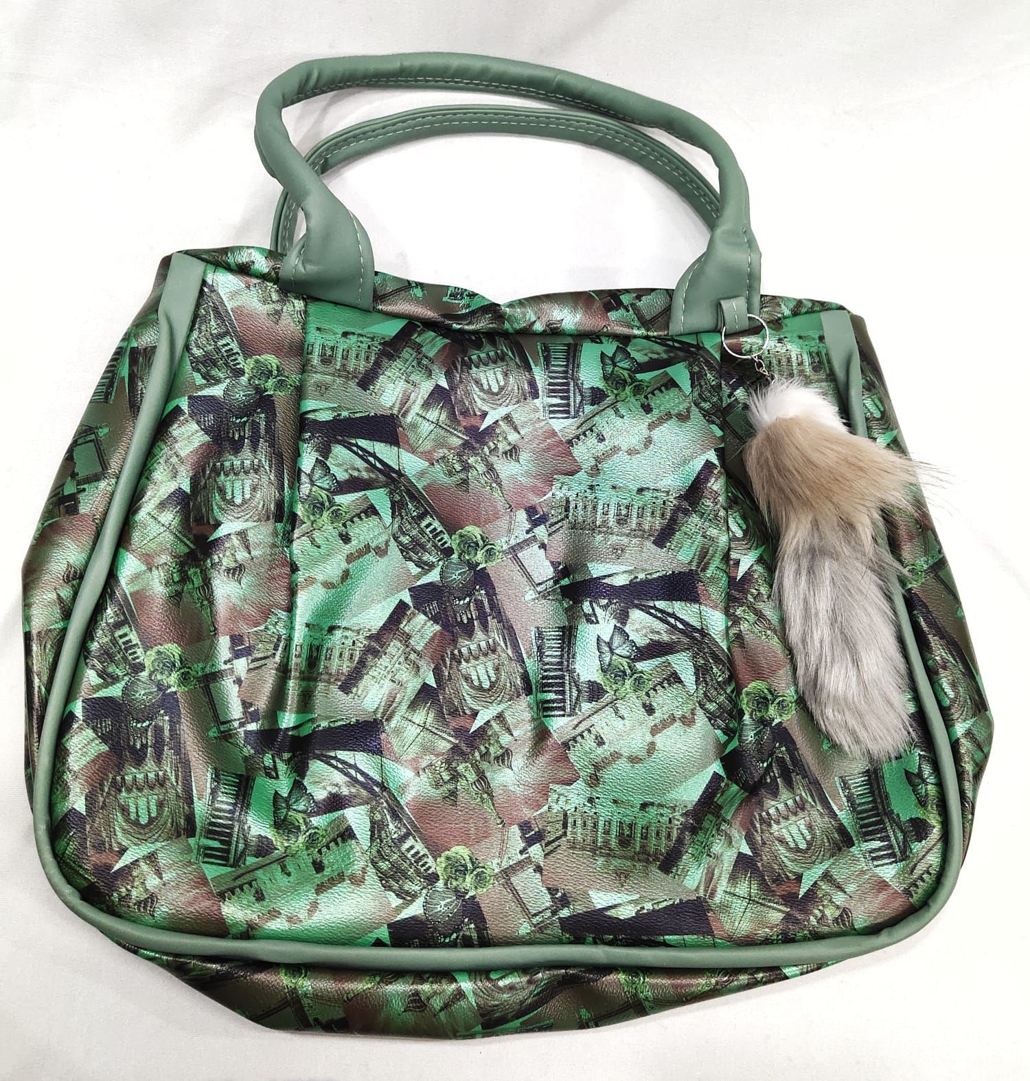

- Vivo

IVOXV - O

) NWIDE

'AlÀTri le Camer

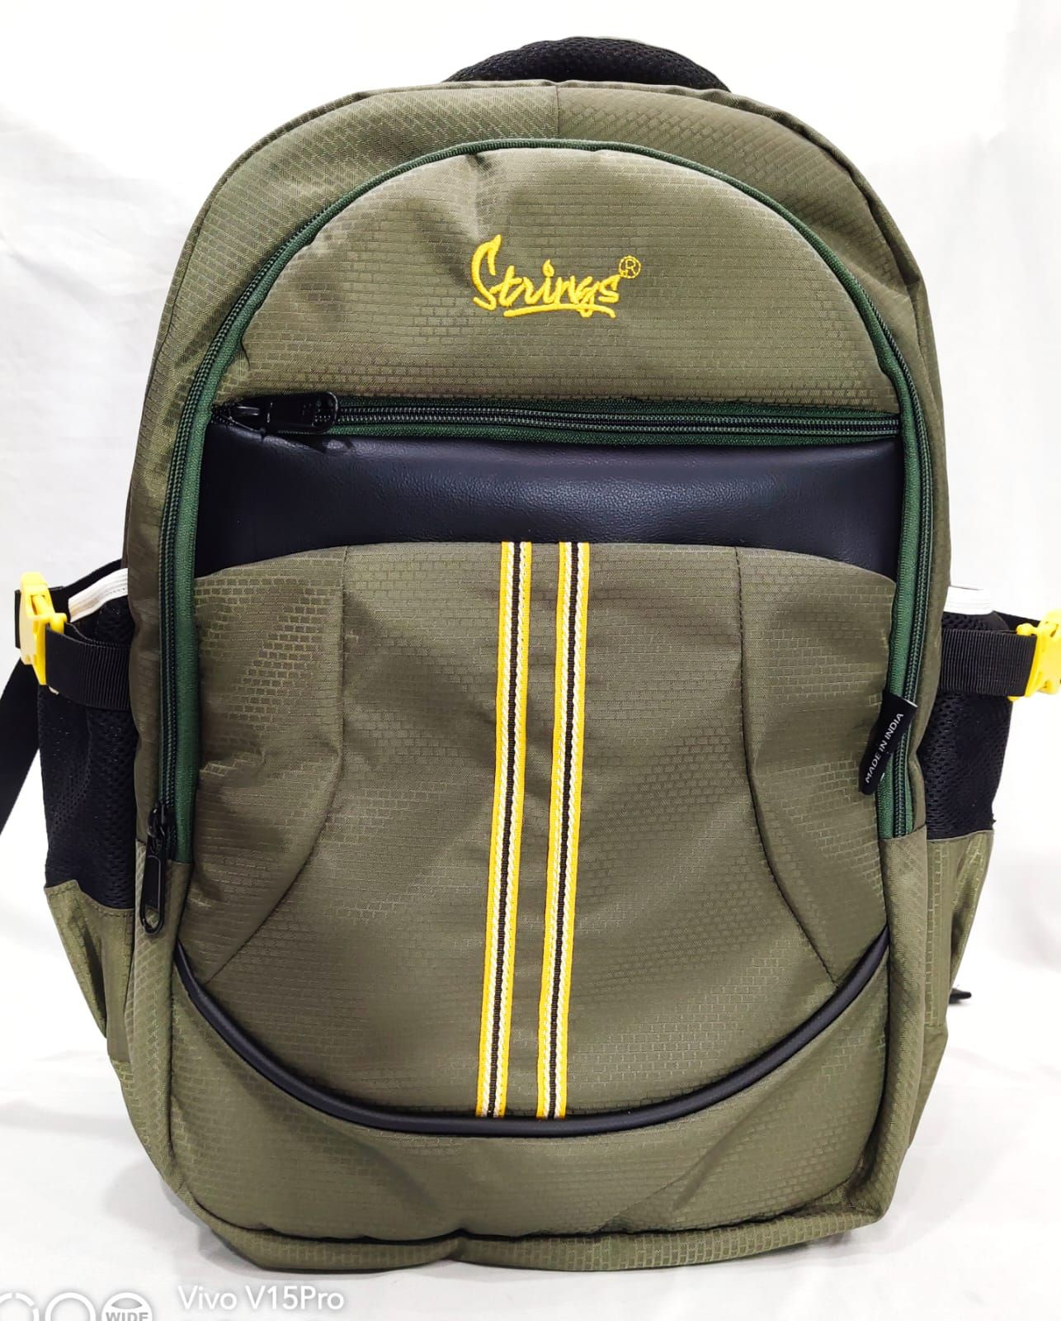

WIDE

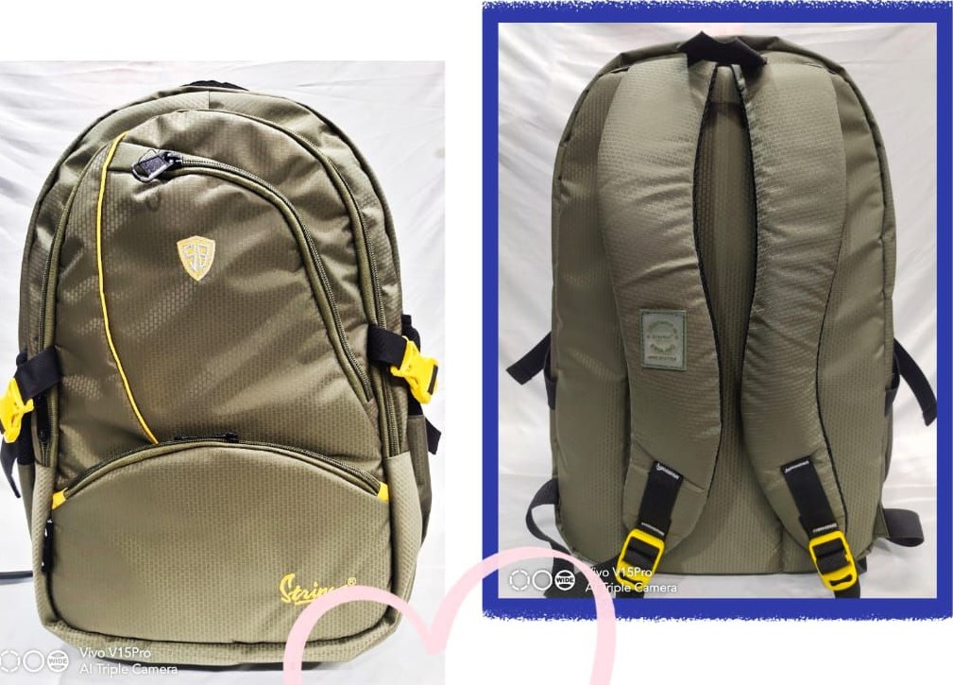

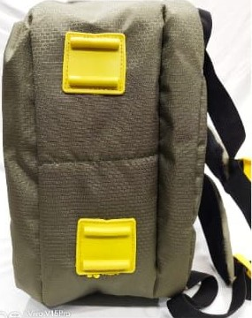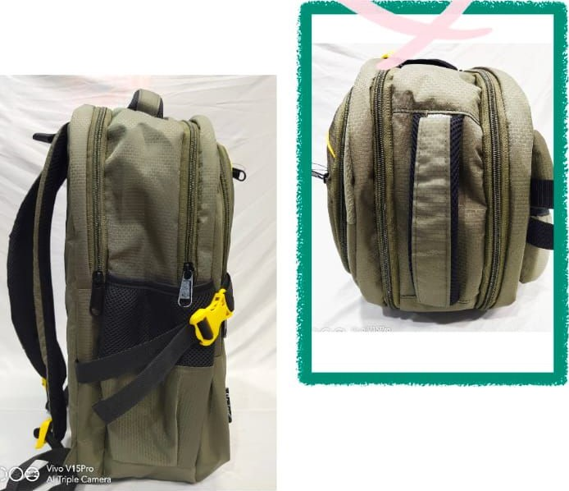 HAPPINESS

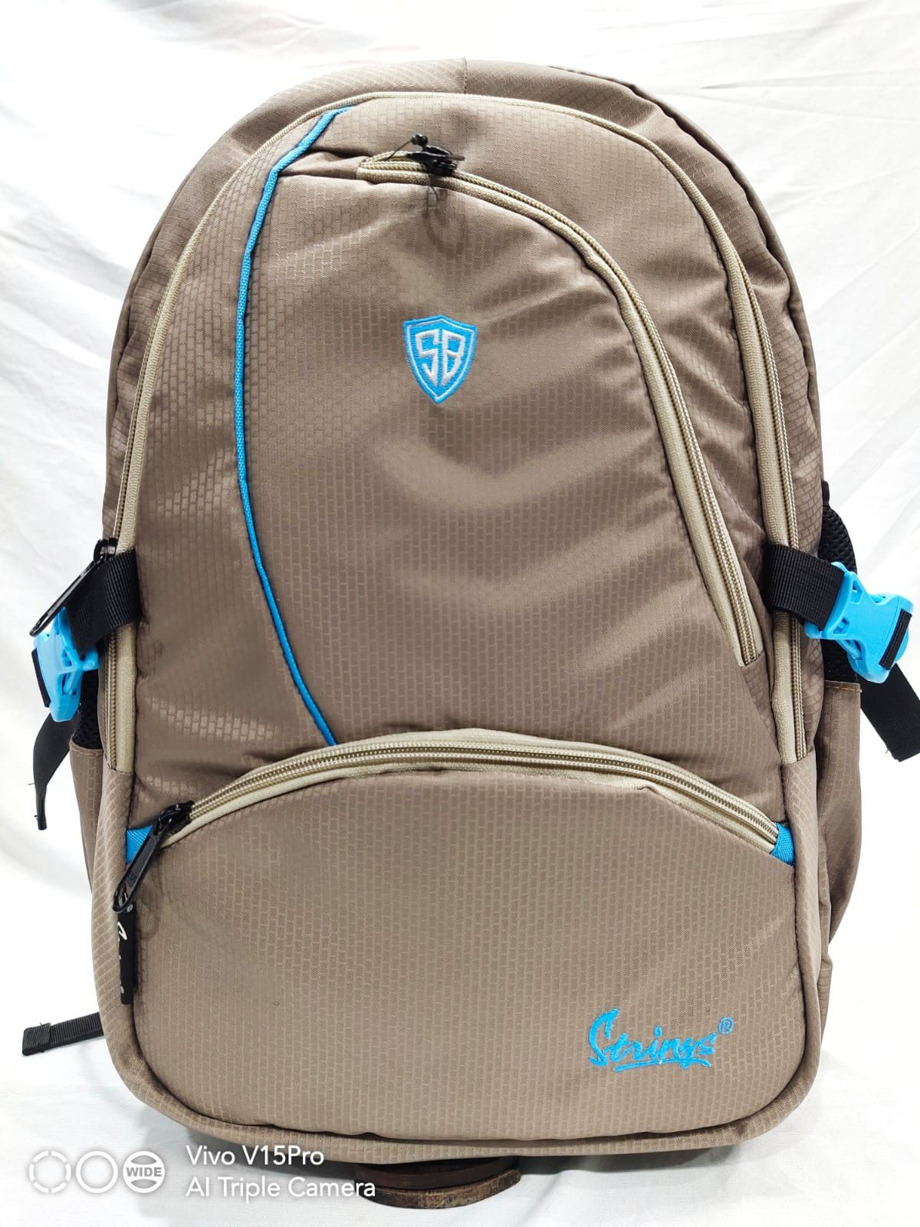

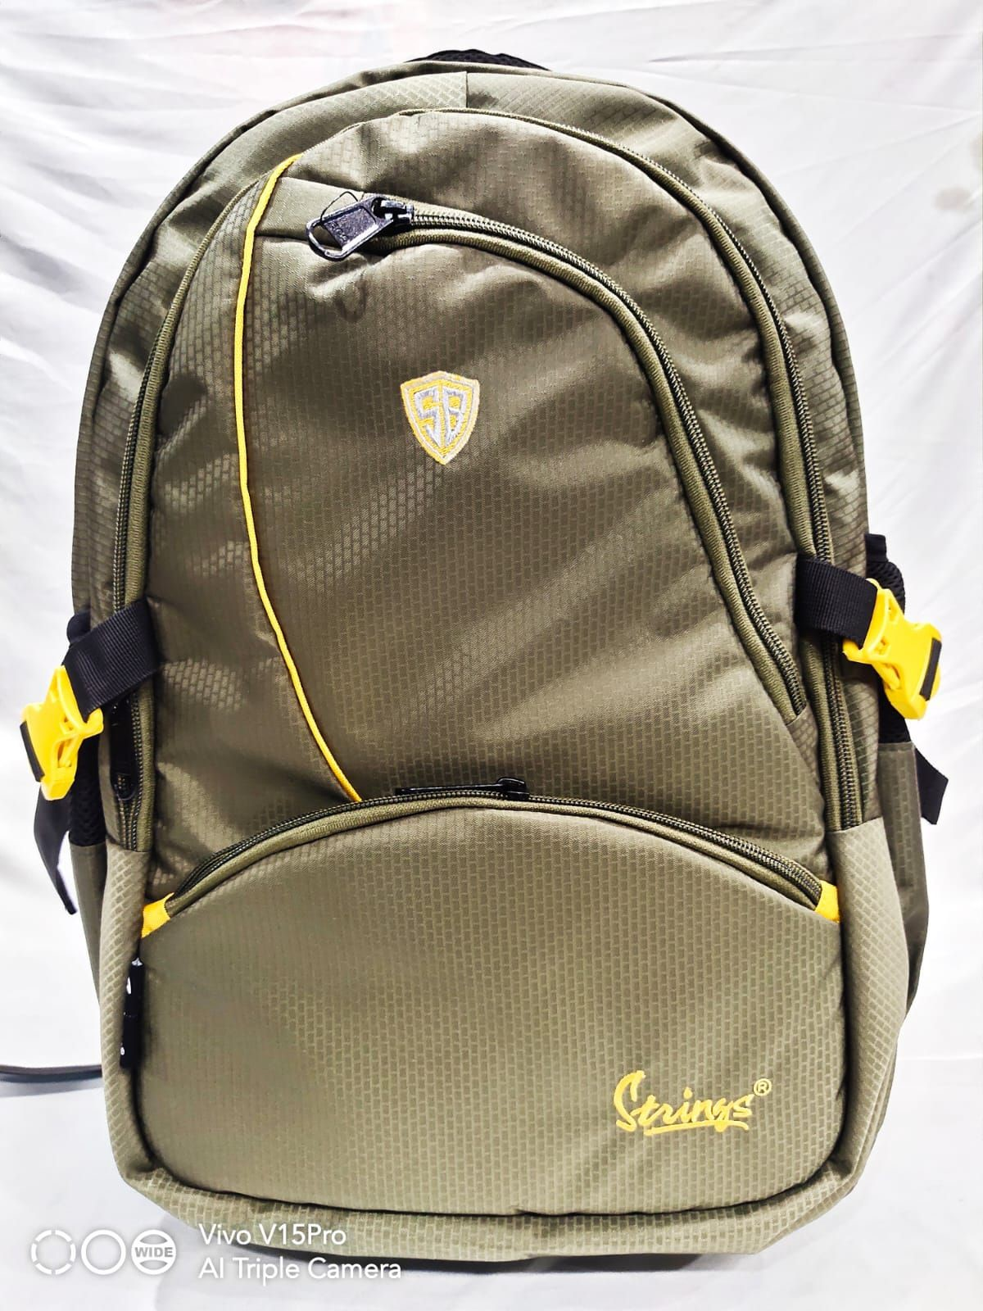

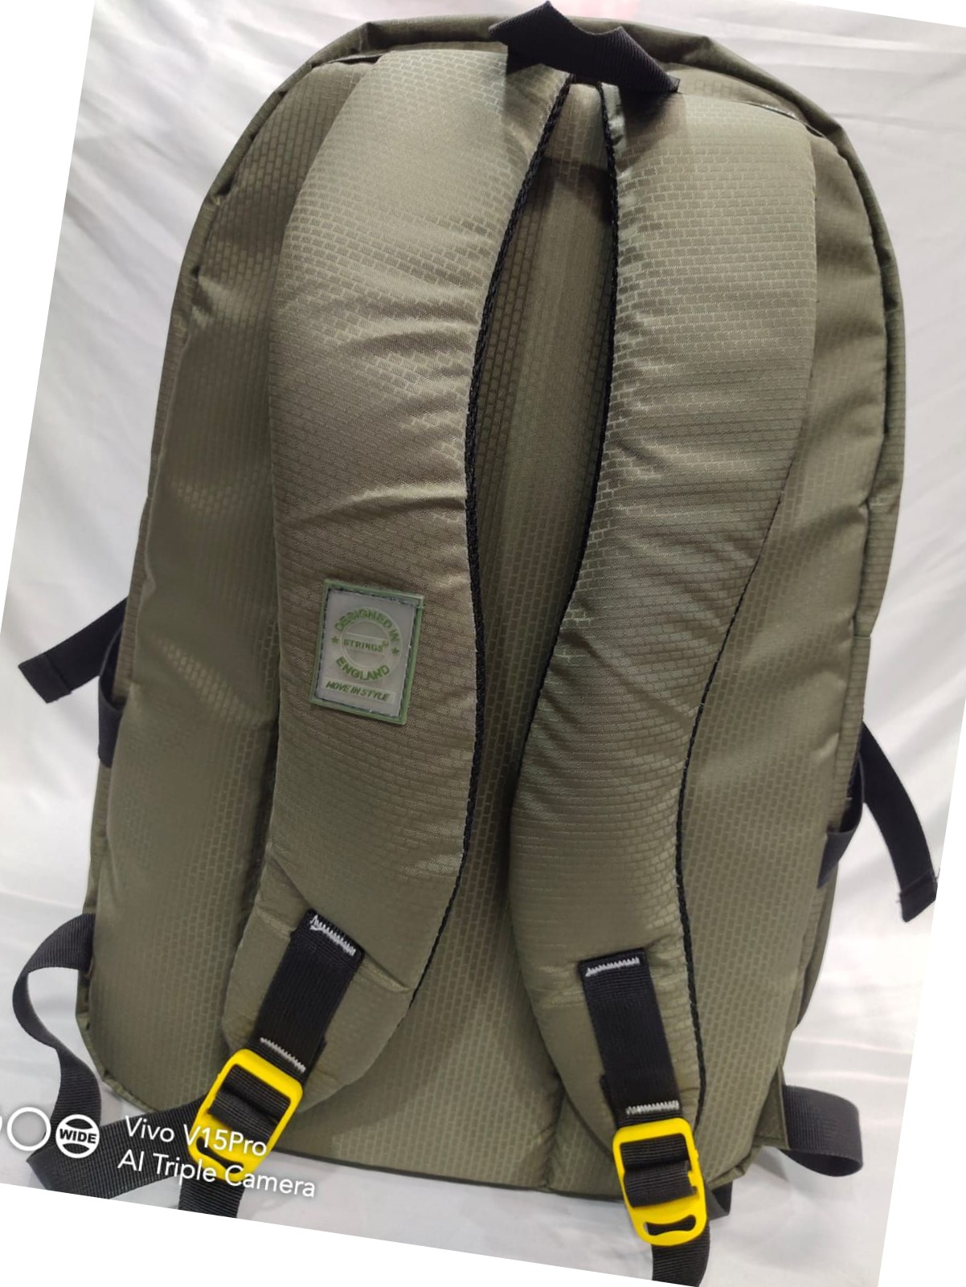

Vivo- = 5Prc

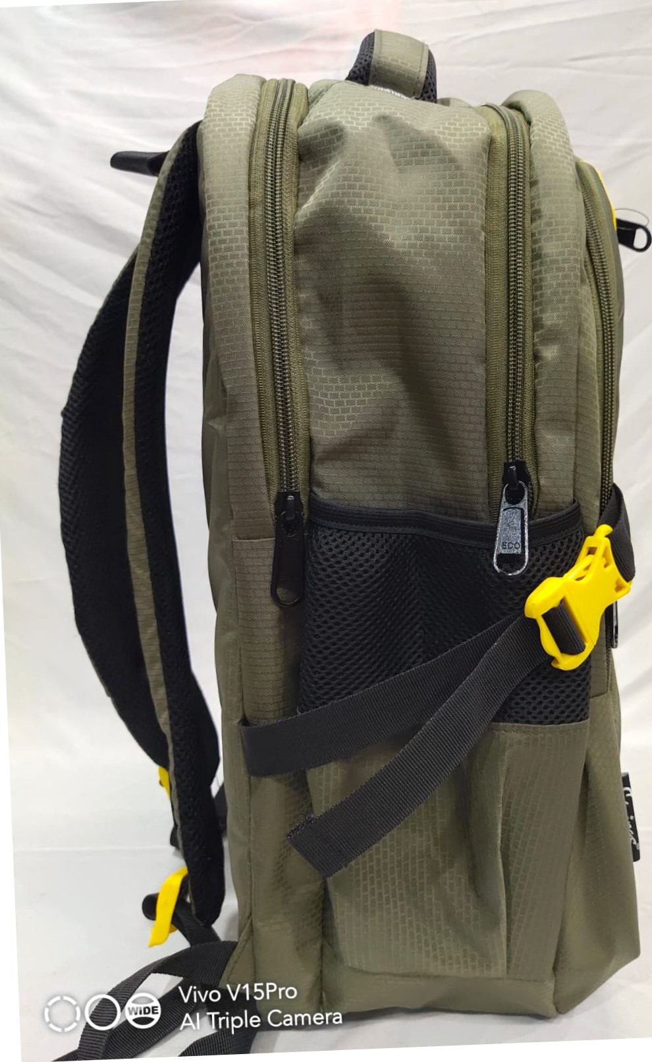

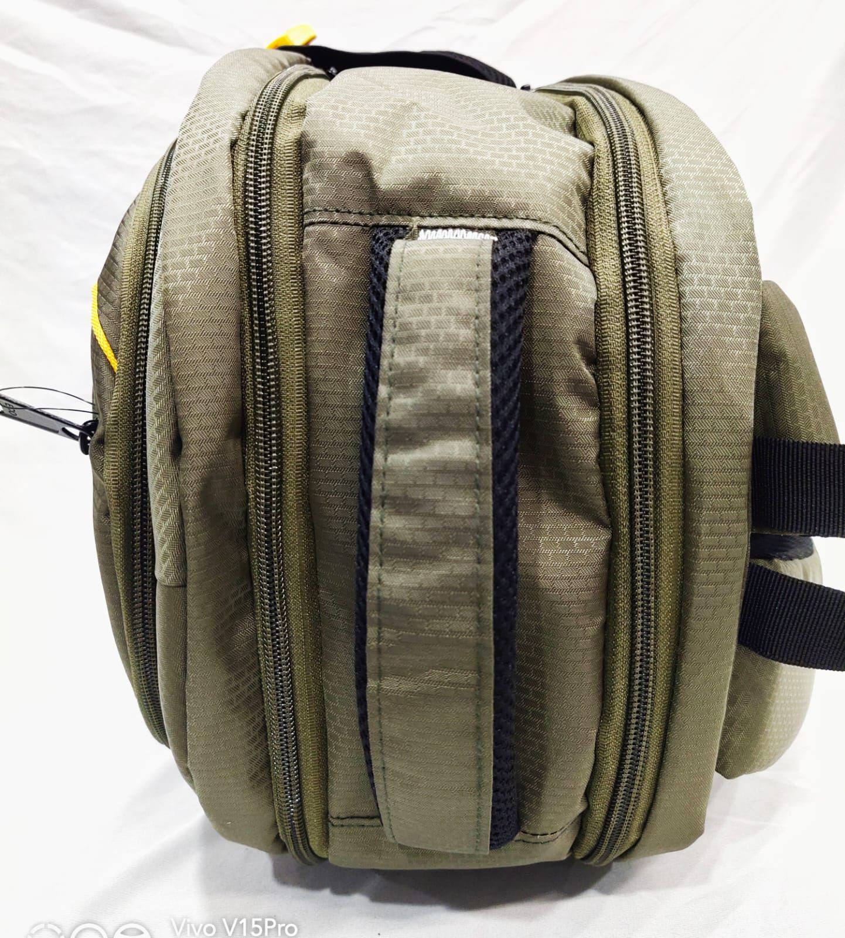



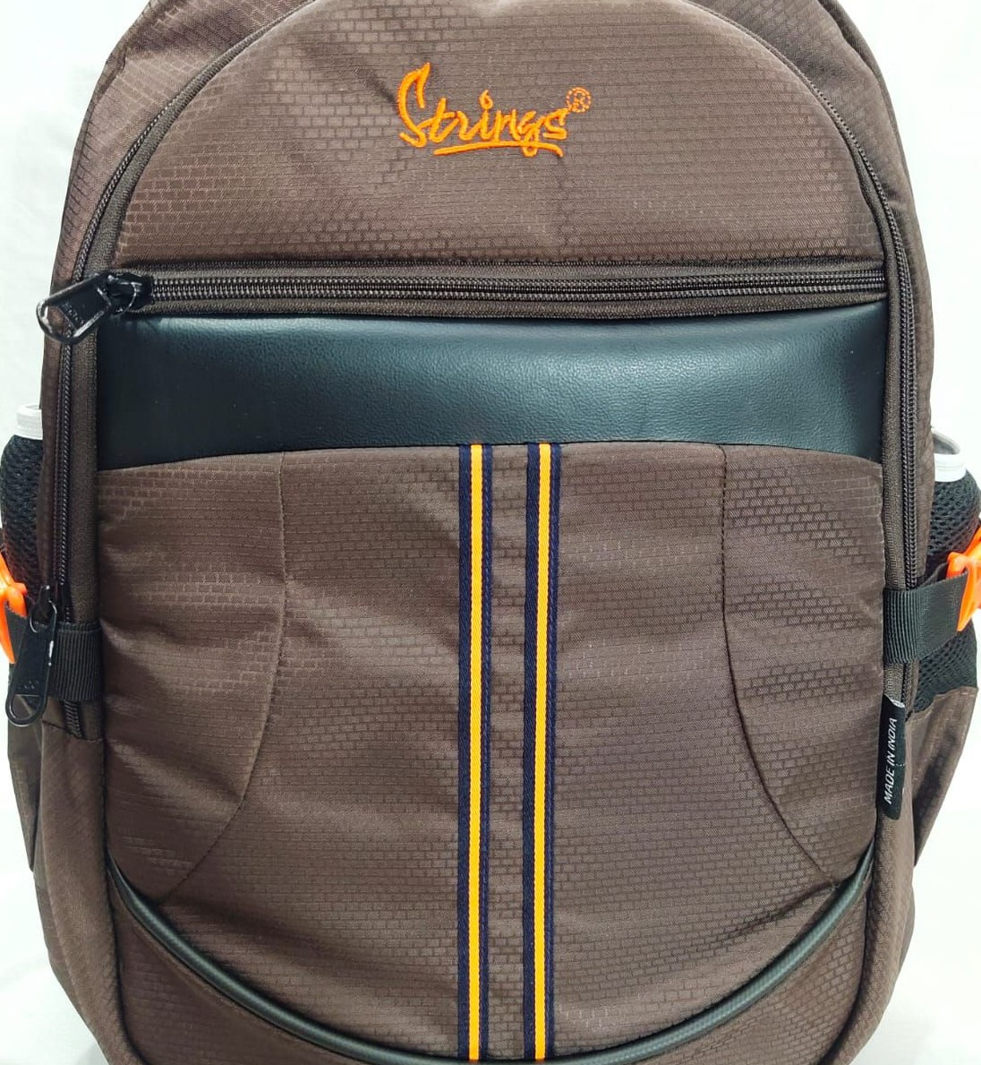



|  |
| --- |
| Vivo VI 5Pro |

WIDE

Vivo 5Pro

WIDE

###### WIDE

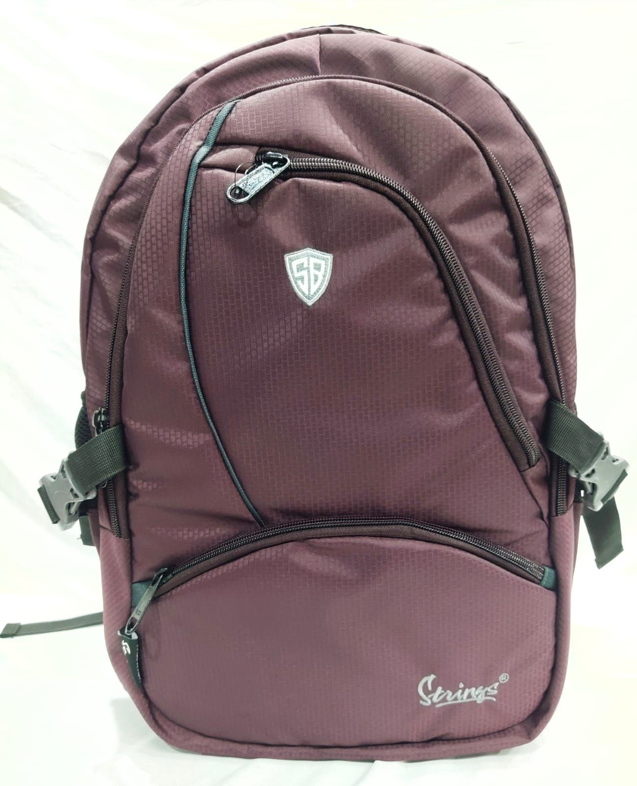

.. \Ιίνο V15Pro

WlDE

ViVov% 15Pro

n WIDE,

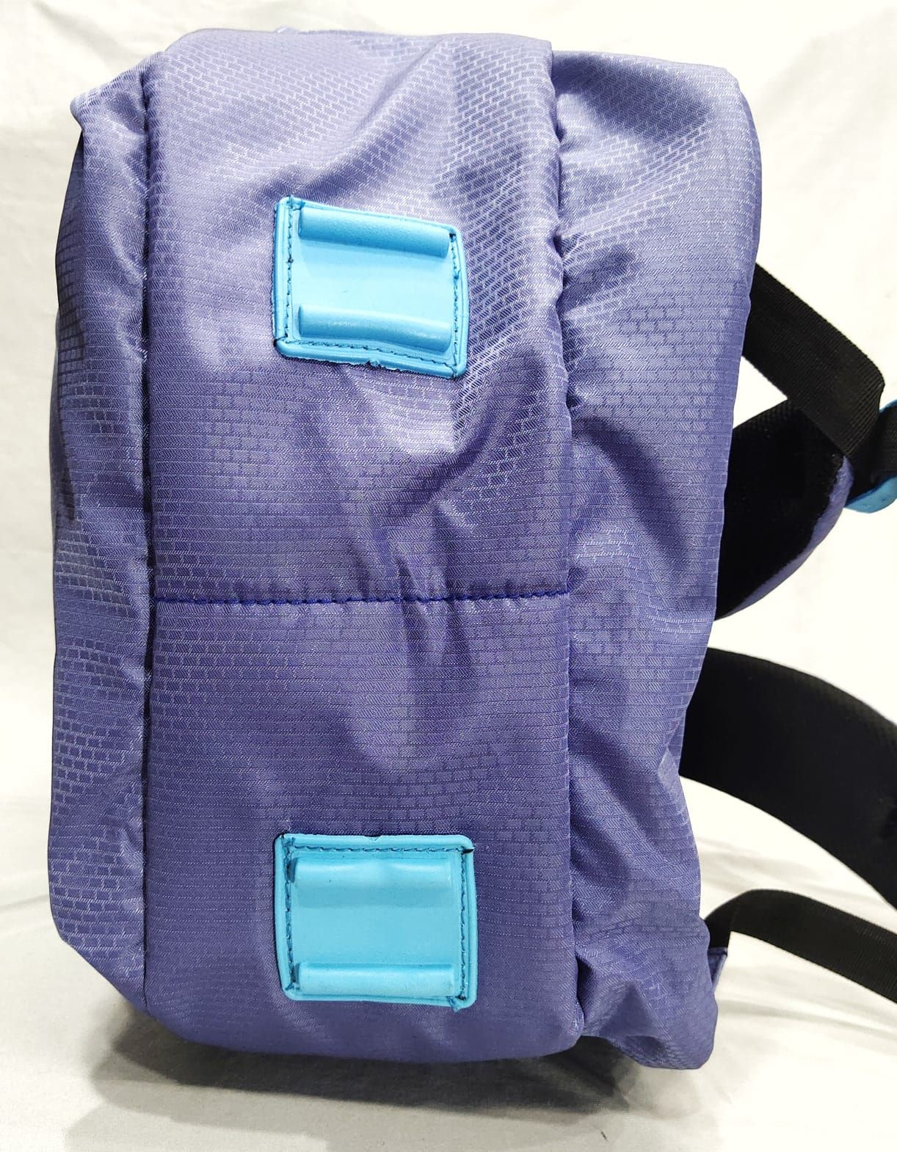

Vivo 15Pr0=

##### 45Pr

AI kTLip_èiCamera

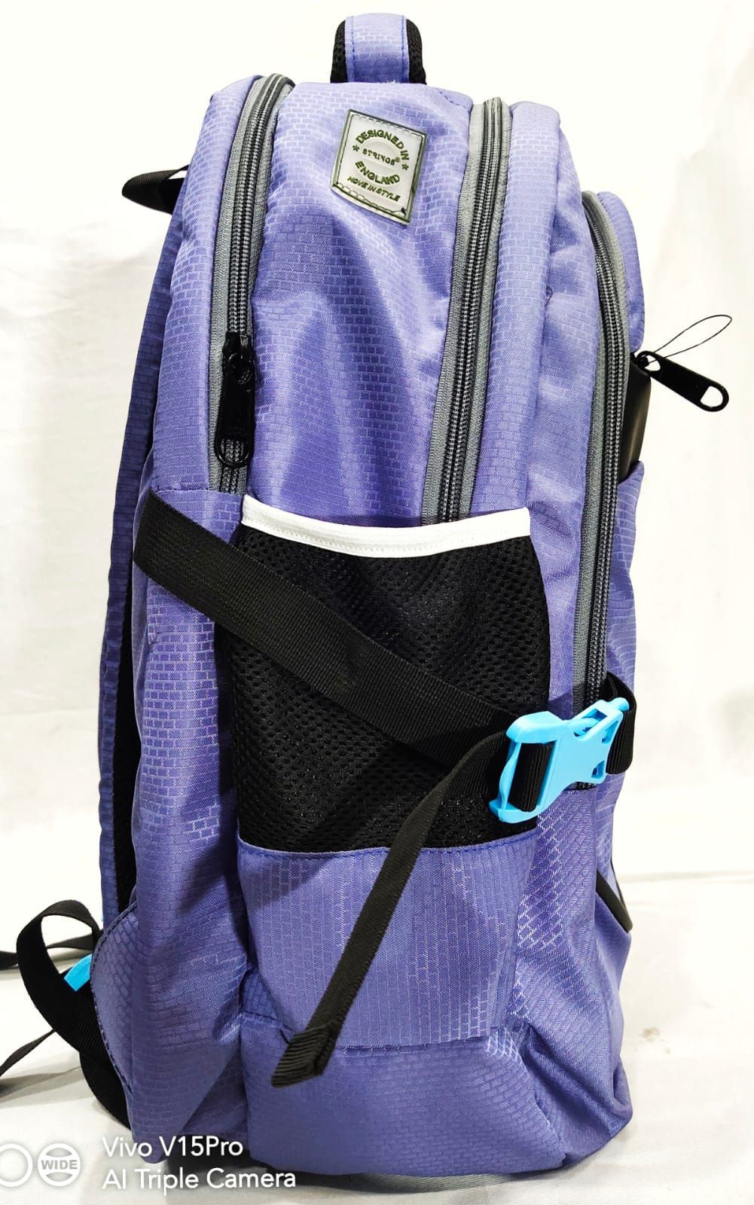

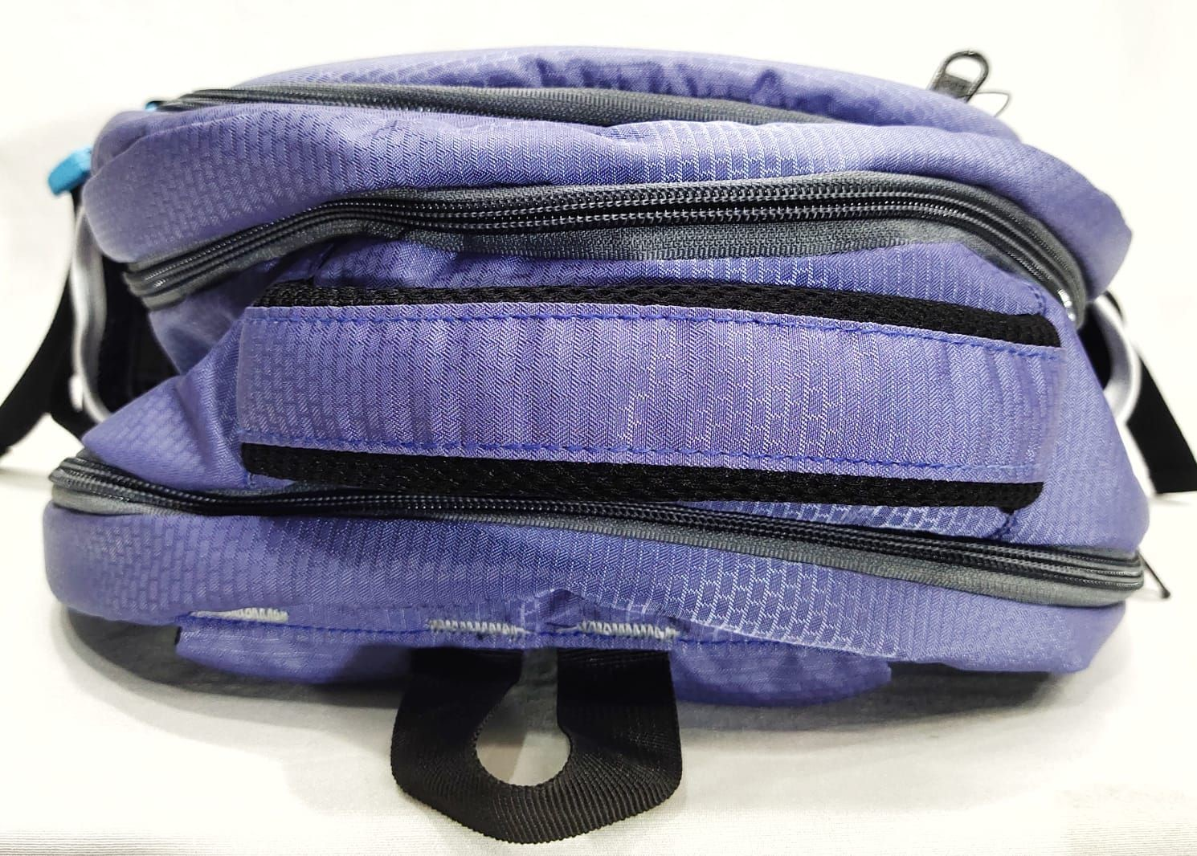

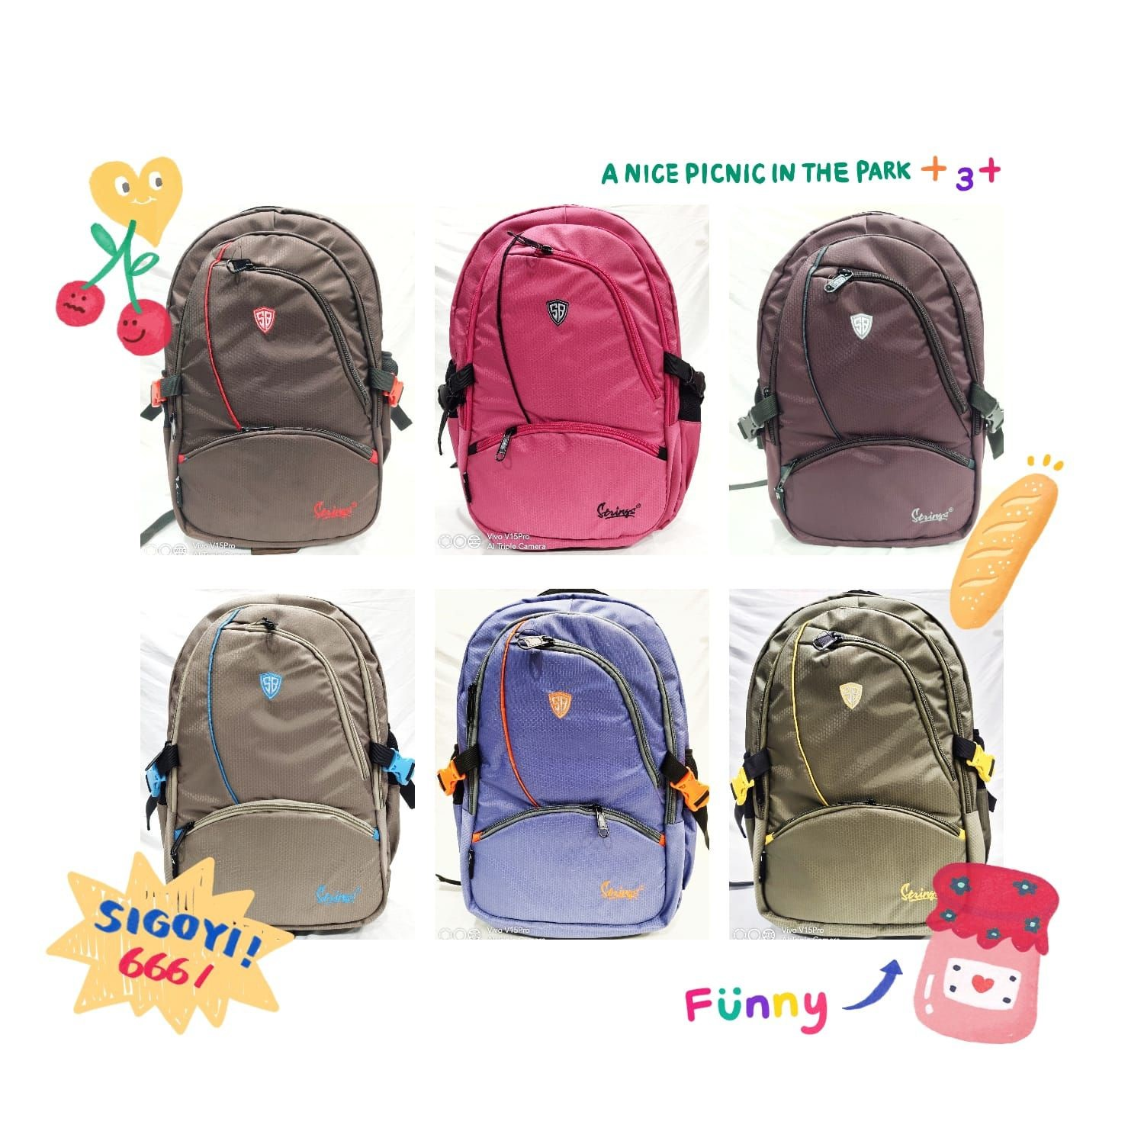

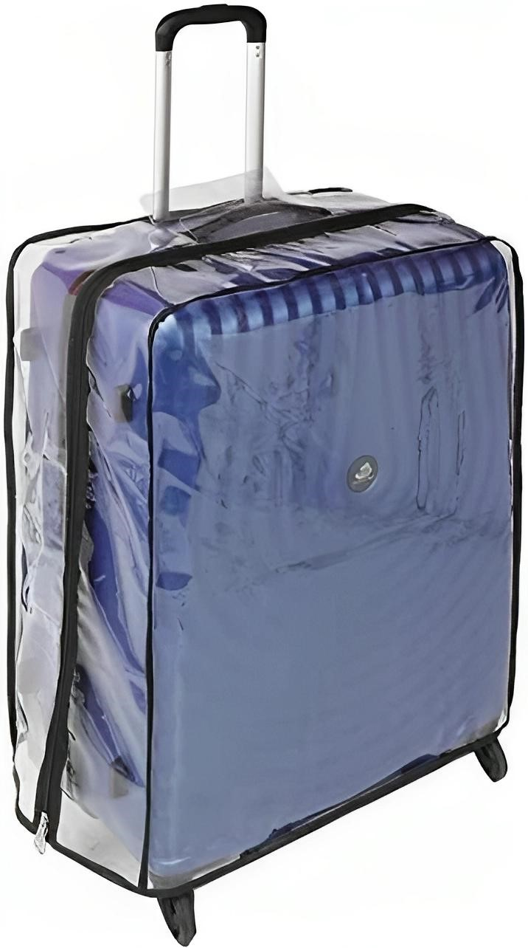

###### VENTEX

GERMANY

### TRAVEL IN STYLE

100% UNBREAKABLE PP LUGGAGE

2 YEARS WORVD WIDE WARRANTY

GARANTIE VIE

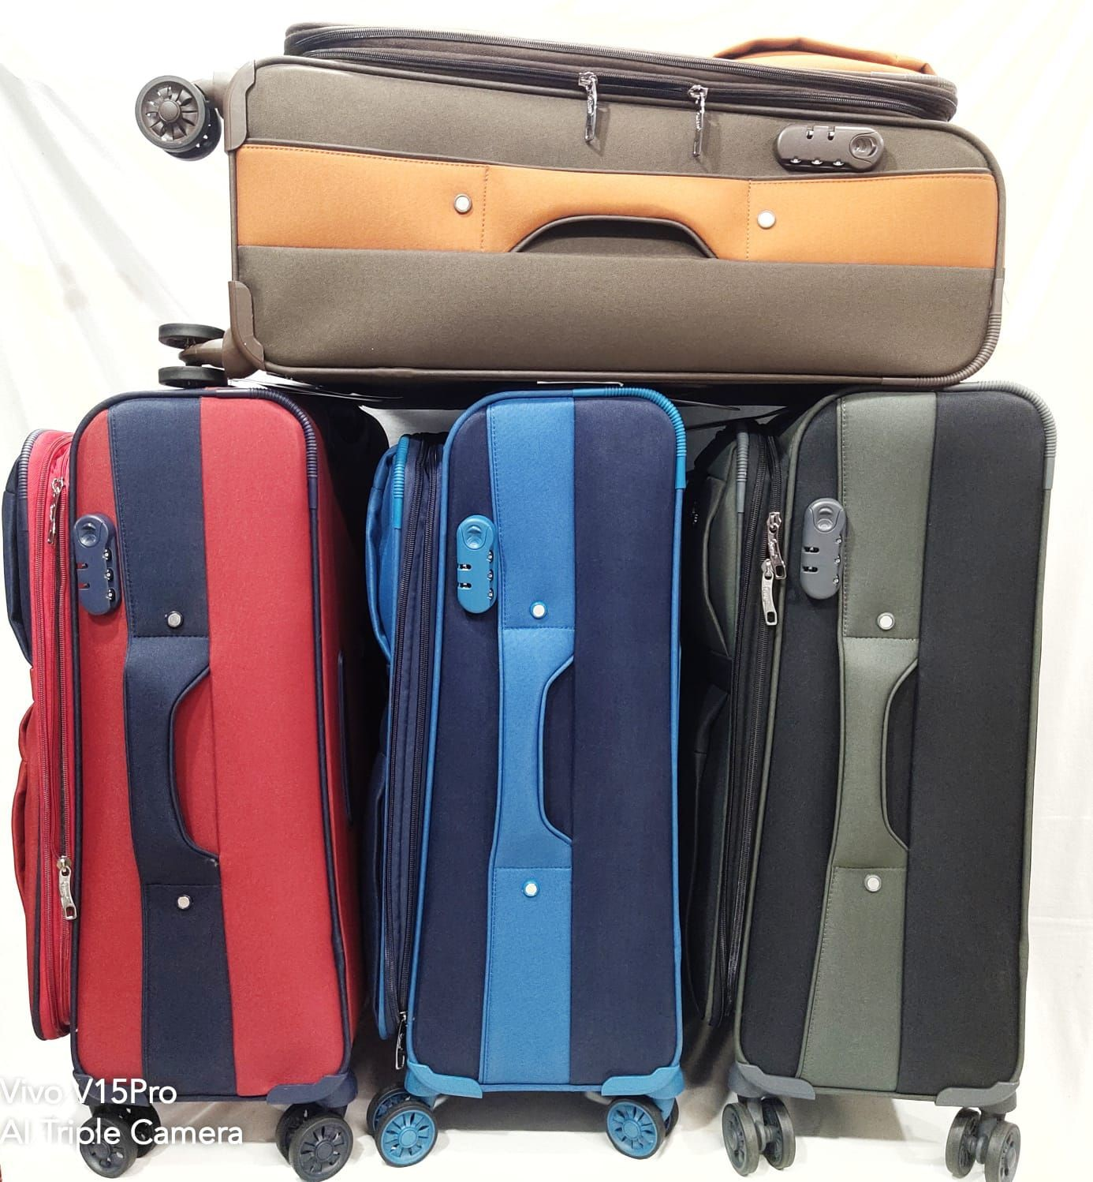

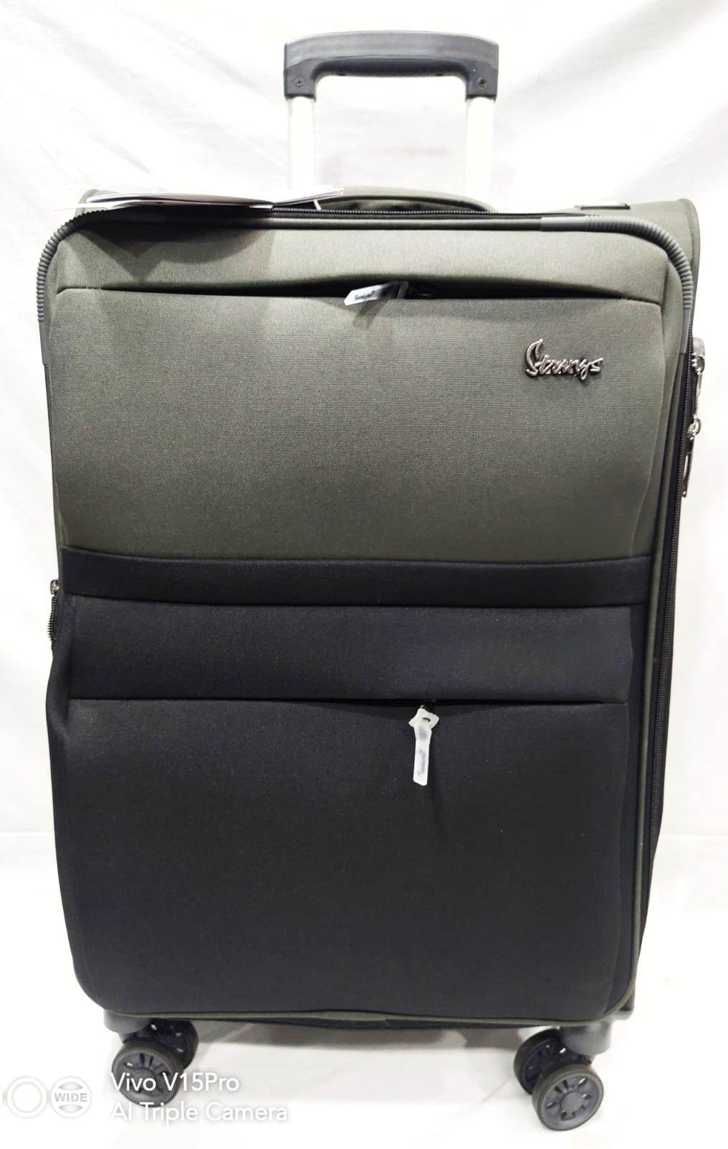

」

o山コ

#### H3NNldS

uピ

山コ9《エコ0

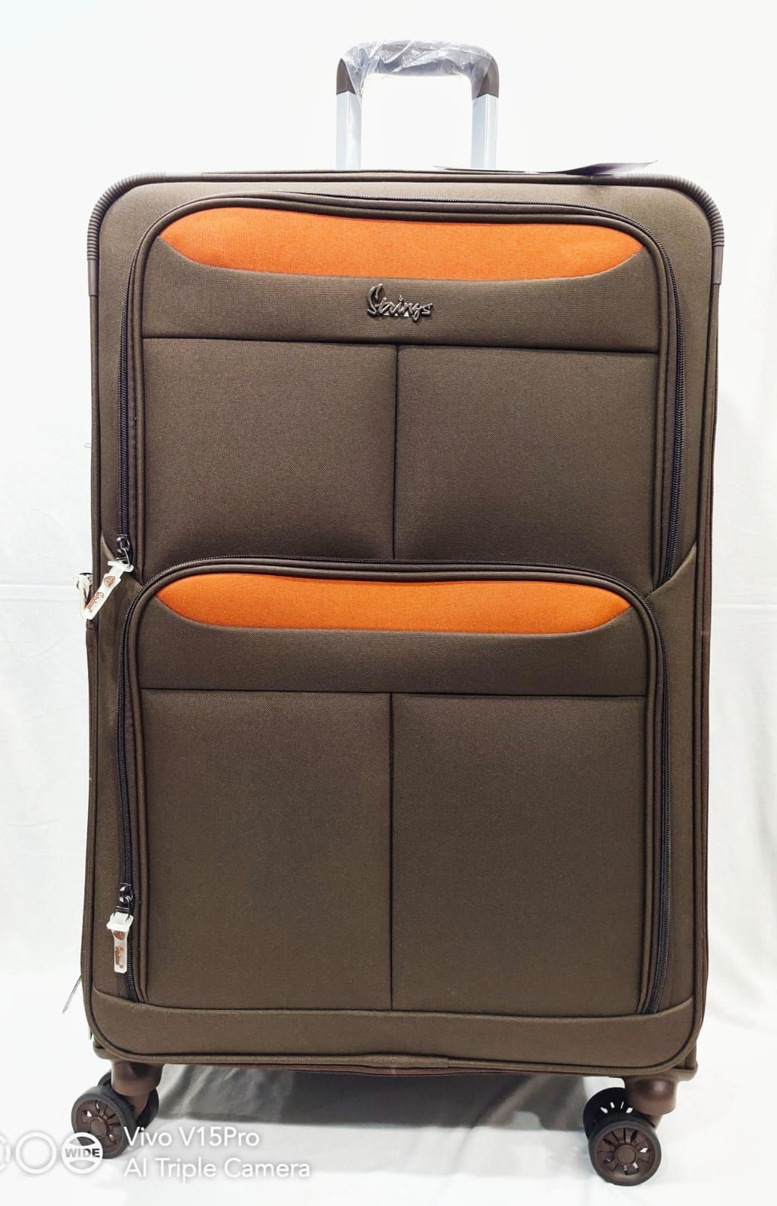

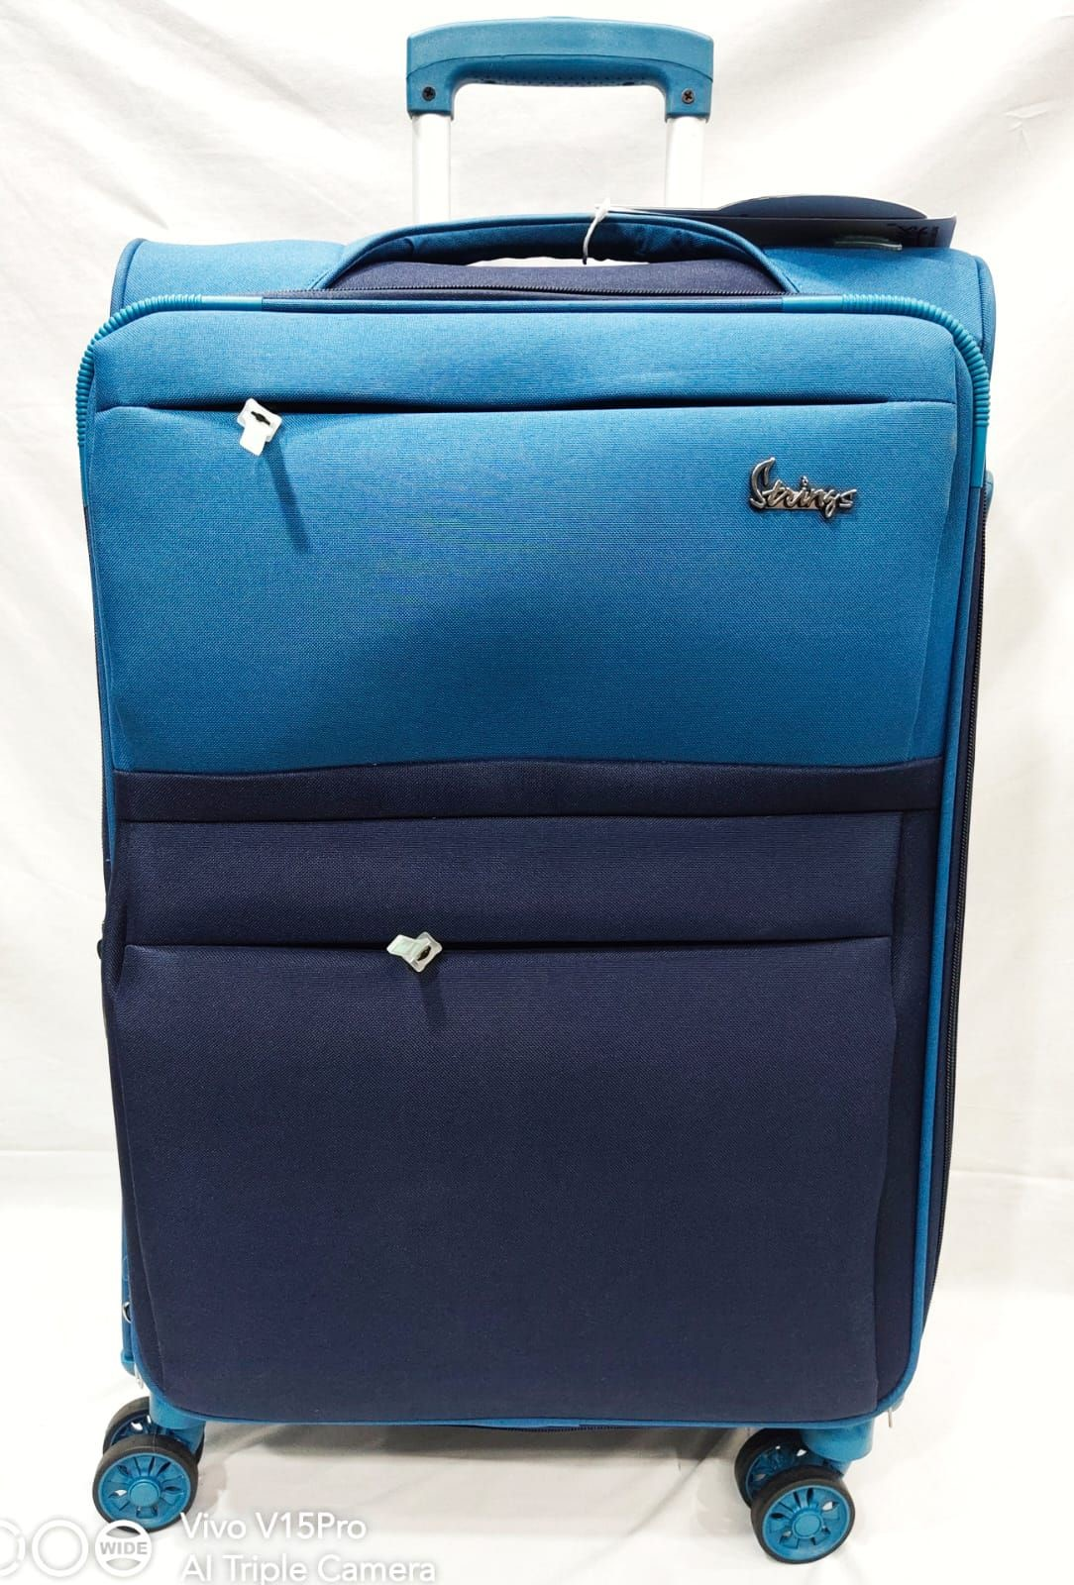

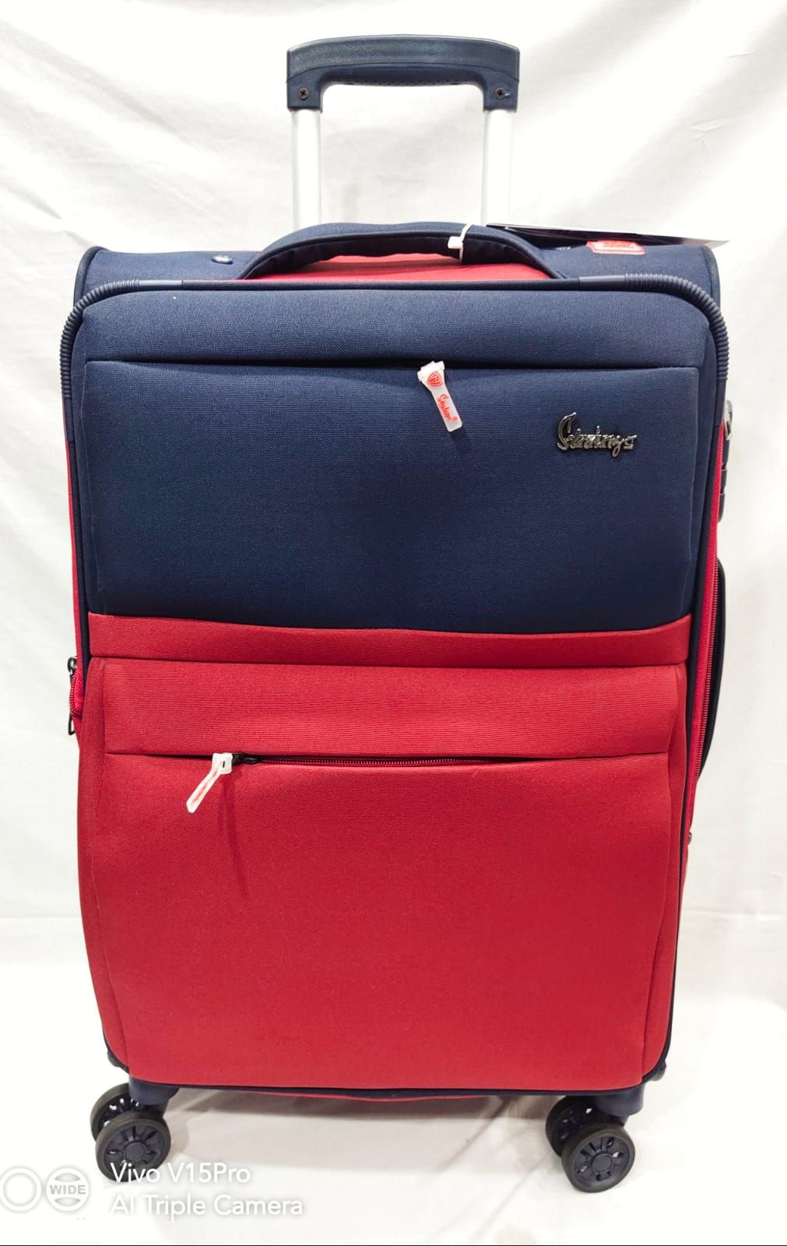

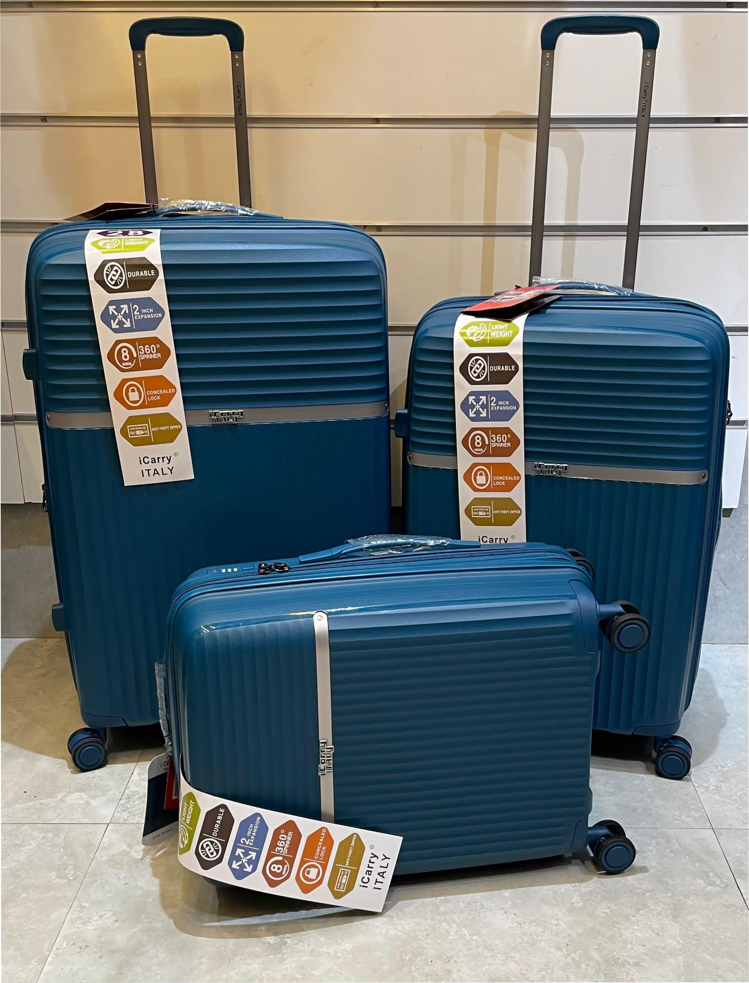

IVO V pro

SWIDE]

.Camera,

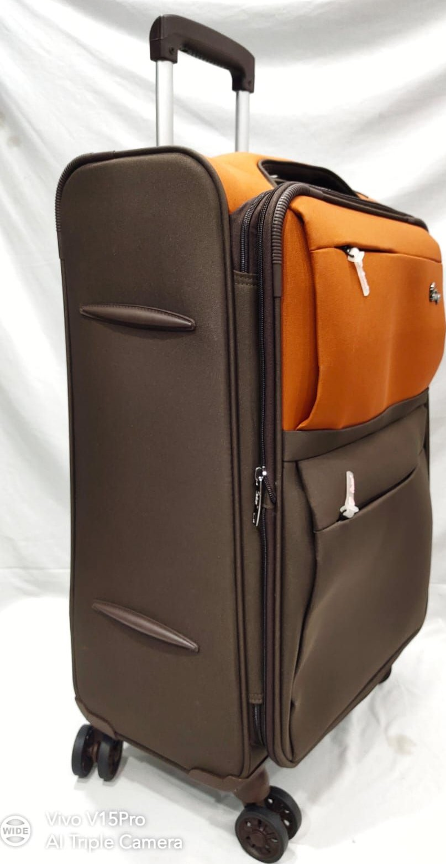

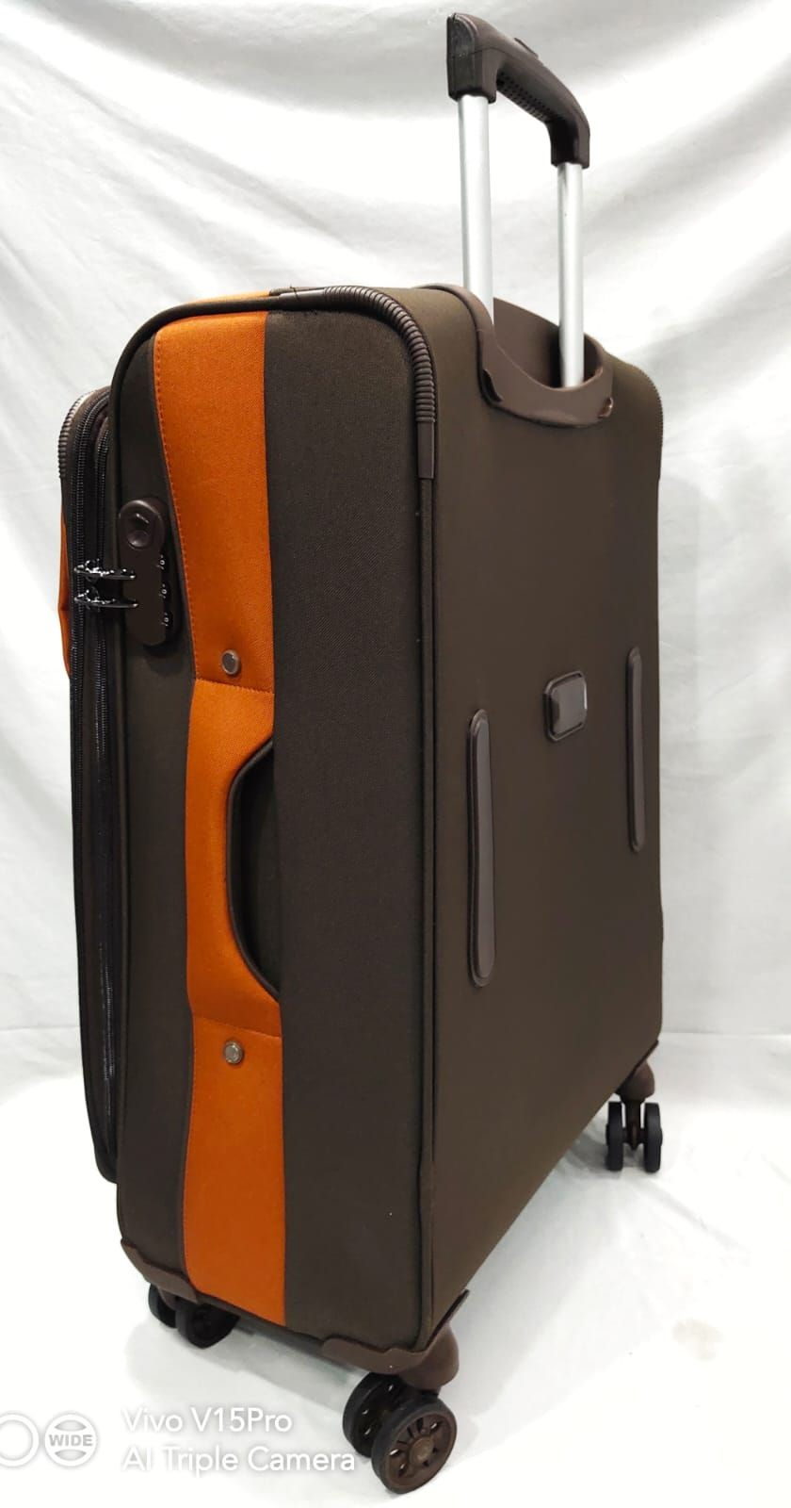

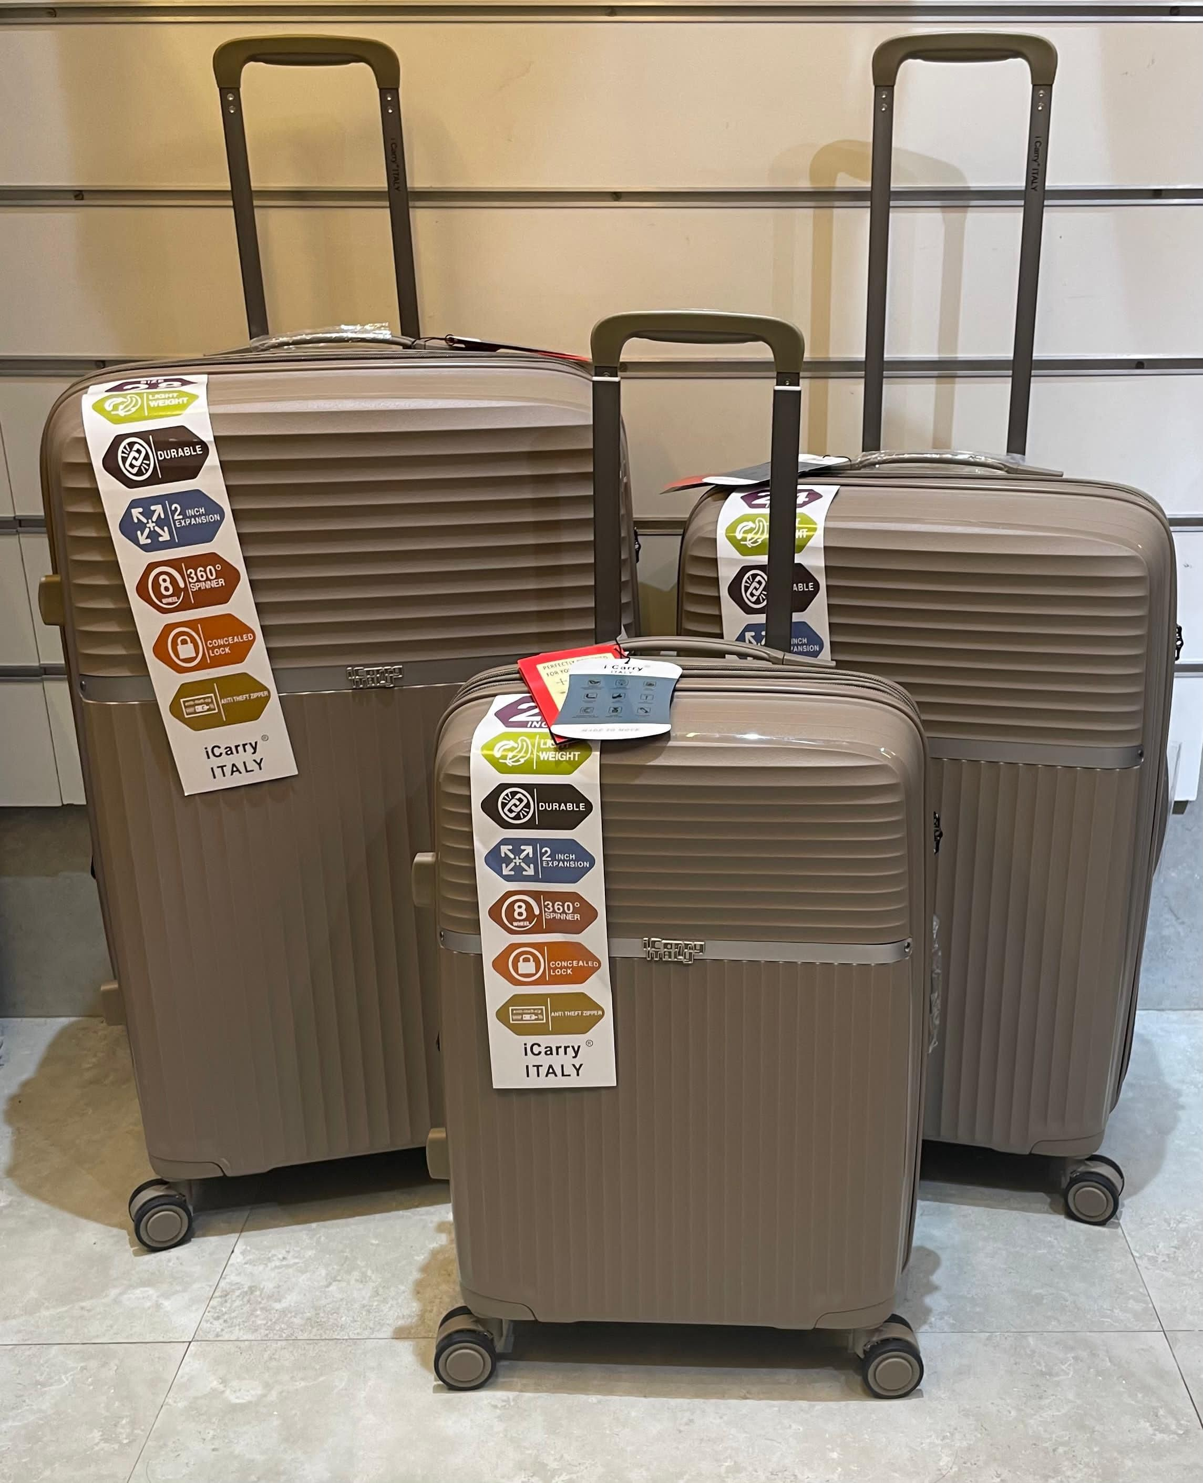

ご「「: ′歳い-いリ.い,リエリ.いロ、い、、、0、、いいをリ

・: .リノいツすい卩.い画い、.いすーい: :.お

ーを吶

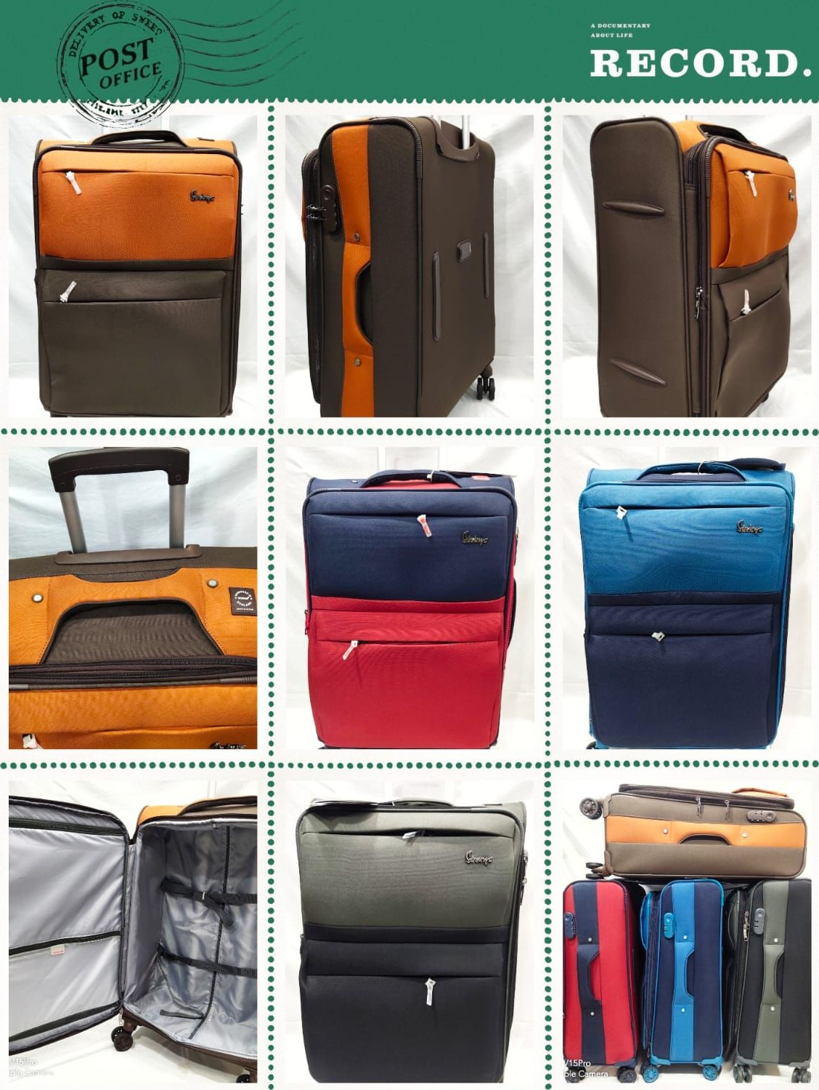

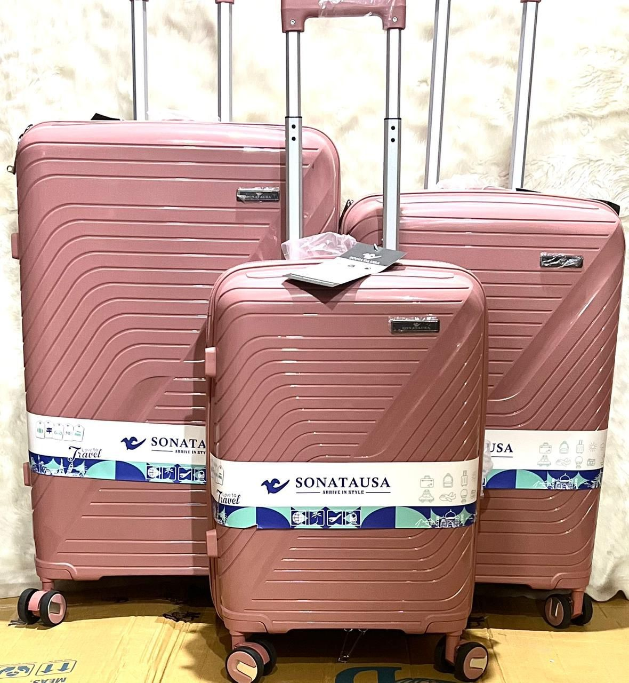

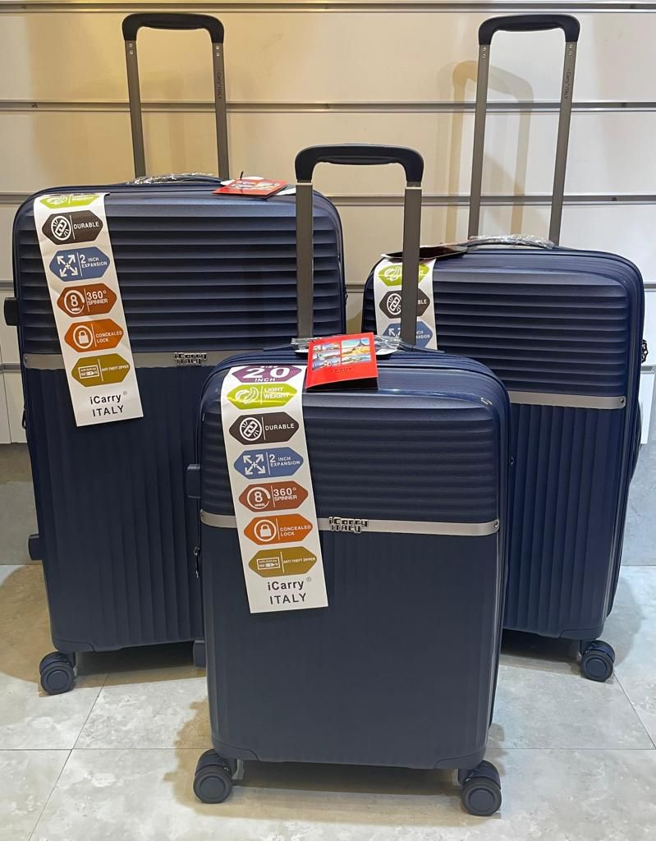

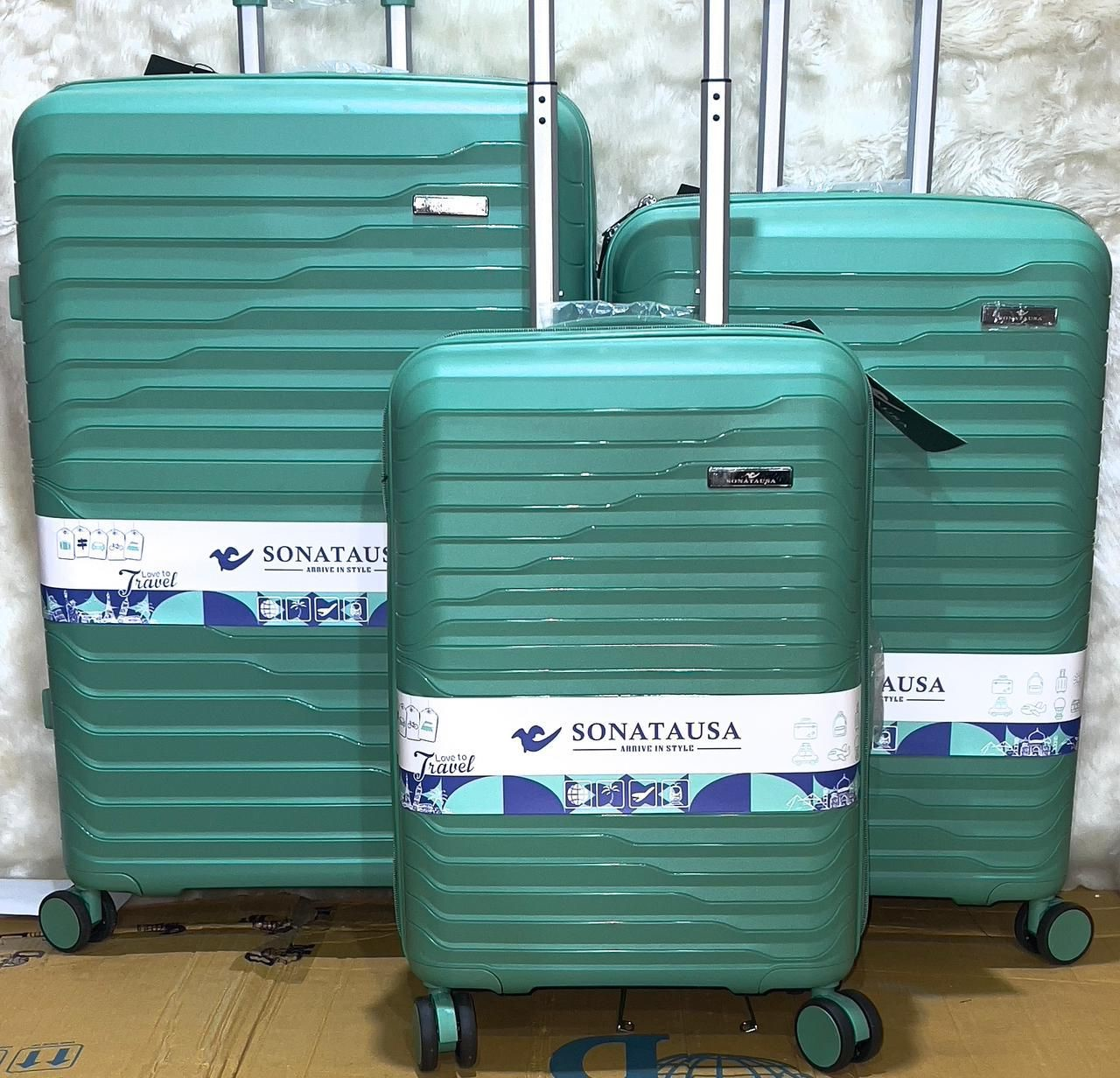

,卜A-T

##### -KUSA

, • SONAL&AUSA

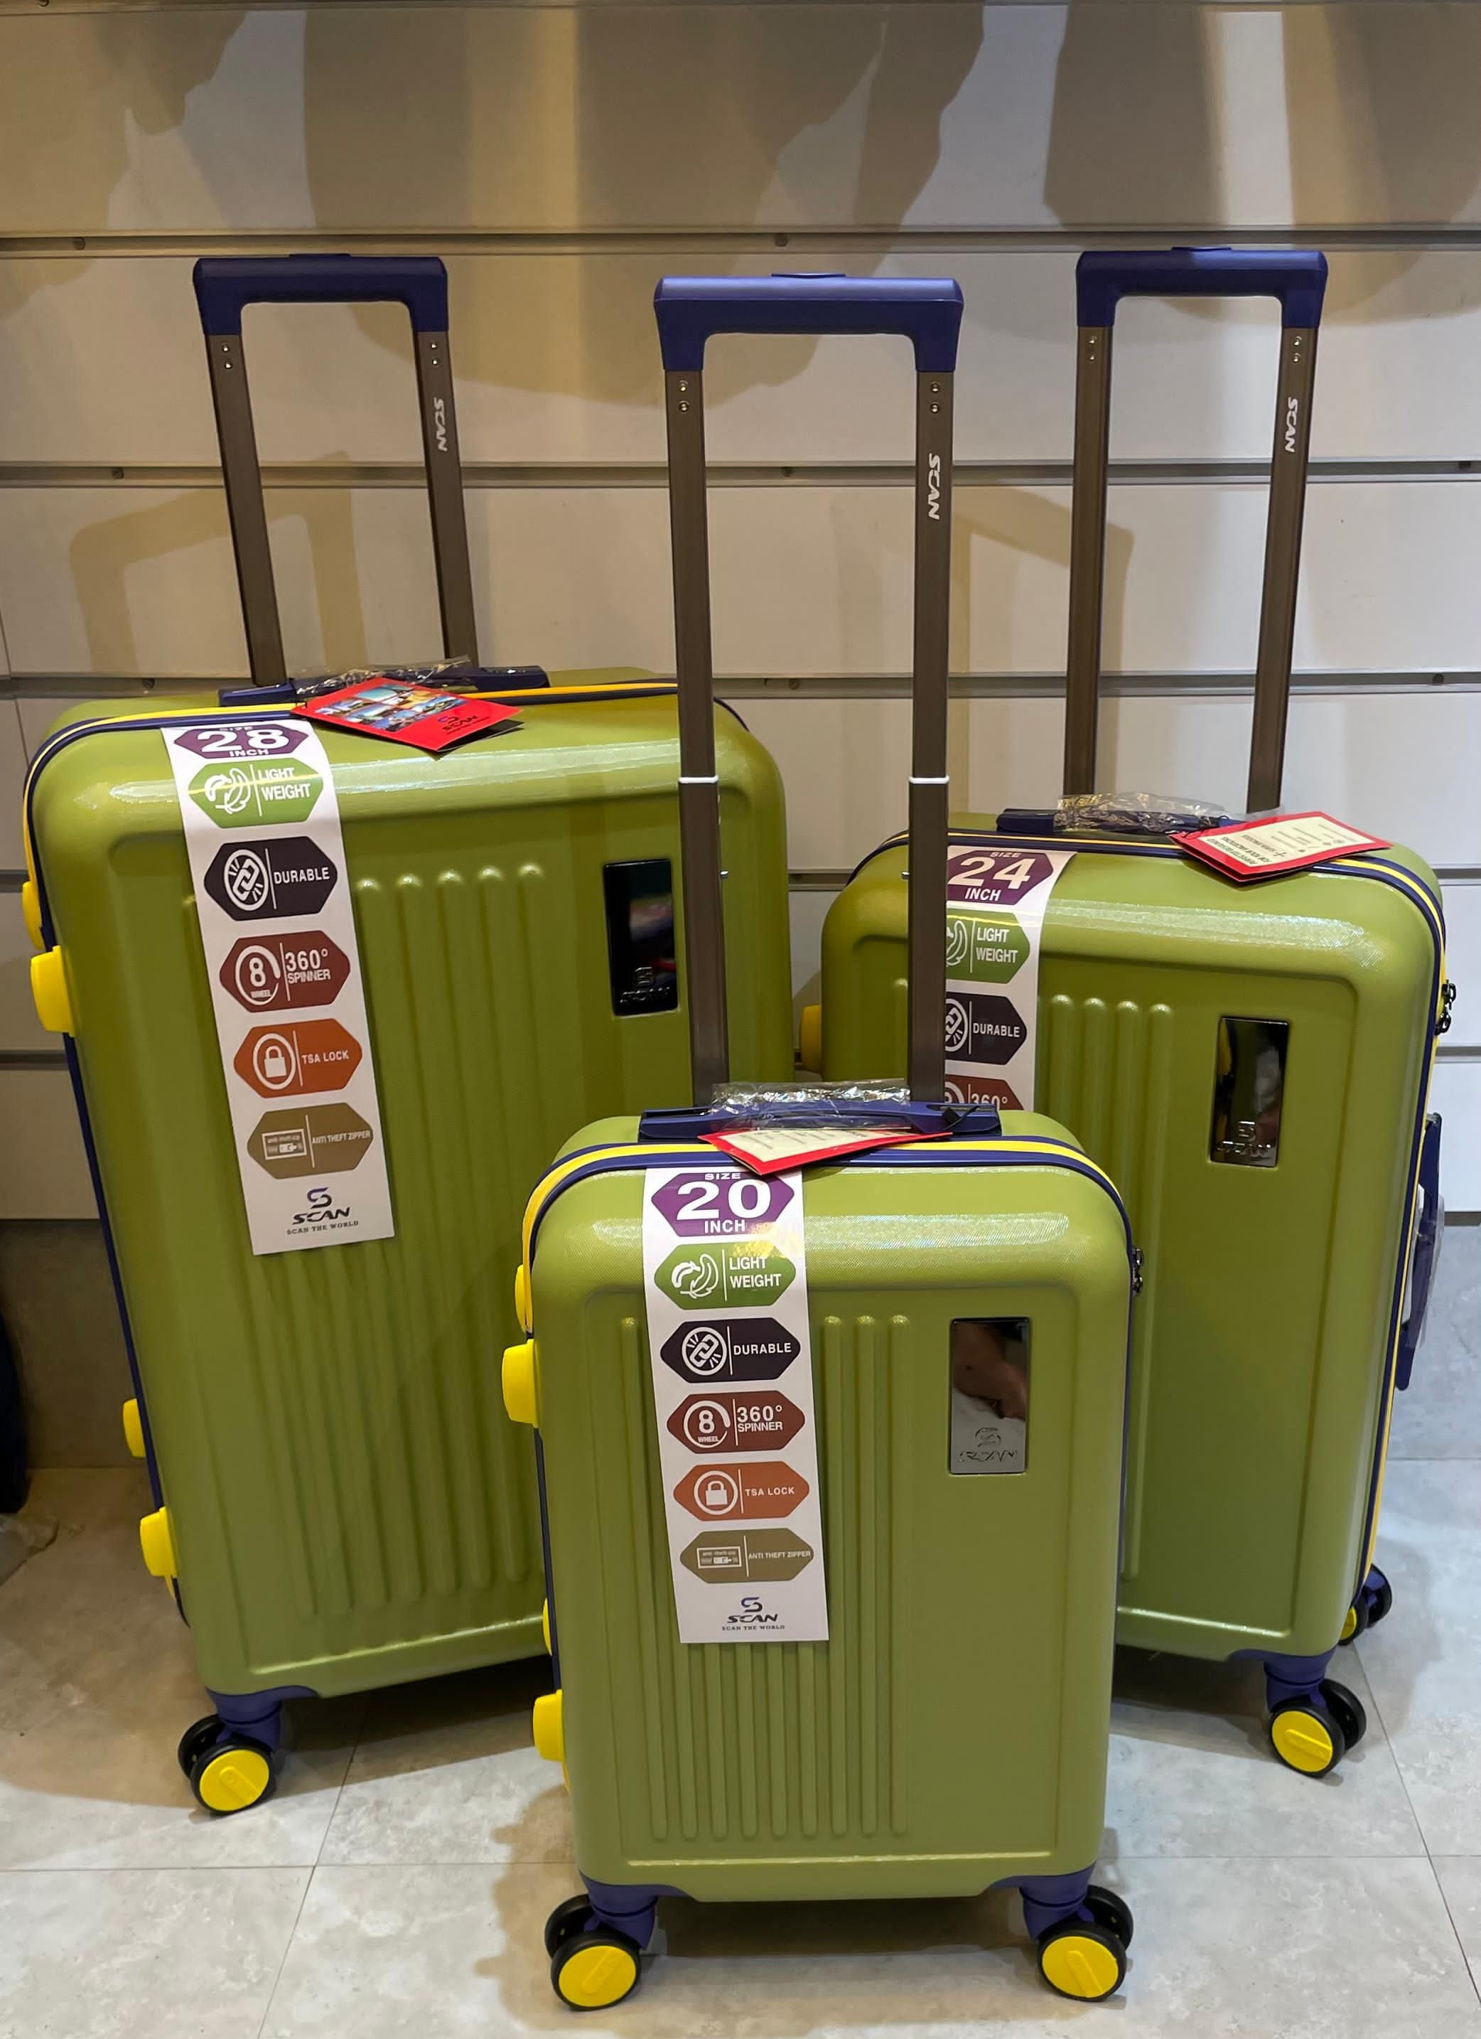

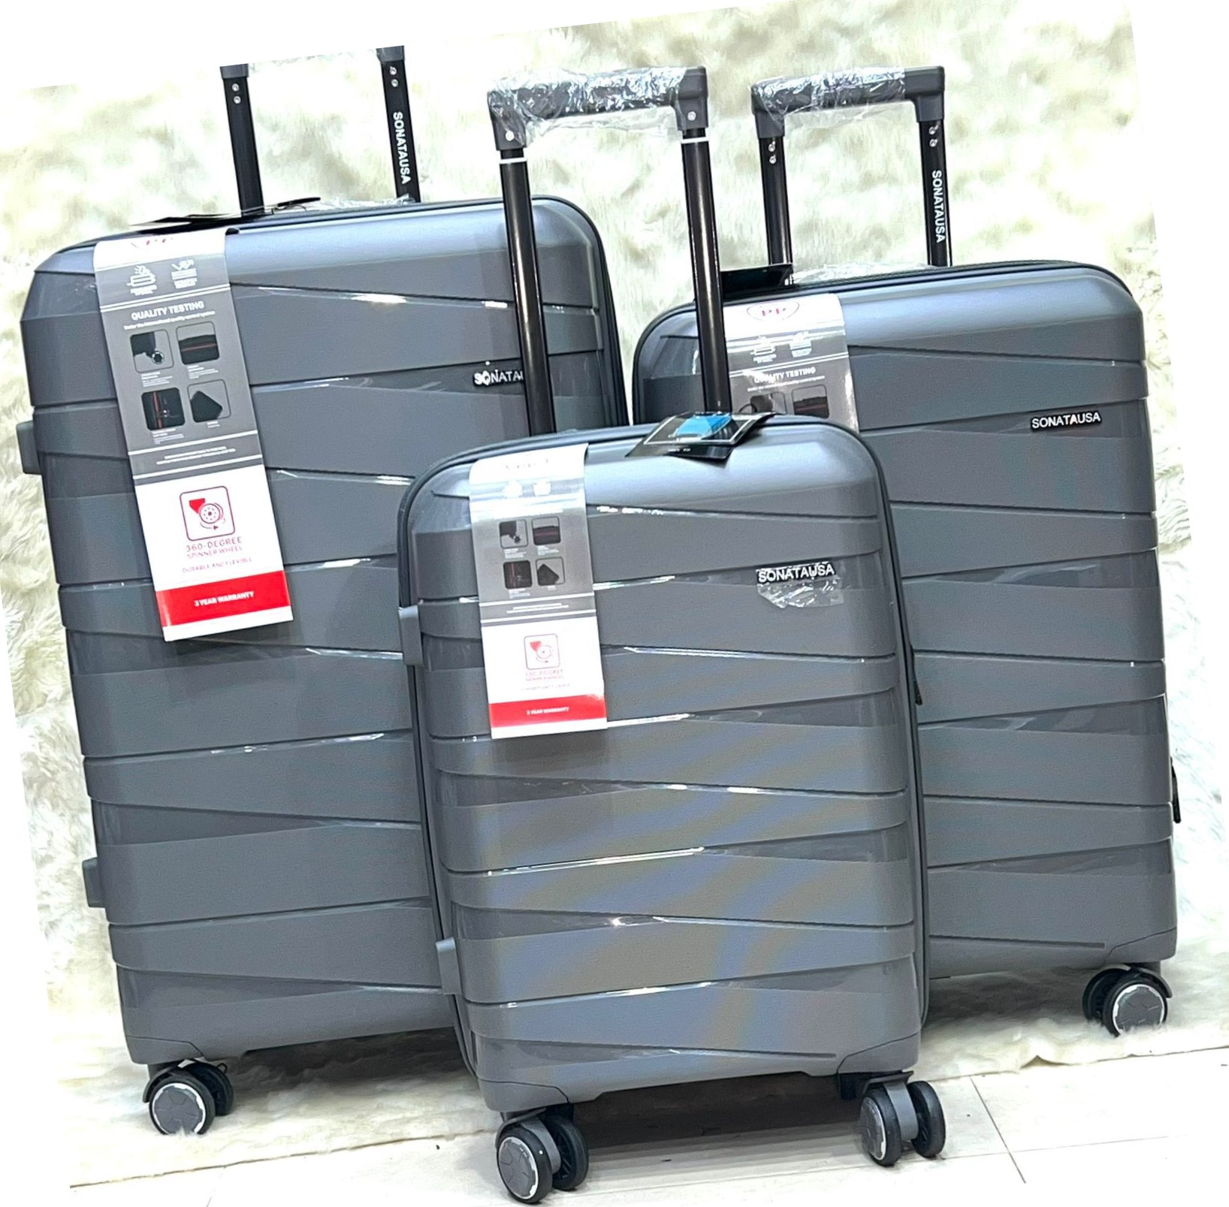

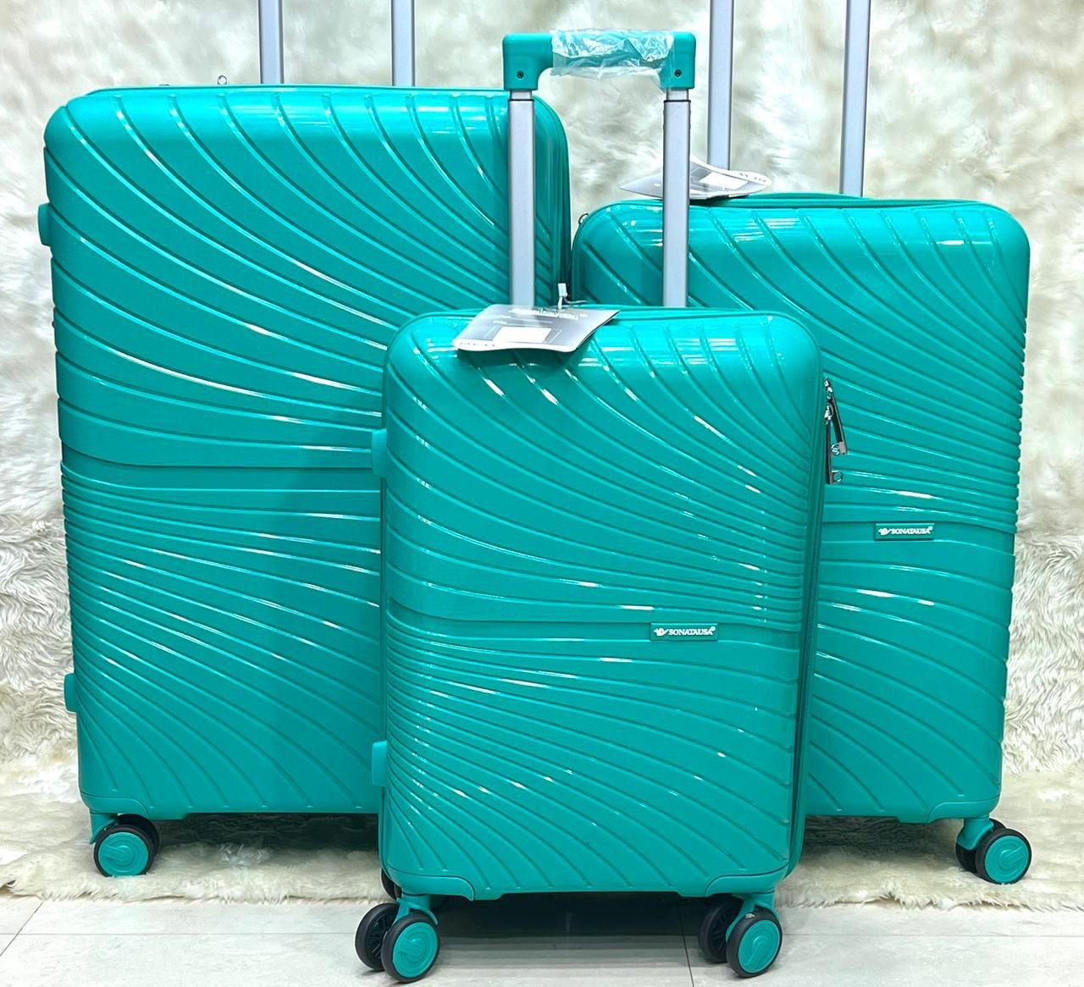

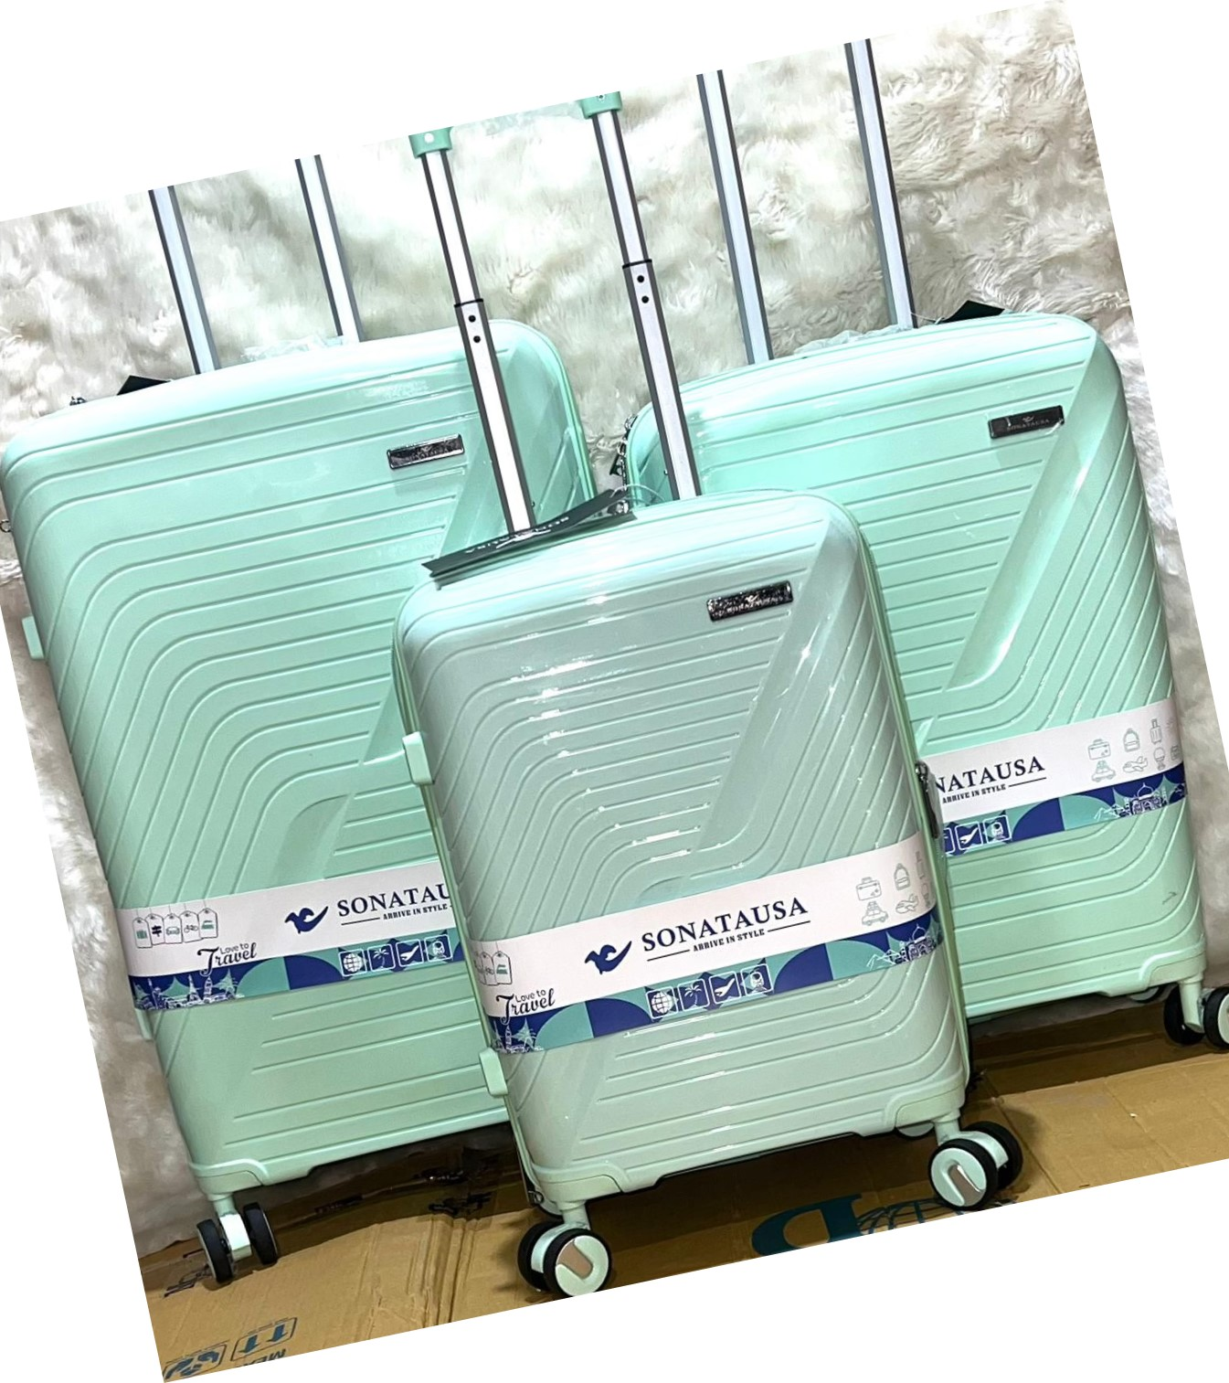

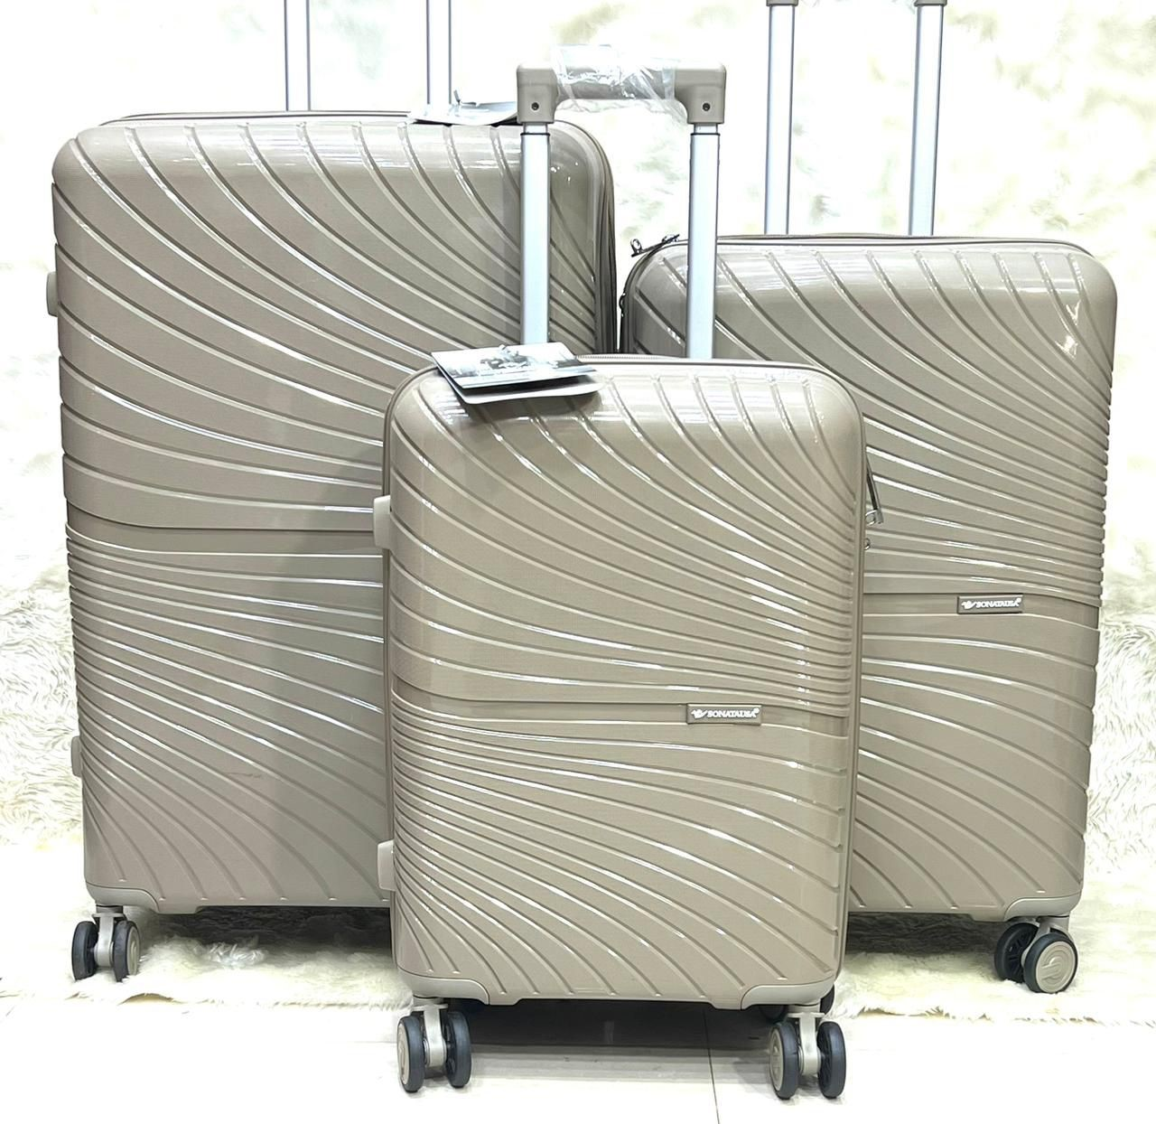

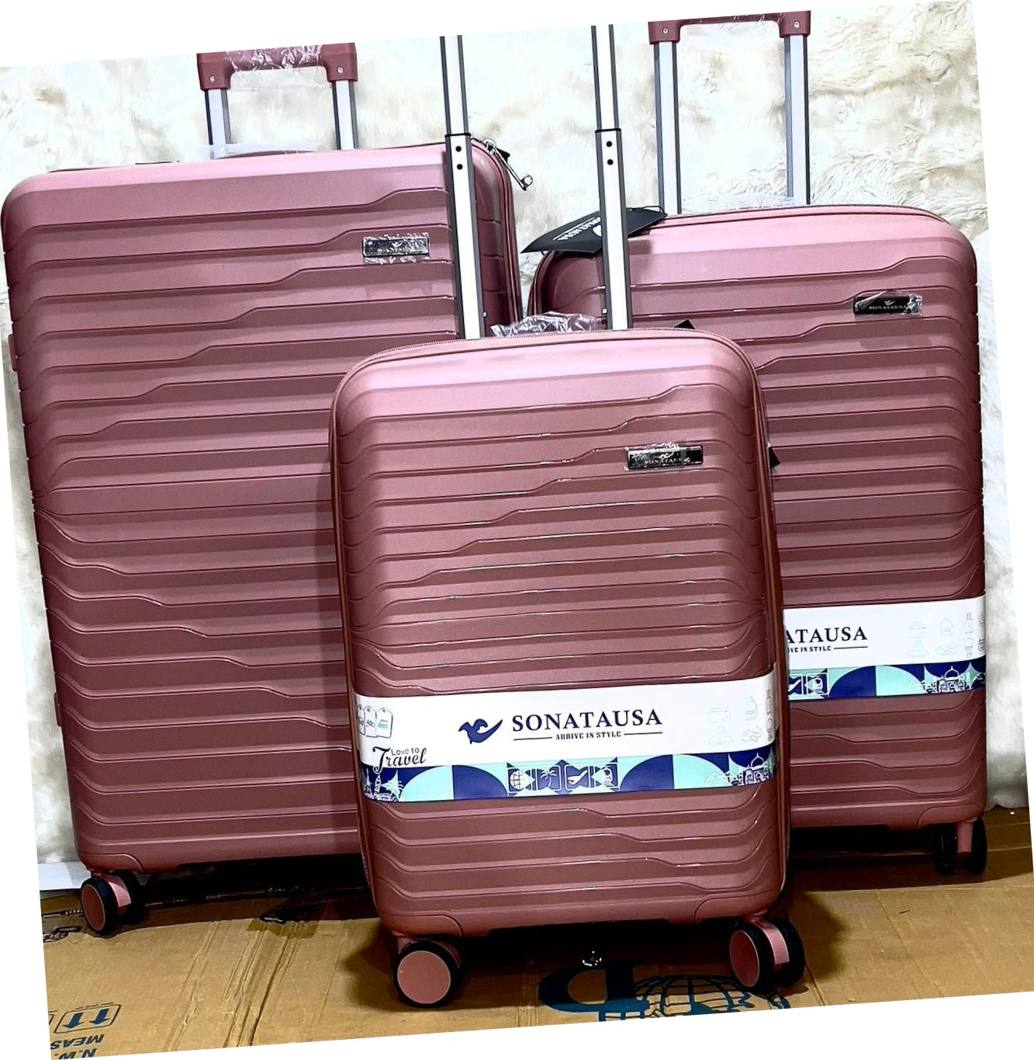

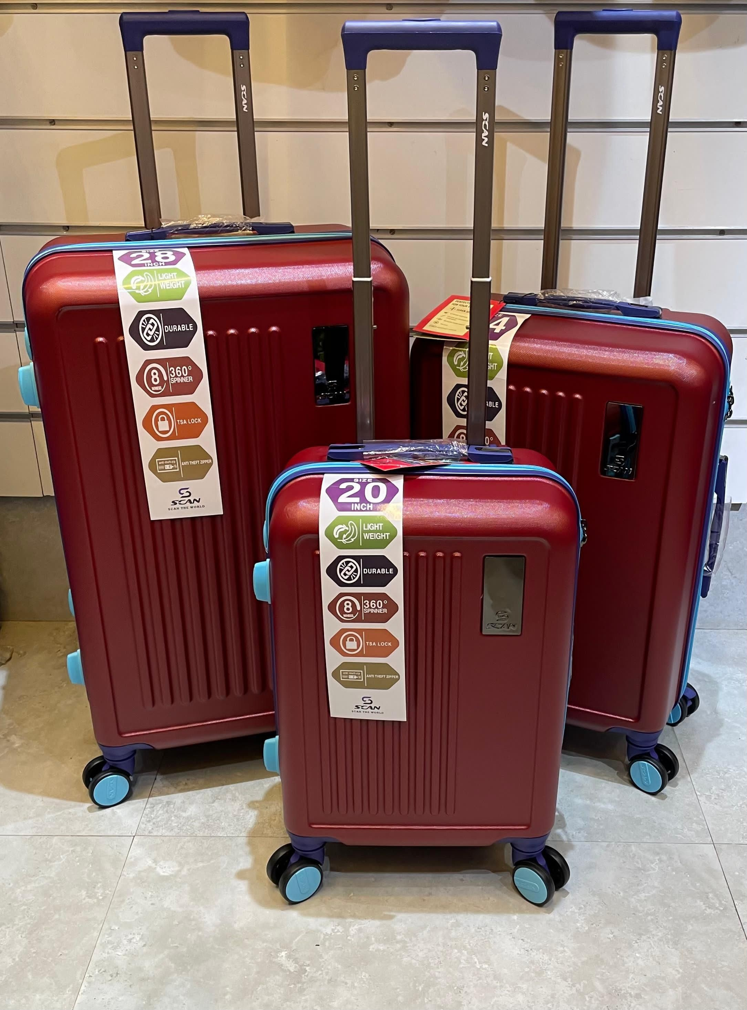

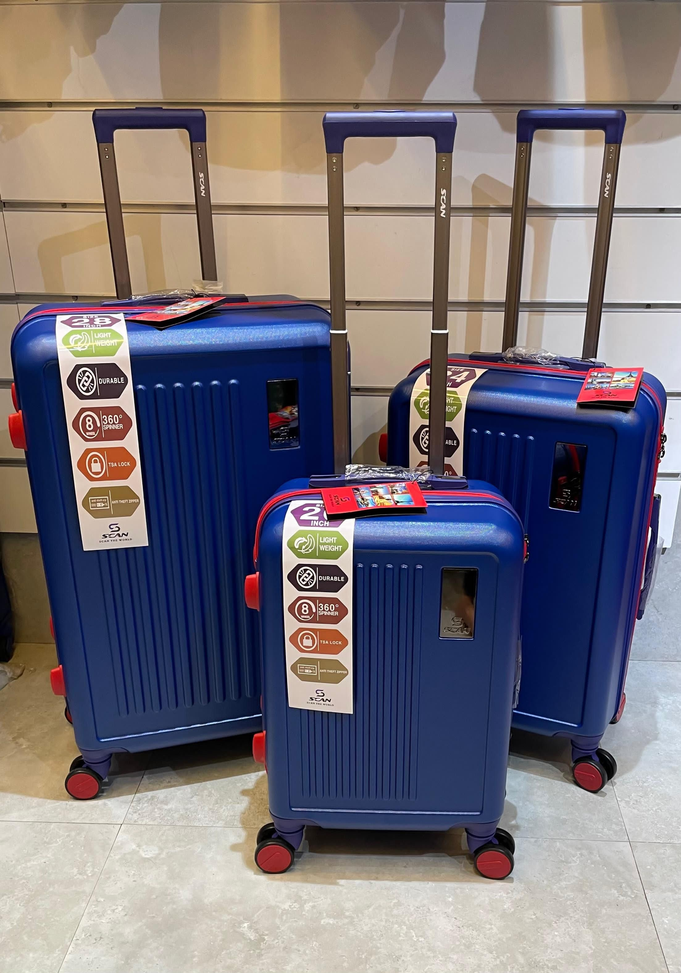

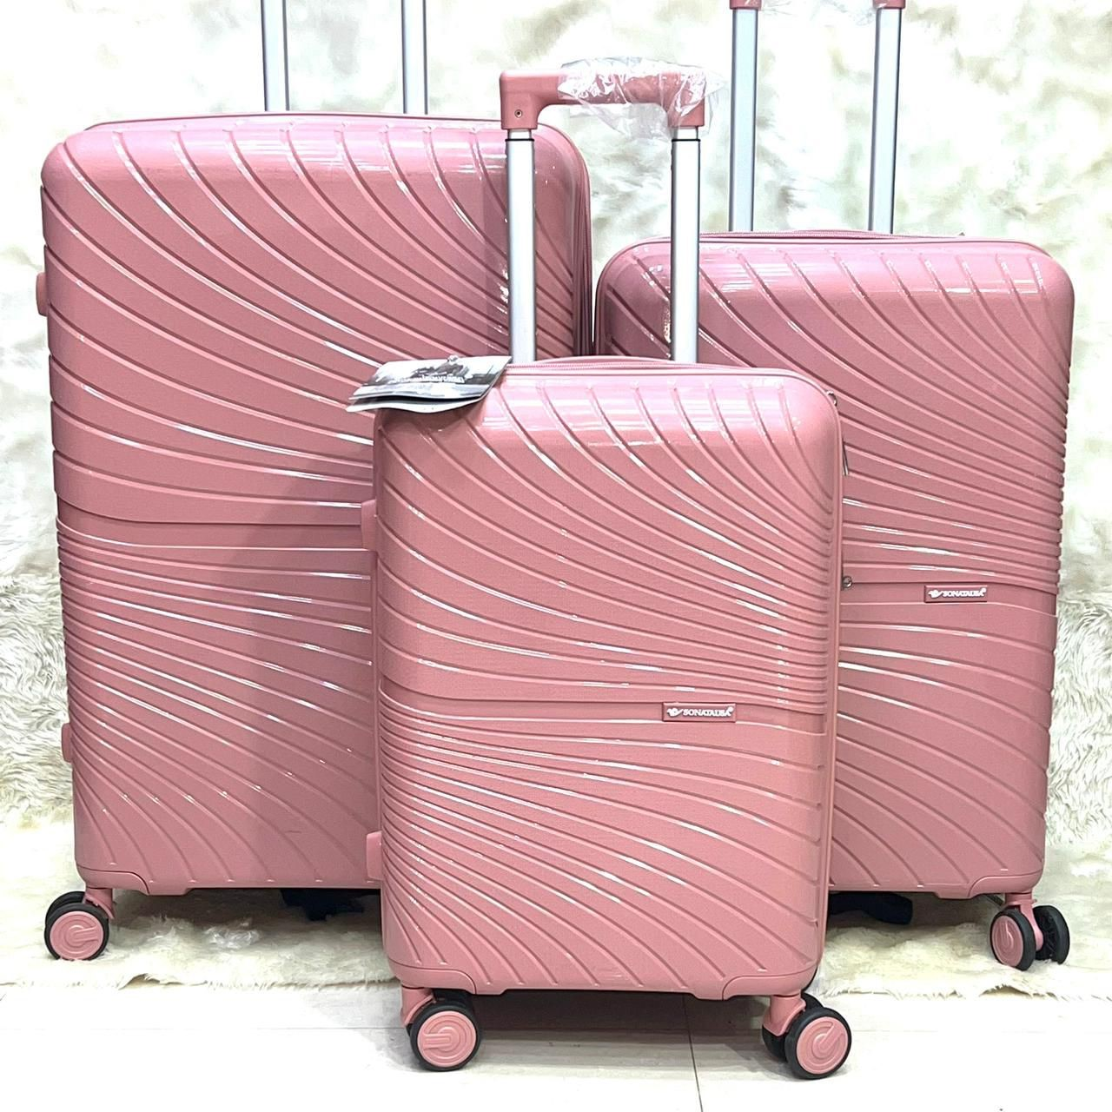

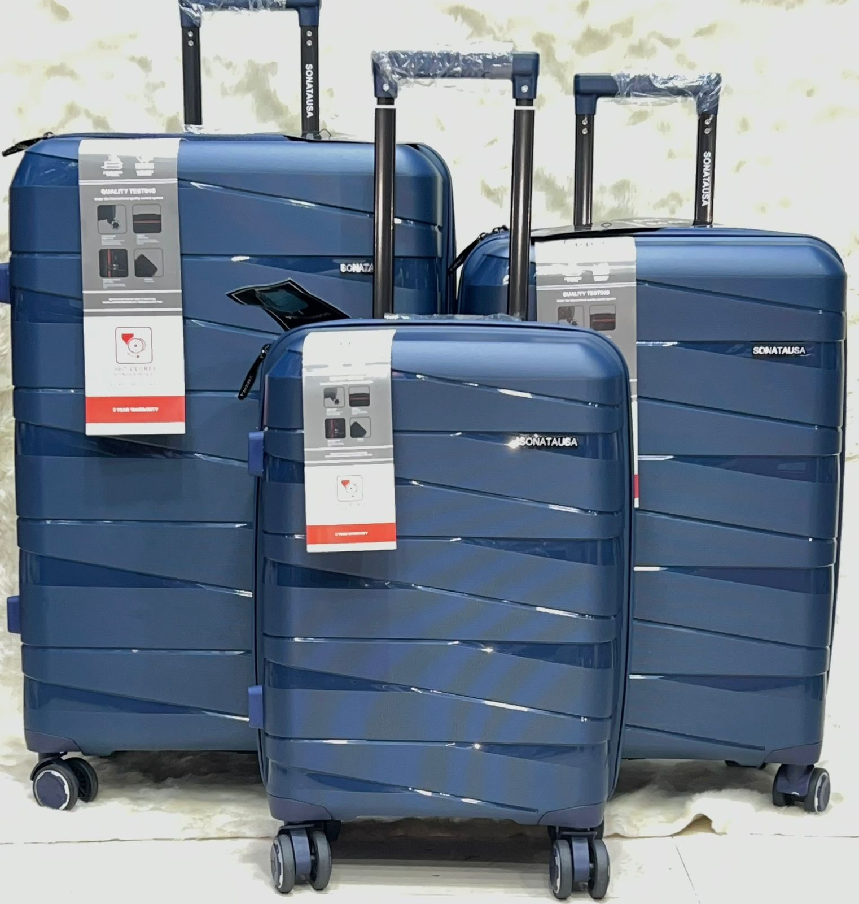

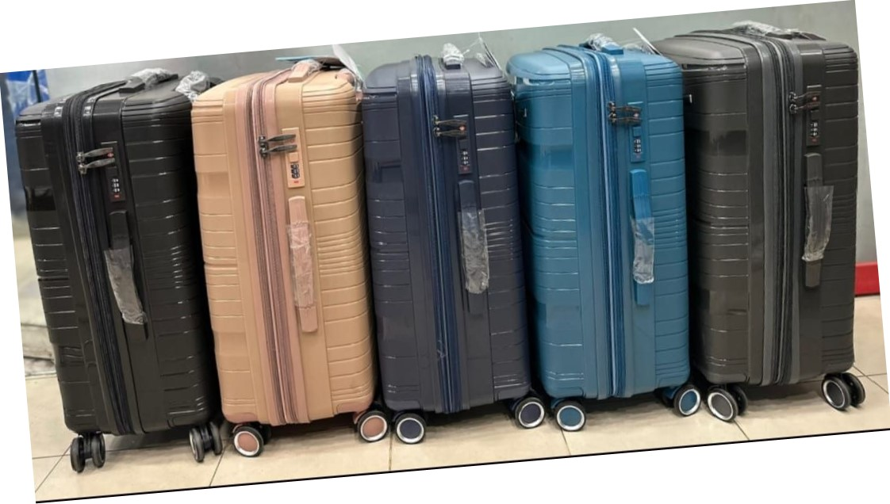

'NCH

3600 WEIGHT

DURABLE

TSA LOCK

SCAN•rue WORLD

vs

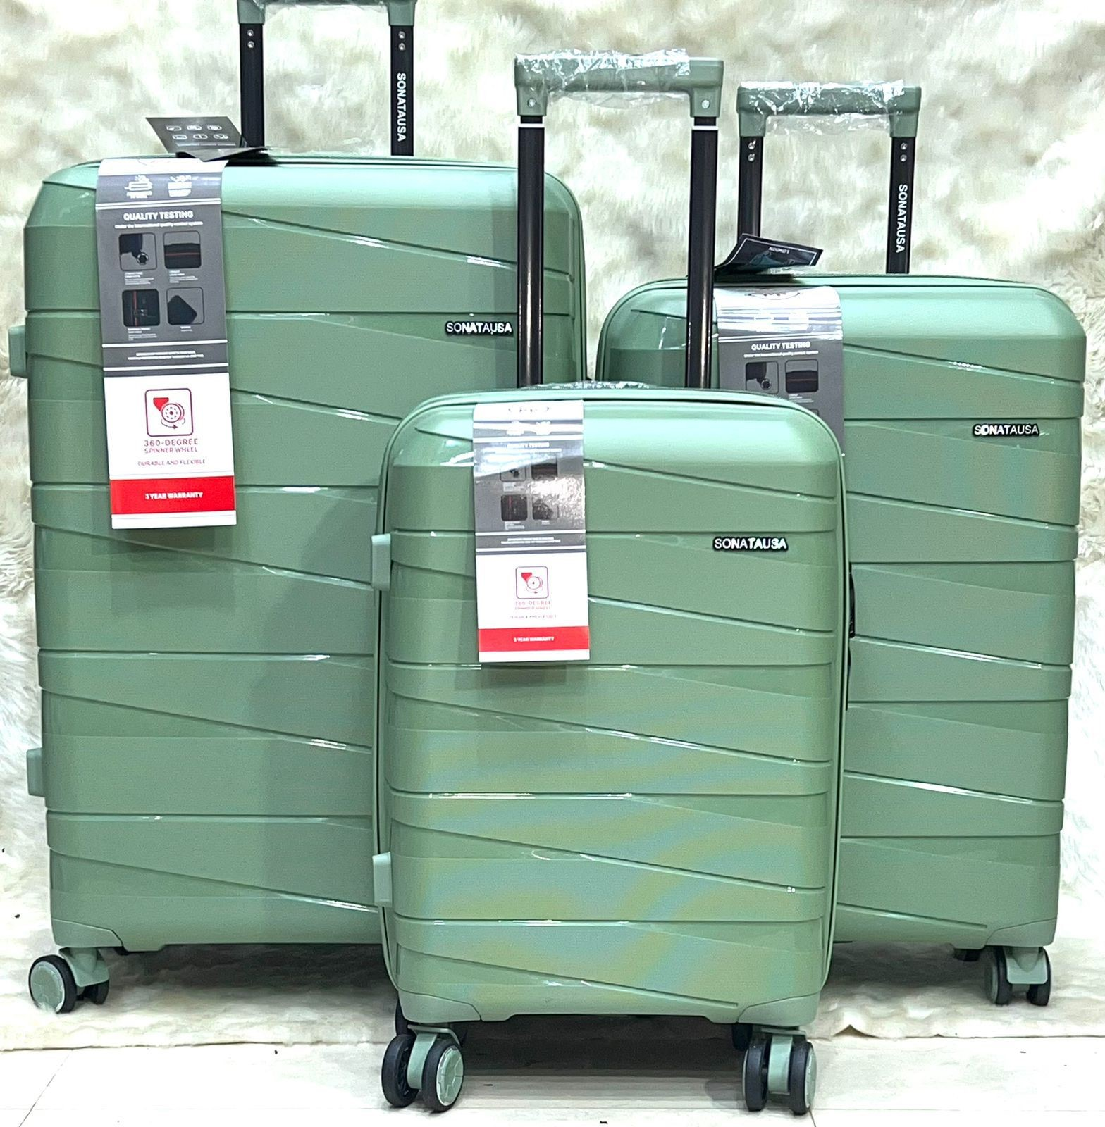

DURABLE

'NCH

3600 WEIGHT

SPINNER

DURABLE

TSA LOCK

8 3600

TSA LOCK

SCAN